TEST DOCUMENT

**Date Created:** 2019/02/22

**Author:** Raymond Yang

**Edit History:**

[2019/02/22] RY: created sections 1.0 and 2.0

[2019/02/24] TG: added template and integrated US sensor section

[2019/02/25] RY: modified numbering and font, added section 1.5, added light sensor test

[2019/02/27] ED: editing

[2019/02/28] RY: add graph to 2.6 and finish 2.7 - 2.10

[2019/03/12] RY: add tests 4 - 9; shorten table of contents

[2019/03/15] RY: create and complete tests up to 8

[2019/03/16] RY: complete test 9 and create test 10

[2019/03/17] RY: complete test 10, and create test 11

[2019/03/19] RY: add tests 12 - 15. Complete tests 11 - 13. Update format of all tables. Insert graphs for tests 9, 10, and 13.

[2019/03/22] RY: add tests 16 - 18.

[2019/03/23] RY: add tests 19 - 20, update test 17 search zone. Complete test 14 - 16.

[2019/03/24] RY: finish report for tests 14 - 16.

[2019/03/26] RY: complete test 18

[2019/03/30] RY: create tests 21 - 22, complete test 21

[2019/03/31] RY: complete tests 17,19, create test 23

[2019/04/01] RY: complete test 17,19.

[2019/04/02] RY: complete test 20,22,23; create tests 24 - 26.

[2019/04/03] RY: complete test 24, 25

[2019/04/07] RY: complete test 26, 27

# 

**Table of Contents**

**1 THE TEST DOCUMENT** **3**

**2 ULTRASONIC SENSOR TEST** **6**

**3 LIGHT SENSOR TEST: RGB** **11**

**4 LIGHT SENSOR TEST: GAUSSIAN DISTRIBUTION** **15**

**5 MOTOR ACCURACY TEST** **20**

**6 TOUCH SENSOR TEST** **24**

**7 LINE DETECTION TEST** **27**

**8 ULTRASONIC LOCALIZATION TEST** **30**

**9 NAVIGATION TEST** **33**

**10 DOUBLE LIGHT LOCALIZATION TEST** **36**

**11 FULL LOCALIZATION TEST** **39**

**12 DOUBLE LIGHT SENSOR CORRECTION** **42**

**13 TUNNEL TRANSIT TEST** **47**

**14 SENSOR MECHANISM TEST** **50**

**15 ULTRASONIC SENSOR SCAN TEST** **53**

**16 CAN IDENTIFICATION TEST** **62**

**17 SEARCH TEST** **65**

**18 PRE-TUNNEL TRAVERSAL TEST 1** **66**

**19 WEIGHT IDENTIFICATION TEST 1** **72**

**20 OBJECT ACQUISITION TEST** **74**

**21 PRE-TUNNEL TRAVERSAL TEST 2** **76**

**22 WIFI CLASS TEST** **84**

**23 PRE-TUNNEL TRAVERSAL TEST 3** **87**

**24 ROTATION TEST** **90**

**25 WEIGHT IDENTIFICATION TEST 2** **92**

**26 INTEGRATION TEST 1** **94**

**27 INTEGRATION TEST 2** **98**

# 

# 1 THE TEST DOCUMENT

This section describes the test document, specifies the general format, and notes other miscellaneous information.

1.1 PURPOSE OF DOCUMENT

This document is a master document for all testing documents. The document serves to provide a detailed explanation and clarification of the testing documents. General information about the testing documents is recorded in this document.

1.2 DOCUMENT TEMPLATE

The test document first starts off with a header section with general information.

**Date:** *YYYY/MM/DD*

**Tester:** *John Doe*

**Duration:** *45 min*

**Author:** *Bob Bobby*

**Hardware Version:** *1.3*

**Software Version:** *1.2.1*

X.1 TEST PURPOSE

Write a brief description of the reason for performing this test and the limitations on the scope of the test.

X.2 TEST OBJECTIVES

Explain specifically what is desired from the test.

X.3 TEST SETUP

Describe in detail the actions to be performed in order to set up the test, such as how the hardware is assembled, what objects are being used, etcetera. Include pseudocode if any used, and attach full code in appendix.

X.4 TEST PROCEDURE

Write each step that must be performed in order to execute the test in a way such that the test is repeatable and results reproducible by another individual.

X.5 EXPECTED RESULTS

Explain what is going to happen if everything goes according to plan.

X.6 TEST RESULTS

Describe briefly the observations and include only concise and summarized data. Do not include full data tables in this section. Include formulas used in computation, if any, in compact form. Show only formula that should require special attention.

X.7 CONCLUSION

Analyze the results obtained. Explain whether there are any deviations from the expected results. Explain the implications and significance of the results.

X.8 ACTIONS

Record the actions taken and decisions made after completion of the test.

X.9 DISTRIBUTION

Record to whom the test document is distributed (sent) to.

X.10 APPENDIX (optional)

Include a full and complete version of the test data or provide link to full data.

X.11 NOTE (optional)

Include any issues or details that requires special attention. This section is optional.

1.3 VERSION NUMBERING SCHEME

There are three types of versions involved in testing documents. An “N/A” signifies that the testing is done before the first version of design is released.

1.3.1 HARDWARE VERSION

The numbering for the hardware version has the following format “#.#”. The first number represents major hardware changes. Major hardware changes are defined as the addition or removal of functional components, such as removing an ultrasonic sensor or adding another EV3 Large Motor. Usually a major hardware change comes with a major software update as well. The second number represents minor hardware changes, such as changing the structure of the robot yet maintaining the same topology — the robot before and after the change has not changed in function.

1.3.2 SOFTWARE VERSION

The numbering for the software version has the following format “#.#”. The first number represents major software changes. Major software changes are defined as a change in the logic of the software, and the two different logics cannot mutually exist. A major software change usually comes with the addition or removal of classes and methods. The second number represents minor software changes, which are smaller updates such as the addition of a helper method, minor improvements in logic, tuning of parameters, or re-structuring the code with the same logic. The logic or approach to the design problem does not change significantly.

1.3.3 DESIGN VERSION

The design version numbering follows the format “#.#”. The first number represents a change in milestone or testing objective. The second number can represents a change in the setup of the robot but with the same or similar testing objective. Further clarification of design is most likely present in the TEST PURPOSE and TEST OBJECTIVE sections of the specific test documents.

1.4 TEST RESULTS FORMAT

Test results are usually given in a table. Raw data are not presented in the TEST RESULTS section, but included as a hyperlink in the APPENDIX section near the end of the document because it usually takes up plenty of space, and hinders the flow. Summarized or representative data in which conclusions can be drawn from are presented in the TEST RESULTS section.

1.5 OPTIONAL NOTES SECTION

A NOTES section is entirely optional and may be used to document observations or issues that requires particular attention. Suggestions for further improvement, if any, can be described in this section.

# 2 ULTRASONIC SENSOR TEST

**Date:** 2019/02/22

**Tester:** Xuemeng Sun

**Duration:** 90 min

**Author:** Raymond Yang

**Hardware Version:** N/A

**Software Version:** N/A

2.1 TEST PURPOSE

This test is performed before the completion of the robot. The purpose of this test is to characterize and evaluate the three ultrasonic sensors through testing. The sensor that reports results with the smallest error will be preferred. With this test, the team also hopes to gain a better understanding of the behaviour and precision of the ultrasonic sensors.

2.2 TEST OBJECTIVES

The objective of this test is to understand and obtain a relationship between the reported distance from the ultrasonic sensor and the actual distance of the ultrasonic sensor and the object of interest. We want to generate a set of data that would allow us to clearly and easily distinguish between the performance of the three ultrasonic sensors. The sensors should be able to accurately report the actual distance within a tolerance level and from the data collected, we should be able to find the tolerance level.

2.3 TEST SETUP

For each sensor, label each one as 1, 2, or 3. The design consists of an EV3 brick, a pair of motors and wheels, and an ultrasonic sensor connected to a port on the brick. The device is placed at 2.5 cm, 5.0 cm, 10.0 cm, 30.48 cm, 60.96 cm[1].

2.3.1 TESTING DEVICE

The device is built such that the EV3 brick sits on top of two EV3 Large motors. The two EV3 Large Motors are placed in parallel. The two motors are separated by a distance of 13.4 cm. The EV3 brick is placed with the control panel facing upwards for easy access and debugging. The ultrasonic sensor is mounted in front of the device. The device receives the program via Wifi and executes the program locally.

2.3.2 ULTRASONIC SENSOR PLACEMENT

The ultrasonic sensor is placed horizontally, with the two openings aligned in a horizontal fashion, pointing forwards. The ultrasonic sensor is 3.0 cm in front of the brick with a height of 9.8 cm relative to the demo floor. Note that the setup is acceptable as long as the sensor is able to detect the can without interference by other parts of the robot.

2.3.3 OBJECT

A tin can is used as the object. The tin can is placed on the demo floor upright.

2.4 TEST PROCEDURE

1. Upload testing code to the device.
2. Place device at the distances specified in section 3.0, measure the separation distance from the nearest edge of the tin can to the front edge of the ultrasonic sensor. The ultrasonic sensor should be placed so that it points straight at the tin can.
3. Start the ultrasonic sensor and take note of reading reported by device.
4. Record data and repeat process for other distances.
5. Repeat steps 1 - 4 for 10 cycles.

2.5 EXPECTED RESULTS

The distance readings reported by the ultrasonic sensor should be the same as the actual distance from the sensor to the tin can. For example, if the device is placed at 30.48 cm away from the can, then the ultrasonic sensor should report a reading of 30.48 cm as well. However, it is known that the reported distance will deviate from the actual distance. The absolute error of mean is expected to be near 0.

2.6 TEST RESULTS

|  |  |  |  |  |  |
| --- | --- | --- | --- | --- | --- |
| **Sensor 1** | **Reported Distances (cm)** | | | | |
| **Item** | **2.5** | **5.0** | **10.0** | **30.48** | **60.96** |
| Mean | 3.72 | 6.42 | 12.76 | 32.89 | 64.03 |
| STDEV | 0.14 | 0.25 | 0.40 | 0.19 | 0.44 |
| Abs. Error | 1.22 | 1.42 | 2.76 | 2.41 | 3.07 |

*Table 1*. Mean, standard deviation, and absolute error of mean for Sensor 1, at different distances from the can.

|  |  |  |  |  |  |
| --- | --- | --- | --- | --- | --- |
| **Sensor 2** | **Reported Distances (cm)** | | | | |
| **Item** | **2.5** | **5.0** | **10.0** | **30.48** | **60.96** |
| Mean | 4.32 | 6.22 | 13.07 | 33.28 | 65.70 |
| STDEV | 0.79 | 0.48 | 0.46 | 0.40 | 0.67 |
| Abs. Error | 1.82 | 1.22 | 3.07 | 2.80 | 4.74 |

*Table 2*. Mean, standard deviation, and absolute error of mean for Sensor 2, at different distances from the can.

|  |  |  |  |  |  |
| --- | --- | --- | --- | --- | --- |
| **Sensor 3** | **Reported Distances (cm)** | | | | |
| **Item** | **2.5** | **5.0** | **10.0** | **30.48** | **60.96** |
| Mean | 4.48 | 6.64 | 12.71 | 33.71 | 65.82 |
| STDEV | 0.19 | 0.10 | 1.01 | 0.34 | 0.42 |
| Abs. Error | 1.98 | 1.64 | 2.71 | 3.23 | 4.86 |

*Table 3*. Mean, standard deviation, and absolute error of mean for Sensor 3, at different distances from the can.

**Formula:**

Mean:

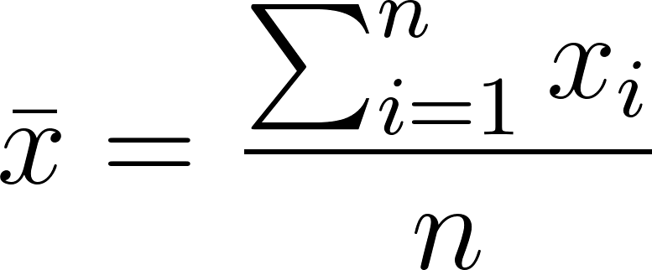

STDEV:

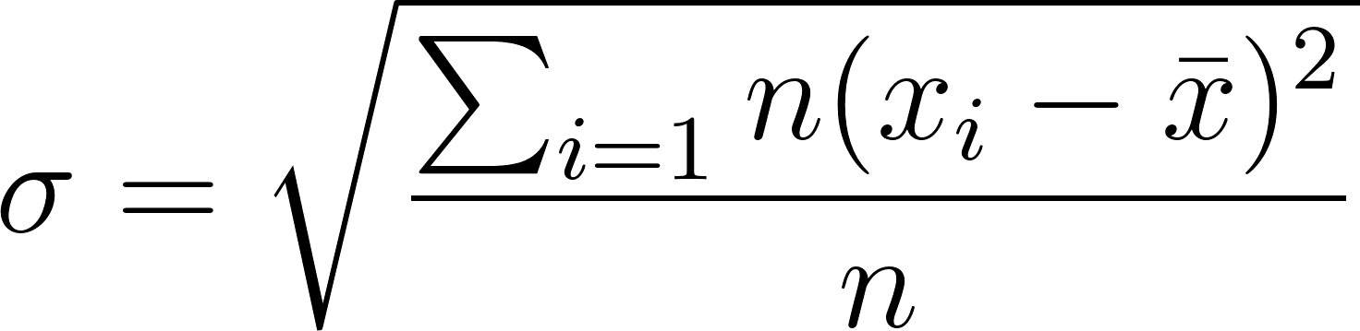

Abs. Error:

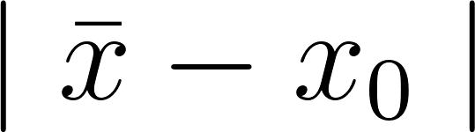 where  is the target value

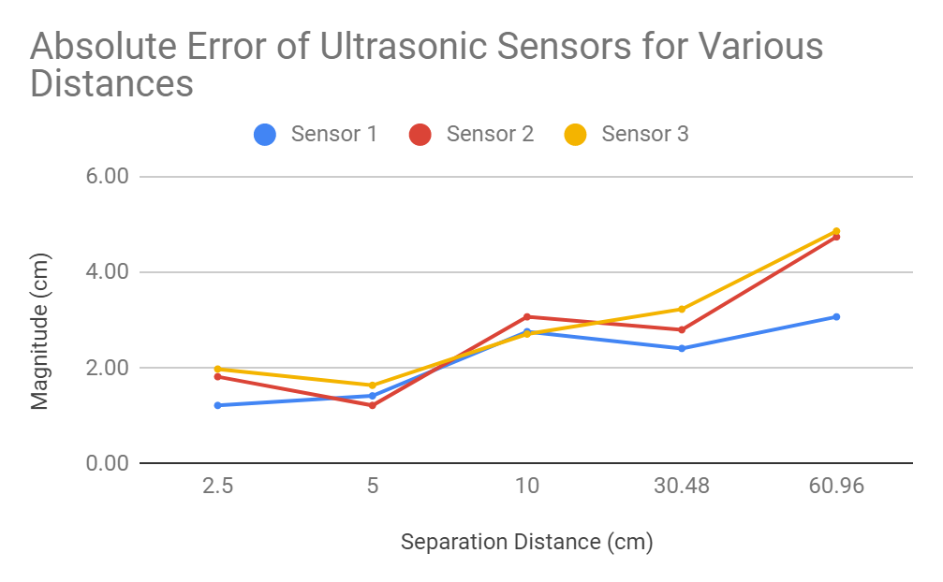

*Figure 1*. Line plot of absolute errors for sensor 1.

2.7 CONCLUSION

The test was successful in obtaining data to compare the sensors. Observing the Abs. Error in Tables 1, 2, and 3 for different distances, sensor 1 reports closest to expected value for 1 tile length, 2 tile length, and 2.5 cm length. Sensor 2 reports closest for only 5.0 cm length. Sensor 3 reports closest for only 10.0 cm. As for STDEV, sensor 1 had the smallest value for all distances except 5.0 cm. Sensor 2 has readings that are closer to the target but a higher standard deviation, compared to sensor 3. Therefore, sensor 1 should be used on the robot. If an additional sensor is needed, sensor 2 should be used if the measurements requires accuracy and sensor 3 should be used if measurement requires precision. Figure 1 gives a more visual representation of the data: sensor 1, represented by the blue line, has the least error.

2.8 ACTIONS

Document data and conclusions on ultrasonic sensor for further use. Sensor 1 will be used as a first choice.

2.9 DISTRIBUTION

Hardware Leader; Hardware Engineer; Project Manager; Documentation Manager; Software Leader; Software Engineer.

2.10 APPENDIX

[Full Data](https://docs.google.com/spreadsheets/d/1jJYBv8L4dGYaDdVwSkBg_dISe0iAHa0Emx689wZuU0U/edit?usp=sharing)

# 3 LIGHT SENSOR TEST: RGB

**Date:** 2019/02/25

**Tester:** Raymond Yang

**Duration:** 60 min

**Author:** Raymond Yang

**Hardware Version:** N/A

**Software Version:** N/A

3.1 TEST PURPOSE

This test is designed to test whether all three sensors can differentiate between cans of different colors. We want to test whether the sensors are able to function correctly.

3.2 TEST OBJECTIVES

In this test, we are gathering the raw RGB values returned by the light sensor when pointed at cans of different colors. We can compute the normalized RGB values of each can.

3.3 TEST SETUP

The design consists of an EV3 brick, with a light sensor connected to a sensor port.

3.3.1 TESTING DEVICE

The device for this test is simple. There are only two components in total: the brick and the light sensor. The light sensor is connected to the brick. Data is transmitted back to the computer using SSH. A piece of code is used in the data gathering process.

3.3.2 OBJECT

Four tin cans of different colors are used. The four tin cans should be under the same conditions (i.e. ambient light) during testing.

3.4 TEST PROCEDURE

1. Execute testing code and wait until “Now” appears on the screen.
2. Place tin can on a flat surface.
3. Point sensor at the surface of the can where the color is homogeneous, at about 1.0 cm to 2.0 cm away from the can.
4. Click any button on the EV3, other than escape, to gather 1 set of data.
5. Repeat steps 3 - 4 with another spot on the can where the color is homogeneous.
6. Use another tin can of a different color and repeat steps 4 - 5, until all four colors have been tested and data recorded.
7. Export data to computer.

3.5 EXPECTED RESULTS

In terms of RGB values: for the color red, the R values should be much larger than G or B; for the color green, G should be much larger than R or B; for the color blue, B should be much larger than R or G; for the color yellow, R and G should be equal, with both of them much larger than B.

3.6 TEST RESULTS

|  |  |  |  |  |  |  |  |  |  |  |  |  |
| --- | --- | --- | --- | --- | --- | --- | --- | --- | --- | --- | --- | --- |
| **S1** | **RED Can** | | | **GREEN Can** | | | **BLUE Can** | | | **YELLOW Can** | | |
| **Trials** | **R** | **G** | **B** | **R** | **G** | **B** | **R** | **G** | **B** | **R** | **G** | **B** |
| **1** | 0.98 | 0.16 | 0.06 | 0.29 | 0.95 | 0.07 | 0.26 | 0.93 | 0.27 | 0.84 | 0.53 | 0.10 |
| **2** | 0.99 | 0.16 | 0.05 | 0.34 | 0.93 | 0.12 | 0.21 | 0.70 | 0.68 | 0.91 | 0.40 | 0.10 |
| **3** | 1.00 | 0.09 | 0.03 | 0.21 | 0.96 | 0.19 | 0.30 | 0.85 | 0.43 | 0.92 | 0.38 | 0.09 |
| **4** | 0.99 | 0.09 | 0.13 | 0.40 | 0.91 | 0.12 | 0.22 | 0.92 | 0.31 | 0.88 | 0.47 | 0.09 |

*Table 1*. Normalized mean RGB values for different cans measured using sensor 1.

|  |  |  |  |  |  |  |  |  |  |  |  |  |
| --- | --- | --- | --- | --- | --- | --- | --- | --- | --- | --- | --- | --- |
| **S2** | **RED Can** | | | **GREEN Can** | | | **BLUE Can** | | | **YELLOW Can** | | |
| **Trials** | **R** | **G** | **B** | **R** | **G** | **B** | **R** | **G** | **B** | **R** | **G** | **B** |
| **1** | 0.99 | 0.09 | 0.06 | 0.33 | 0.93 | 0.23 | 0.26 | 0.62 | 0.74 | 0.95 | 0.29 | 0.10 |
| **2** | 0.99 | 0.07 | 0.07 | 0.35 | 0.91 | 0.23 | 0.33 | 0.46 | 0.82 | 0.94 | 0.32 | 0.11 |
| **3** | 0.99 | 0.09 | 0.07 | 0.37 | 0.91 | 0.18 | 0.33 | 0.37 | 0.87 | 0.95 | 0.30 | 0.11 |
| **4** | 0.99 | 0.07 | 0.07 | 0.35 | 0.92 | 0.20 | 0.41 | 0.65 | 0.65 | 0.94 | 0.31 | 0.09 |

*Table 2*. Normalized mean RGB values for different cans measured using sensor 2.

|  |  |  |  |  |  |  |  |  |  |  |  |  |
| --- | --- | --- | --- | --- | --- | --- | --- | --- | --- | --- | --- | --- |
| **S3** | **RED Can** | | | **GREEN Can** | | | **BLUE Can** | | | **YELLOW Can** | | |
| **Trials** | **R** | **G** | **B** | **R** | **G** | **B** | **R** | **G** | **B** | **R** | **G** | **B** |
| **1** | 0.99 | 0.10 | 0.05 | 0.31 | 0.94 | 0.16 | 0.33 | 0.69 | 0.64 | 0.91 | 0.42 | 0.07 |
| **2** | 1.00 | 0.09 | 0.04 | 0.33 | 0.93 | 0.17 | 0.36 | 0.71 | 0.60 | 0.91 | 0.41 | 0.09 |
| **3** | 1.00 | 0.08 | 0.05 | 0.36 | 0.91 | 0.17 | 0.25 | 0.43 | 0.87 | 0.91 | 0.40 | 0.08 |
| **4** | 1.00 | 0.07 | 0.05 | 0.33 | 0.92 | 0.20 | 0.29 | 0.67 | 0.68 | 0.91 | 0.40 | 0.07 |

*Table 3*. Normalized mean RGB values for different cans measured using sensor 3.

**Formula:**

Mean:



STDEV:



Norm. Mean:

[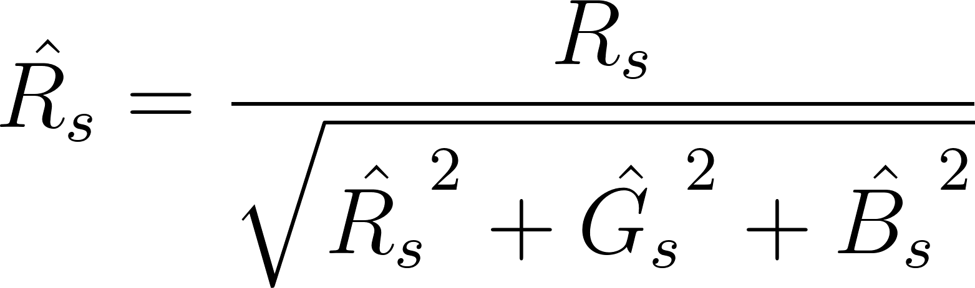](https://www.codecogs.com/eqnedit.php?latex=%5Chat%7BR_%7Bs%7D%7D%20%3D%20%5Cdfrac%7BR_%7Bs%7D%7D%7B%5Csqrt%7B%5Chat%7BR_%7Bs%7D%7D%5E%7B2%7D%20%2B%20%5Chat%7BG_%7Bs%7D%7D%5E%7B2%7D%20%2B%20%5Chat%7BB_%7Bs%7D%7D%5E%7B2%7D%7D%7D%250)

[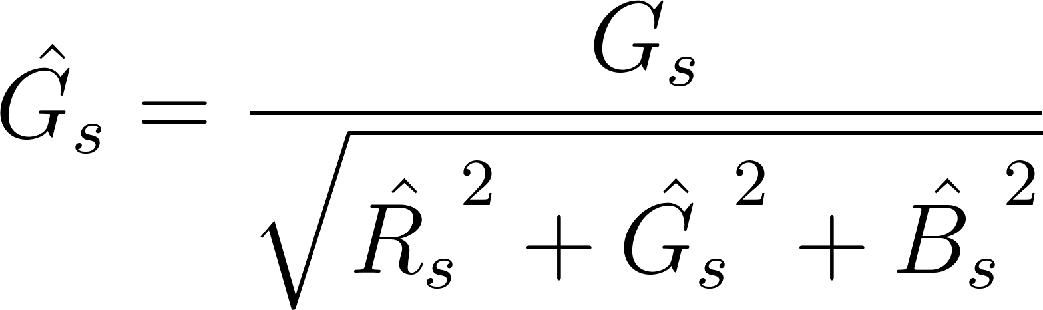](https://www.codecogs.com/eqnedit.php?latex=%5Chat%7BG_%7Bs%7D%7D%20%3D%20%5Cdfrac%7BG_%7Bs%7D%7D%7B%5Csqrt%7B%5Chat%7BR_%7Bs%7D%7D%5E%7B2%7D%20%2B%20%5Chat%7BG_%7Bs%7D%7D%5E%7B2%7D%20%2B%20%5Chat%7BB_%7Bs%7D%7D%5E%7B2%7D%7D%7D%250)

[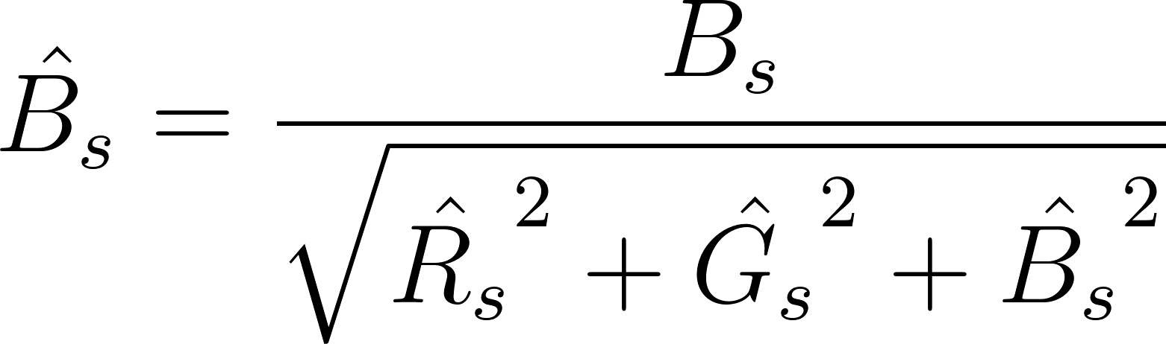](https://www.codecogs.com/eqnedit.php?latex=%5Chat%7BB_%7Bs%7D%7D%20%3D%20%5Cdfrac%7BB_%7Bs%7D%7D%7B%5Csqrt%7B%5Chat%7BR_%7Bs%7D%7D%5E%7B2%7D%20%2B%20%5Chat%7BG_%7Bs%7D%7D%5E%7B2%7D%20%2B%20%5Chat%7BB_%7Bs%7D%7D%5E%7B2%7D%7D%7D%250)

3.7 CONCLUSION

From the data gathered, there is a clear pattern for R, G, and B values corresponding to cans of different colors. The RGB values for red and green cans are as expected, but the values for blue and yellow cans are not. There is no preferred light sensor, all three are functional.

3.8 ACTIONS

Schedule further testing to see whether sensor is able to produce a gaussian distribution based on readings.

3.9 DISTRIBUTION

Hardware Leader; Hardware Engineer; Software Leader; Software Engineer; Project Manager; Documentation Manager.

3.10 APPENDIX

[Full data](https://docs.google.com/spreadsheets/d/1oGyhpdJ-pF7DBLw1z-mPtCT61TznEHaDWiEvMkcWwDg/edit?usp=sharing)

[Testing Code](https://gist.github.com/27aa619220ef61a889294d6d6ddedd4b.git)

# 4 LIGHT SENSOR TEST: GAUSSIAN DISTRIBUTION

**Date:** 2019/03/04

**Tester:** Raymond Yang

**Duration:** 45 min

**Author:** Raymond Yang

**Hardware Version:** N/A

**Software Version:** N/A

4.1 TEST PURPOSE

The purpose of this test is to confirm whether the light sensor return RGB data that fits a Gaussian distribution for cans of four colors: red, green, blue, and yellow. If the distribution is a Gaussian distribution, we can apply the empirical rule to determine the probability of different values appearing.

4.2 TEST OBJECTIVES

We expect to obtain RGB values for cans of different colors, calculate the mean and standard deviation of the RGB data. The Gaussian distribution will be constructed to check normality of the data.

4.3 TEST SETUP

The design consists of an EV3 brick, with a light sensor connected to a sensor port.

4.3.1 TESTING DEVICE

The device for this test is simple. There are only two components in total: the brick and the light sensor. The light sensor is connected to the brick. Data is transmitted back to the computer using SSH. A piece of code is used in the data gathering process.

4.3.2 OBJECT

Four tin cans of different colors are used. The four tin cans should be under the same conditions (i.e. ambient light) during testing.

4.4 TEST PROCEDURE

1. Execute testing code and wait until “Now” appears on the screen.
2. Place tin can on a flat surface.
3. Point sensor at the surface of the can where the color is homogeneous, at about 1.0 cm to 2.0 cm away from the can.
4. Click any button on the EV3, other than escape, to gather 1 set of data.
5. Repeat steps 3 - 4 with another can of a different color
6. Export data to computer.

4.5 EXPECTED RESULTS

Since the samples are independent and identical, with sample size over 30, the distribution should be a Gaussian distribution.

4.6 TEST RESULTS

|  |  |  |  |
| --- | --- | --- | --- |
| **RED** | **R** | **G** | **B** |
| **Norm. Mean** | 0.985 | 0.135 | 0.104 |
| **Std. Dev.** | 0.002 | 0.001 | 0.001 |

*Table 1*. Normalized mean and standard deviation for RGB of the red can.

|  |  |  |  |
| --- | --- | --- | --- |
| **GREEN** | **R** | **G** | **B** |
| **Norm. Mean** | 0.205 | 0.934 | 0.294 |
| **Std. Dev.** | 0.001 | 0.003 | 0.002 |

*Table 2*. Normalized mean and standard deviation for RGB of the green can.

|  |  |  |  |
| --- | --- | --- | --- |
| **BLUE** | **R** | **G** | **B** |
| **Norm. Mean** | 0.193 | 0.424 | 0.885 |
| **Std. Dev.** | 0.001 | 0.001 | 0.001 |

*Table 3*. Normalized mean and standard deviation for RGB of the blue can.

|  |  |  |  |
| --- | --- | --- | --- |
| **YELLOW** | **R** | **G** | **B** |
| **Norm. Mean** | 0.897 | 0.402 | 0.182 |
| **Std. Dev.** | 0.001 | 0.002 | 0.001 |

*Table 4*. Normalized mean and standard deviation for RGB of the yellow can.

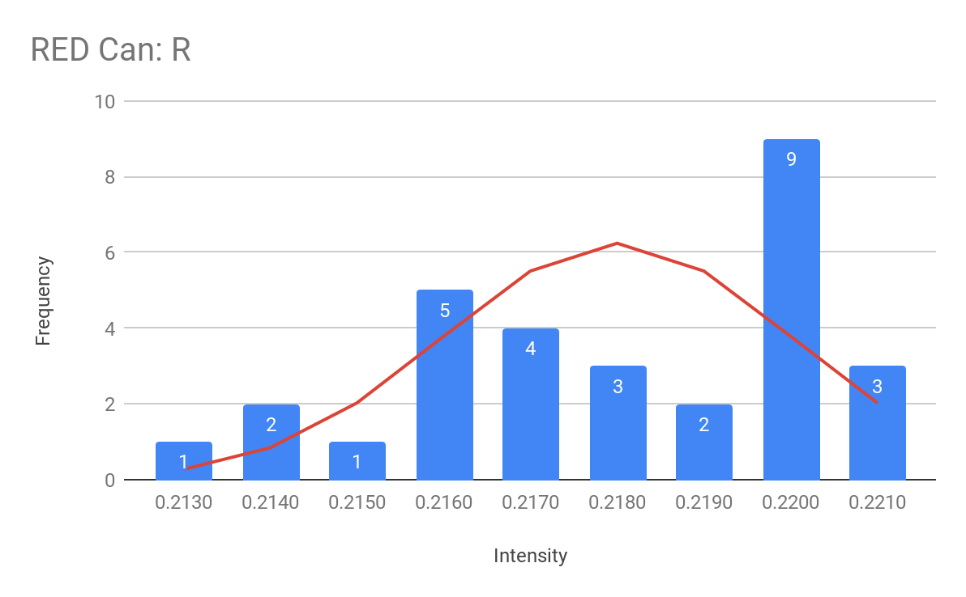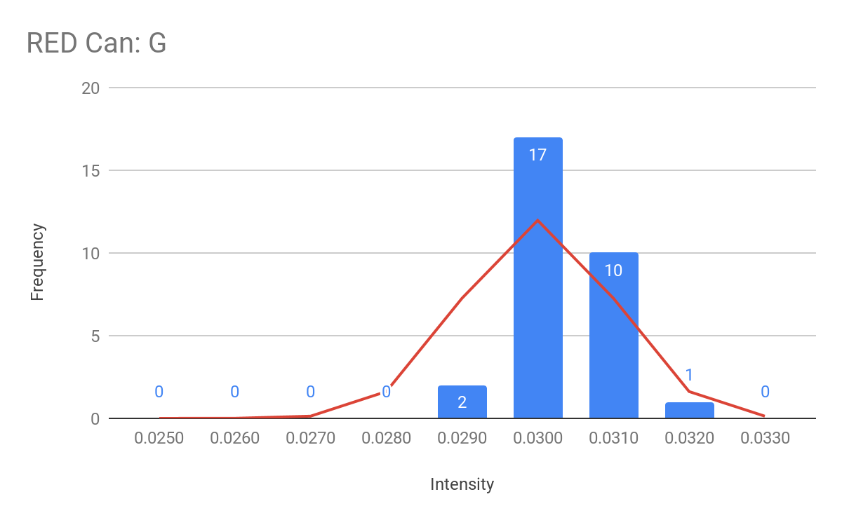

Figure 1.1. Frequency distribution for R value of red cans.

Figure 1.2. Frequency distribution for G value of red cans.

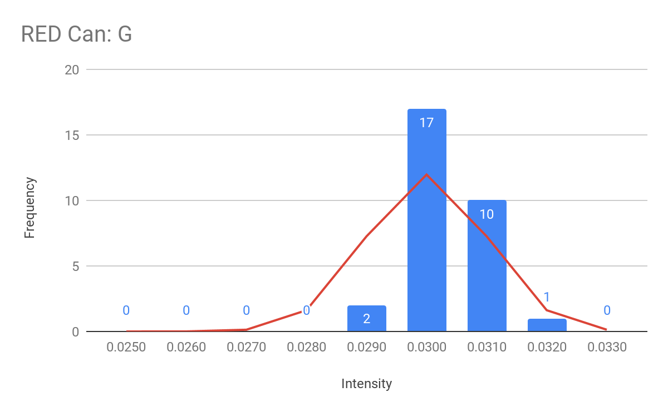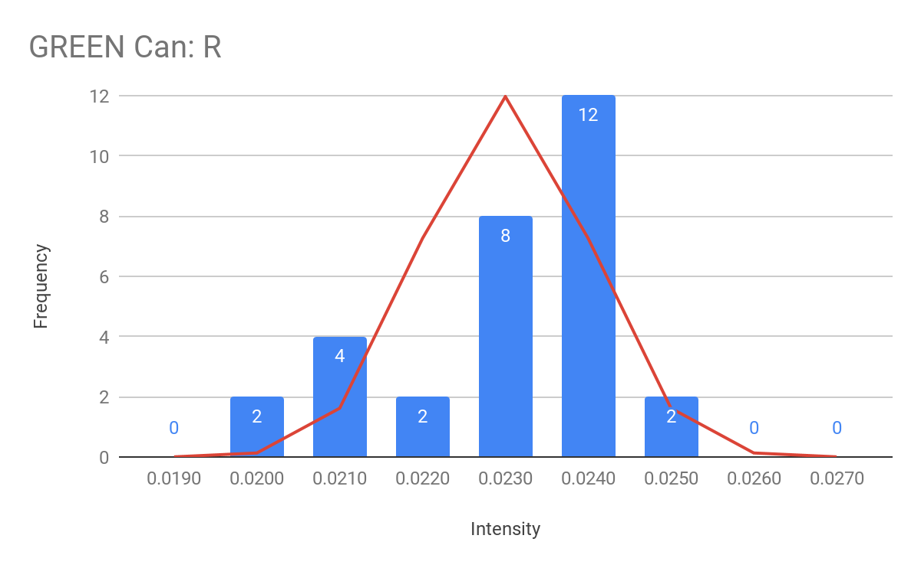

Figure 1.3. Frequency distribution for B value of red cans.

Figure 2.1. Frequency distribution for R value of green cans.

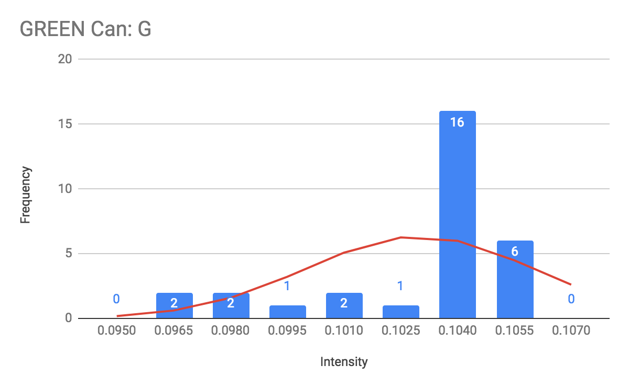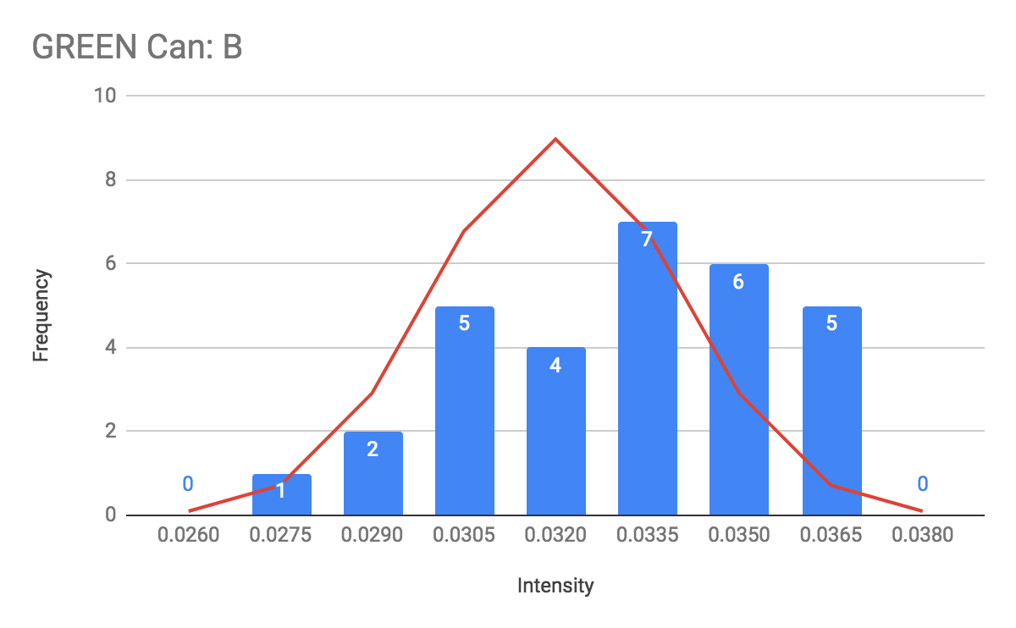

Figure 2.2. Frequency distribution for G value of green cans.

Figure 2.3. Frequency distribution for B value of green cans.

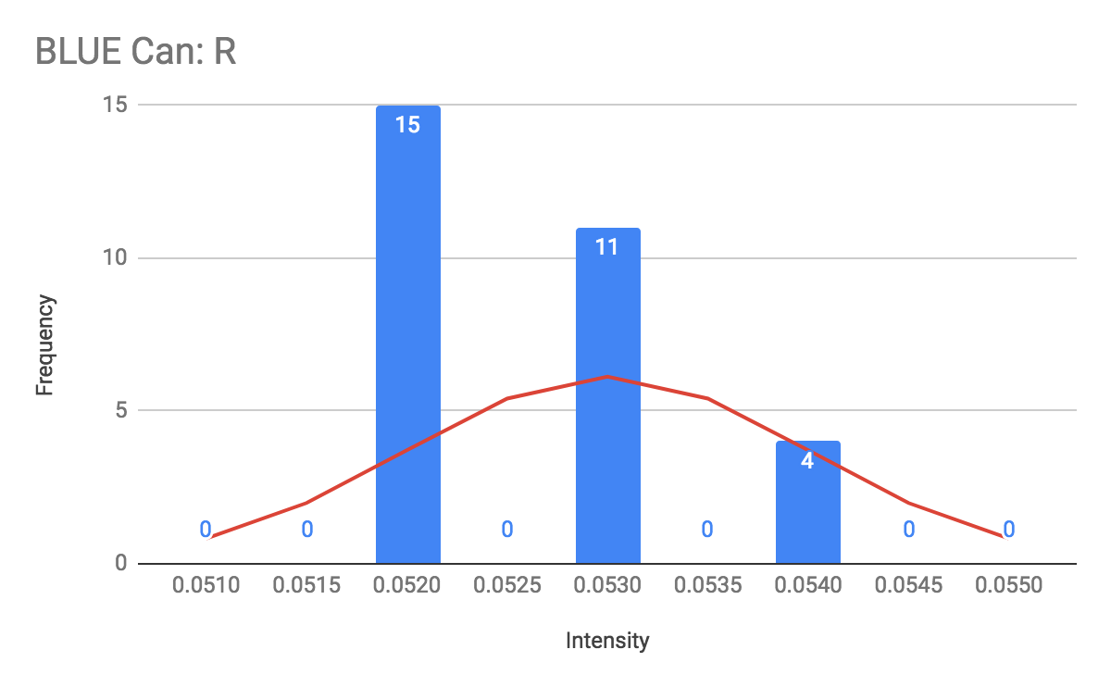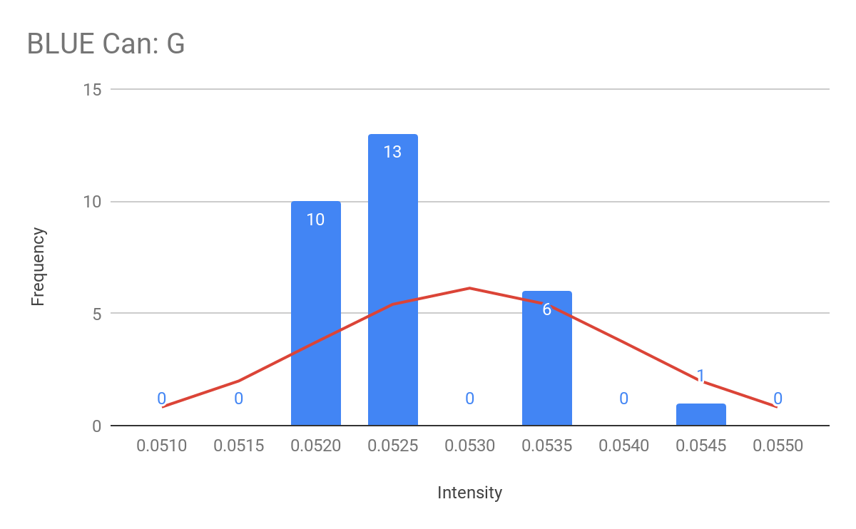

Figure 3.1. Frequency distribution for R value of blue cans.

Figure 3.2. Frequency distribution for G value of blue cans

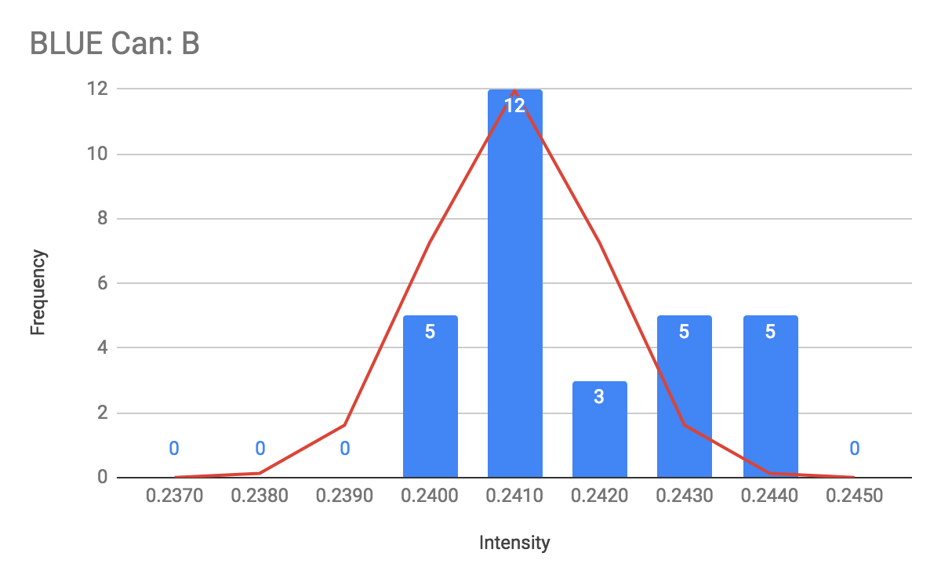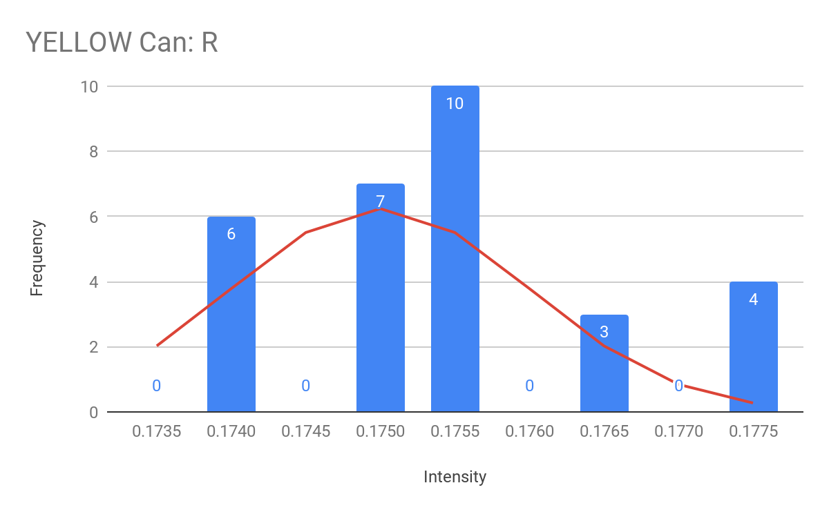

Figure 3.3. Frequency distribution for B value of blue cans.

Figure 4.1. Frequency distribution for R value of yellow cans.

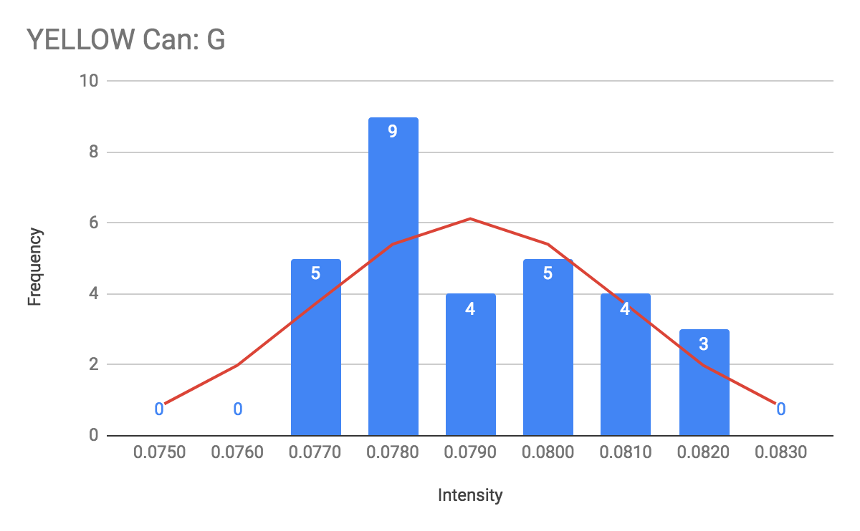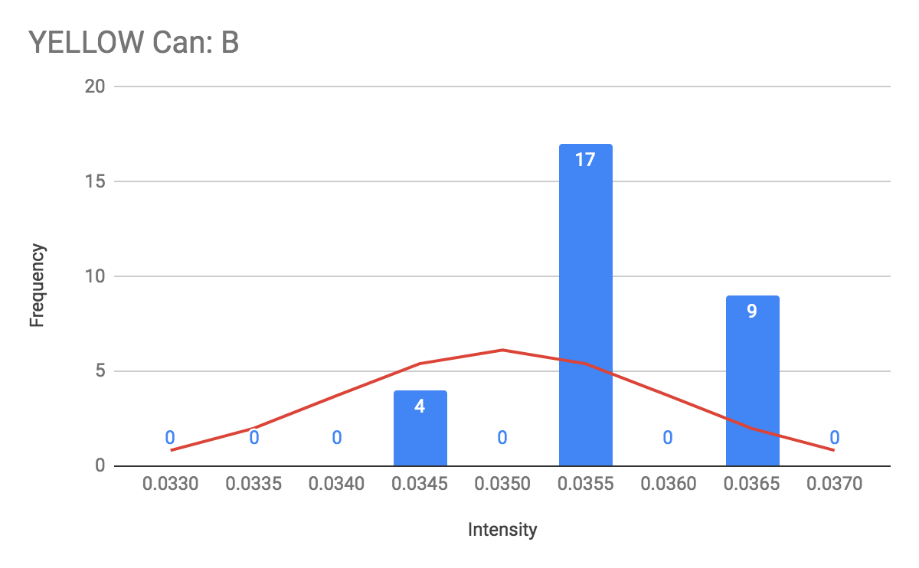

Figure 4.2. Frequency distribution for G value of blue cans.

Figure 4.3. Frequency distribution for B value of yellow cans.

4.7 CONCLUSION

In tables 1 to 4, the normalized mean and standard deviation give a rough estimate of the RGB values corresponding to cans of different colors. The figures 1 to 4 (a total of 12) shows the distribution of the RGB readings. The RGB data of the light sensor is approximately normal, with a sample size of 30. The normality is assumed to be stronger as sample size increases. However, factors such as the uneven surface of the can are able to cause deviations in the data.

4.8 ACTIONS

Test for RGB thresholds of each color for color detection and can identification. A standard could be set up, the mean and standard deviation can be used for color identification. With a Gaussian distribution, we can related the probability of a value occuring to the standard deviation directly.

4.9 DISTRIBUTION

Software Leader; Software Engineer; Project Manager; Documentation Manager.

4.10 APPENDIX

[Test Code](https://gist.github.com/687ed43bf42be399dcf1f940c4ecc20e.git)

[Full Data](https://docs.google.com/spreadsheets/d/1C3CXNbM0ZSHugta19zmp-MtR7anGANI6dMFZXnzZQOw/edit?usp=sharing)

# 5 MOTOR ACCURACY TEST

**Date:** 2019/03/04

**Tester:** Antoine Wang, Xuemeng Sun

**Duration:** 90 min

**Author:** Raymond Yang

**Hardware Version:** 2.0

**Software Version:** N/A

5.1 TEST PURPOSE

The purpose of this test is to check whether all 6 motors can turn the amount it is supposed to accurately. We want to eliminate any problems that are within the motor itself.

5.2 TEST OBJECTIVES

We expect to obtain the error of the motor when it is specified to turn a fixed amount of degrees. We also aim to obtain the degrees turned that is recorded by the motor itself, and the error between the recorded angle with the turned angle. We expect to obtain the relationship between error and magnitude of turning, if there is one.

5.3 TEST SETUP

The design uses the hardware design version 2.0. This design consists of the EV3 brick, two motors for the wheels. An orange indicator (Figure 1, right) to indicate the angle. The degrees to be turned are: 90, 180, 270, 360, 450, 540, 720, 900, 1080, 1260, 1440. The acceleration of the motor is set to a default value of 6000, and the speed is set to 250. Robot is placed on the demo floor facing any direction.

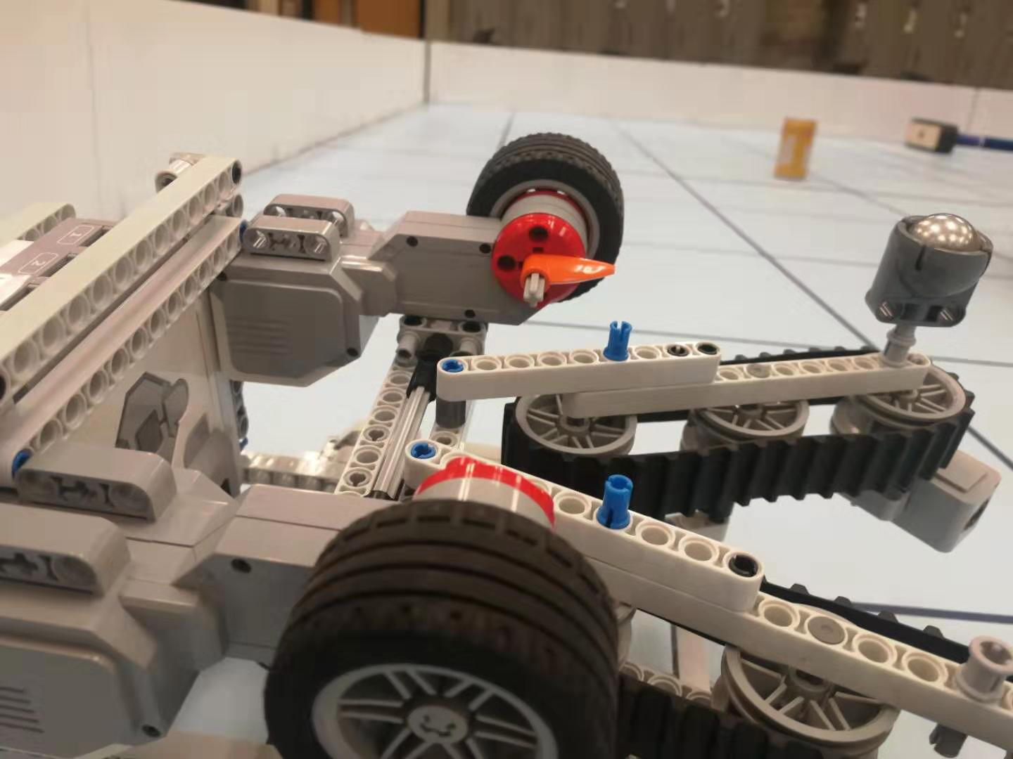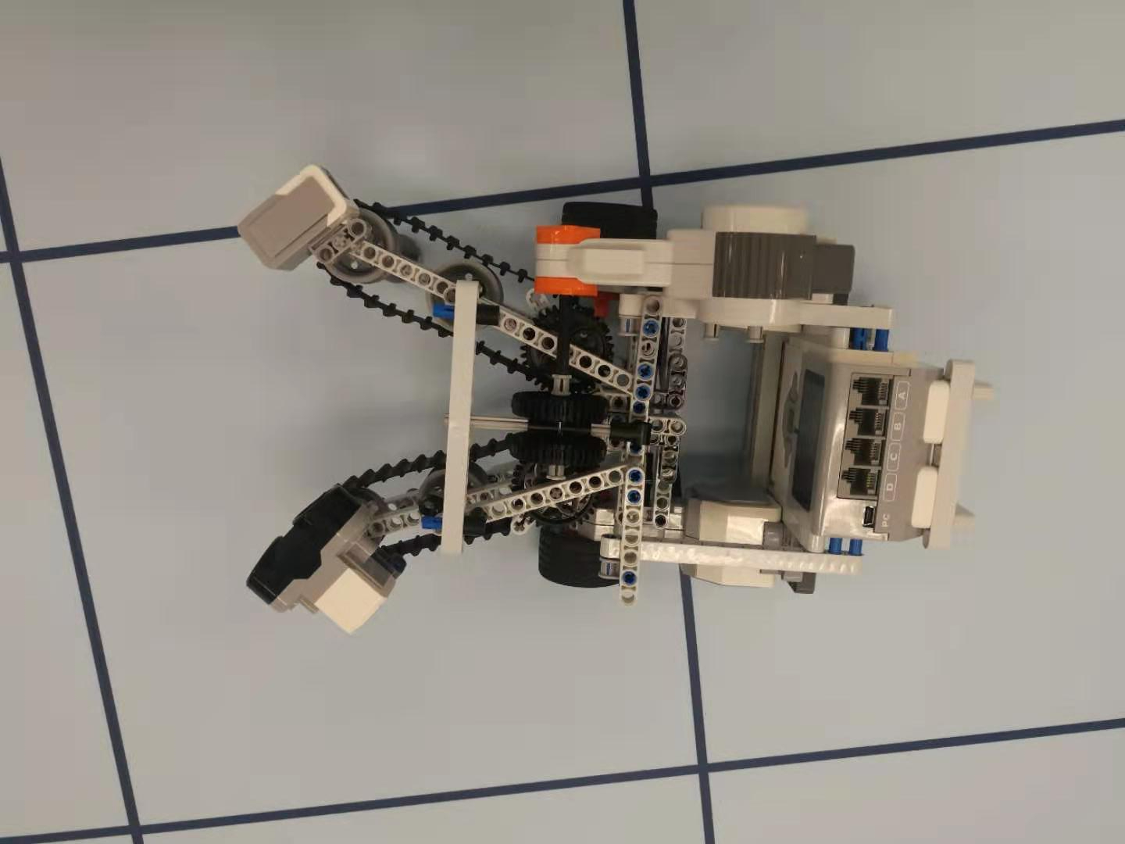

Figure 1. Robot used in testing.

5.4 TEST PROCEDURE

1. Note where the orange indicator is pointing.
2. Set program parameters and execute program.
3. Measure final angle and determine error.
4. Repeat steps 1 - 3 for all degrees.
5. Repeat steps 1 - 4 for all motors.

5.5 EXPECTED RESULTS

The motor is expected to turn to the angle specified, so angle turned should be consistent with angle expected. The motor is expected to have a recorded angle same as the turned angle. Although friction is present, the encoder should account for that and turn more or less to reach the degrees. The error should be within 5 degrees.

5.6 TEST RESULTS

|  |  |
| --- | --- |
| **Motor 1** | **Degrees** |
| Mean Error (expected and turned) | -0.64 |
| Mean Error (turned and reported) | -0.82 |

*Table 1*. Mean errors for motor 1.

|  |  |
| --- | --- |
| **Motor 2** | **Degrees** |
| Mean Error (expected and turned) | 0.27 |
| Mean Error (turned and reported) | 0.18 |

*Table 2*. Mean errors for motor 2.

|  |  |
| --- | --- |
| **Motor 3** | **Degrees** |
| Mean Error (expected and turned) | -0.64 |
| Mean Error (turned and reported) | 0.00 |

*Table 3*. Mean errors for motor 3.

|  |  |
| --- | --- |
| **Motor 4** | **Degrees** |
| Mean Error (expected and turned) | -3.09 |
| Mean Error (turned and reported) | -3.18 |

*Table 4*. Mean errors for motor 4.

|  |  |
| --- | --- |
| **Motor 5** | **Degrees** |
| Mean Error (expected and turned) | 0.64 |
| Mean Error (turned and reported) | 0.36 |

*Table 5*. Mean errors for motor 5.

|  |  |
| --- | --- |
| **Motor 6** | **Degrees** |
| Mean Error (expected and turned) | 1.00 |
| Mean Error (turned and reported) | 0.73 |

*Table 6*. Mean errors for motor 6.

5.7 CONCLUSION

All motors have error less than 5 degrees in magnitude, they are all functional and work properly. The mean error of all the motors except motor 4 are contained within one degrees. Most of the time, the error of the motor is reported by the odometer. All motors are in acceptable condition. Other motors are preferred to motor 4.

5.8 ACTIONS

Proceed with current hardware design.

5.9 DISTRIBUTION

Hardware Leader; Software Leader; and Project Manager; Documentation Manager.

5.10 APPENDIX

[Testing Code](https://gist.github.com/fb2d54d5c94419f8291ab793035f5adf.git)

[Full Data](https://docs.google.com/spreadsheets/d/1Mlj06aopShnnRYrHDIJGAMzDRIG_IO3u6ajtjYV9c5M/edit?usp=sharing)

# 6 TOUCH SENSOR TEST

**Date:** 2019/03/04

**Tester:** Antoine Wang, Xuemeng Sun

**Duration:** 60 min

**Author:** Raymond Yang

**Hardware Version:** 1.0

**Software Version:** N/A

6.1 TEST PURPOSE

The purpose of this test is to determine whether the touch sensor can be triggered by using the robot and the can. We want to use the touch sensor as a mechanism for weight detection.

6.2 TEST OBJECTIVES

We expect to let the robot hit the can with the touch sensor over a range of speeds, and determine whether the robot is able to activate the sensor by hitting the can at each speed.

6.3 TEST SETUP

The design is based on the hardware design 1.0, replacing the ultrasonic sensor with the touch sensor. Robot is to go at speeds: 100, 250, 500, 750, 1000, 1250, 1500. The speeds are in degrees per second.

6.3.1 ROBOT

A stick is attached to the touch sensor, and a pad is attached to the other end of the stick. This reduces the requirements of the precision (of the robot’s orientation) needed in the test.

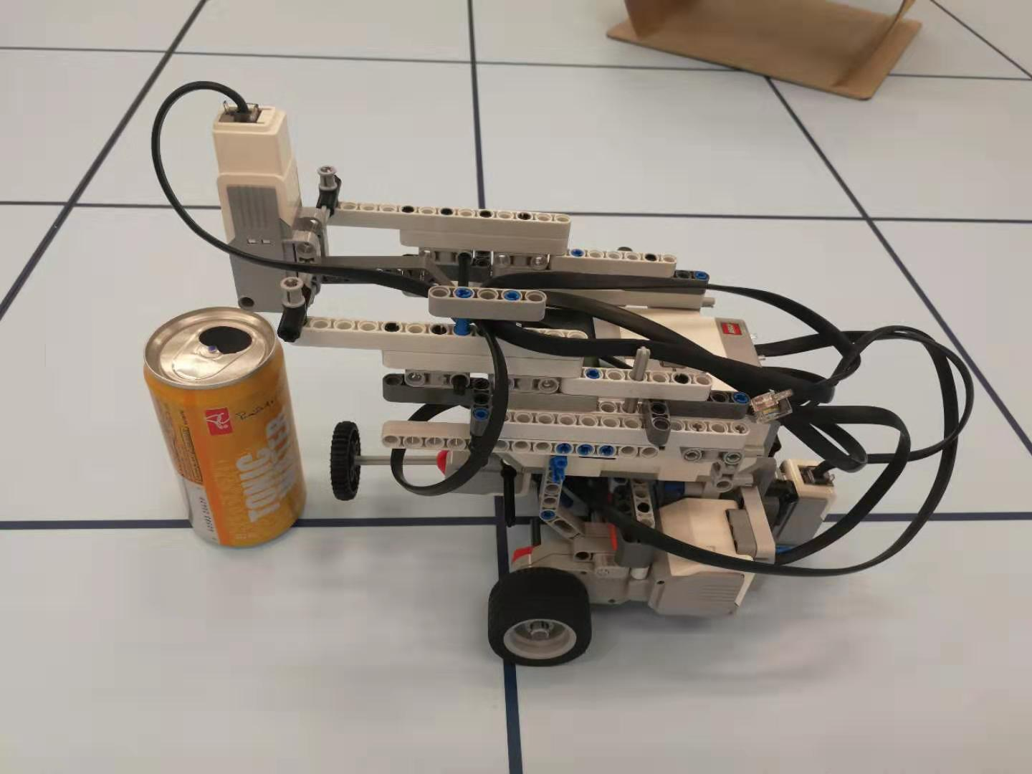

*Figure 1*. Robot with touch sensor.

6.3.2 OBJECT

The can is placed on the demo floor in an upright fashion, where the robot can easily hit the can.

6.4 TEST PROCEDURE

1. Place can at about 1.5 to 2.0 tile lengths away, so robot is able to reach target speed but not deviate too much from its path
2. Execute program. Robot should travel, hit can with touch sensor, and stop immediately upon activation of sensor
3. Repeat steps 1 - 2 for different speeds. For each test the touching process is repeated 5 times and the number of successes are recorded

6.5 EXPECTED RESULTS

Sensor will activate for at least one speed of the nine speeds. At the right speeds, the sensor should get triggered when it hits a heavy can, and not get triggered when it hits a light can.

6.6 TEST RESULTS

Touch Sensor 1

|  |  |  |  |  |  |  |  |
| --- | --- | --- | --- | --- | --- | --- | --- |
| **Speed (deg/sec)** | **100** | **250** | **500** | **750** | **1000** | **1250** | **1500** |
| **Light (triggered / 5)** | 0 | 0 | 0 | 0 | 0 | 0 | 0 |
| **Heavy (triggered / 5)** | 0 | 0 | 3 | 4 | 4 | 5 | 5 |

Table 1. Activation count for touch sensor 1 on impact with light and heavy cans.

Touch Sensor 2

|  |  |  |  |  |  |  |  |
| --- | --- | --- | --- | --- | --- | --- | --- |
| **Speed (deg/sec)** | **100** | **250** | **500** | **750** | **1000** | **1250** | **1500** |
| **Light (triggered / 5)** | 0 | 0 | 0 | 0 | 0 | 0 | 0 |
| **Heavy (triggered / 5)** | 0 | 0 | 4 | 4 | 5 | 5 | 5 |

Table 2. Activation count for touch sensor 2 on impact with light and heavy cans.

Touch Sensor 3

|  |  |  |  |  |  |  |  |
| --- | --- | --- | --- | --- | --- | --- | --- |
| **Speed (deg/sec)** | **100** | **250** | **500** | **750** | **1000** | **1250** | **1500** |
| **Light (triggered / 5)** | 0 | 0 | 0 | 0 | 0 | 0 | 0 |
| **Heavy (triggered / 5)** | 0 | 1 | 2 | 4 | 5 | 4 | 5 |

Table 3. Activation count for touch sensor 3 on impact with light and heavy cans.

6.7 CONCLUSION

From the data of 3 sensor, when the velocity of the impact is raised to 750 degree/sec, the probability of successfully detecting a heavy can is over 80%. The possibility raises to 100% when speed is 1000 degree/sec, suggesting that using touch sensor to distinguish between heavy and light can is valid. All three sensors are capable of performing weight detection.

However, when the point of impact is not at the center of the can, the force is not strong enough to trigger the sensor.

6.8 ACTIONS

Document capability and performance of touch sensors. Add this to one of the plans for weight detection.

6.9 DISTRIBUTION

Hardware Leader; Hardware Engineer; Project Manager; Documentation Manager;

6.10 APPENDIX

[Test Code](https://gist.github.com/dfaa93a23fdaeae0967fc5bc38f8a59b.git)

[Full Data](https://docs.google.com/spreadsheets/d/1uR3SDxkPQQyUZfAePPQZSh2Wxq1X7iKJAE64v-UvZ4w/edit?usp=sharing)

# 7 LINE DETECTION TEST

**Date:** 2019/03/12

**Tester:** Raymond Yang

**Duration:**

**Author:** Raymond Yang

**Hardware Version:** 2.0

**Software Version:** N/A

7.1 TEST PURPOSE

The purpose of this test is to determine whether the light sensor is able to detect the grid line correctly, and obtain data on the sensor readings when passing a grid line. Test is done on both blue and yellow demo boards.

7.2 TEST OBJECTIVES

Gather readings returned from the light sensor when passing a grid line. Plot the data in a line plot to identify the difference between the readings when passing a grid line. Obtain a threshold ratio (between the current and initial reading) that would determine whether a line is present.

7.3 TEST SETUP

The design uses the robot with hardware version 2.0. The light sensor responsible for detection is the light sensor mounted at the back. The test is done on both blue and yellow demo boards. The width of the grid line is 0.50 cm. The speed of the robot is 250 degrees/sec. The sampling rate is once per 30 ms. The threshold intensity ratio is 0.75.

7.4 TEST PROCEDURE

1. Place robot in the center of a tile, facing towards the center where the robot can cross at least 3 grid lines in a trial.
2. Execute program.
3. Repeat steps 1 - 2 on a different demo board.

7.5 EXPECTED RESULTS

The robot should beep when it crosses a gridline. The data reported and plotted should show obvious peaks indicating the crossing of a grid line.

7.6 TEST RESULTS

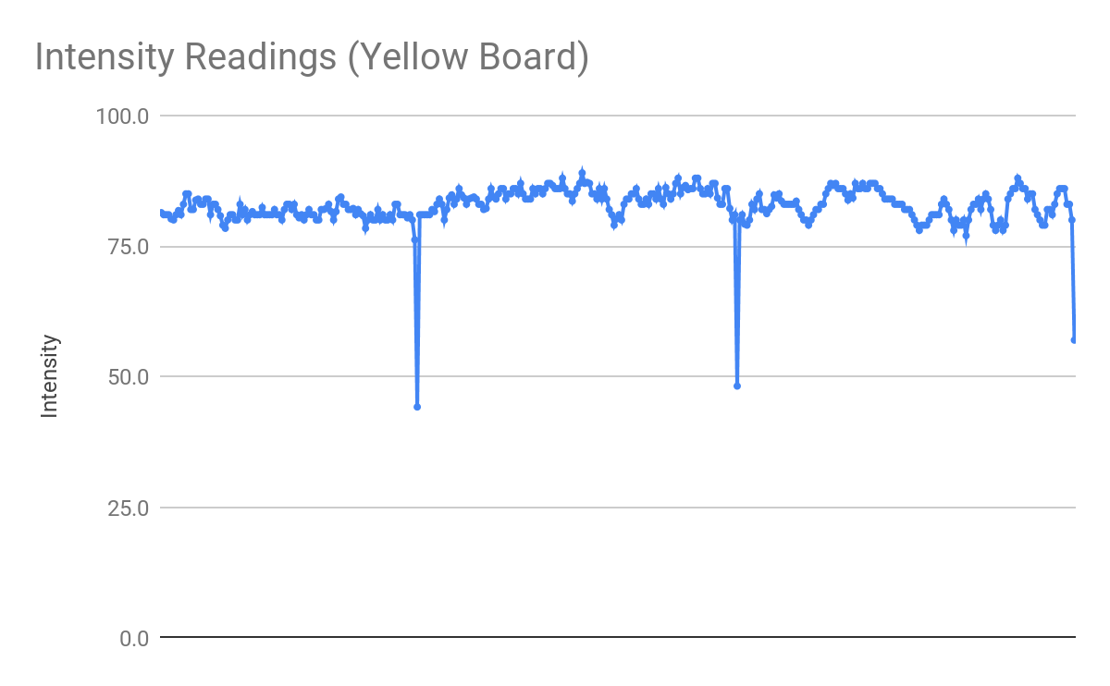

*Figure 1*. Scatter plot of intensity readings on yellow demo board.

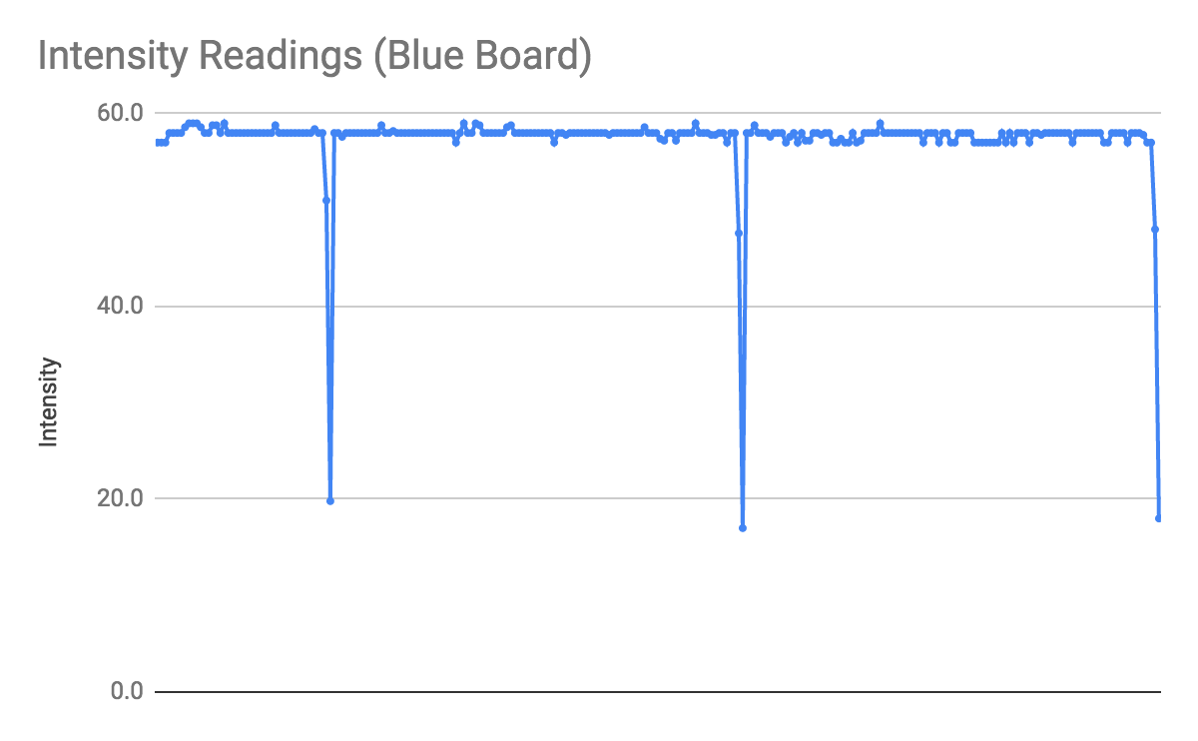

*Figure 2*. Scatter plot of intensity readings on blue demo board.

|  |  |  |  |
| --- | --- | --- | --- |
| Yellow Board | Line 1 | Line 2 | Line 3 |
| Detected? | Yes | Yes | Yes |

*Table 1*. Detection results of three grid lines on yellow demo board.

|  |  |  |  |
| --- | --- | --- | --- |
| Blue Board | Line 1 | Line 2 | Line 3 |
| Detected? | Yes | Yes | Yes |

*Table 2*. Detection results of three grid lines on blue demo board.

7.7 CONCLUSION

The grid lines can be clearly identified using the line detection algorithm. From figures 1 and 2, the negative peaks can be clearly identified. Furthermore, under a threshold intensity ratio of 0.75, a sampling time of 30 ms, and a speed of 250 deg/sec, the algorithm is able to correctly identify all grid lines on both blue and yellow demo boards, as shown in tables 1 and 2.

7.8 ACTIONS

Proceed with the current line detection algorithm for the software design.

7.9 DISTRIBUTION

Software Leader; Software Engineer; Project Manager; Documentation Manager.

7.10 APPENDIX

[Test Code](https://gist.github.com/bbdb78b52228b06f69dc405bedd00d1b.git)

[Full Data](https://docs.google.com/spreadsheets/d/1DIae1KpLavpeZBzQp1g8IyDDeuvgXN0uTp0nIBUI49U/edit?usp=sharing)

# 8 ULTRASONIC LOCALIZATION TEST

**Date:** 2019/03/12

**Tester:** Raymond Yang

**Duration:** 90 min

**Author:** Raymond Yang

**Hardware Version:** 2.0

**Software Version:** N/A

8.1 TEST PURPOSE

The purpose of this test is to determine which ultrasonic localization algorithm is most accurate given the same set of track and wheel radius.

8.2 TEST OBJECTIVES

Gather data on the accuracy of the three different types of ultrasonic localization algorithms, specifically the error angle in degrees.

8.3 TEST SETUP

This test uses hardware version 2.0.

8.3.1 PLACEMENT

The robot can be placed facing any direction and on the 45 degrees diagonal line, of any corner on the demo board.

8.3.2 SOFTWARE

The algorithms used are Group 43’s, Group 45’s, and Group 50’s codes from Lab 4. The logic in the software are kept same, except the parameters “TRACK” and “WHEEL_RAD” are replaced with values measured from the hardware version 2.0. Rising edge localization is used when robot is facing away from wall; falling edge localization is used when robot is facing the wall

8.4 TEST PROCEDURE

1. Place robot in accordance to the placement requirements in the section above.
2. Select either rising edge or falling edge based on robot orientation.
3. Wait for localization to complete.
4. Record final angle.
5. Repeat steps 1 - 3 for 5 trials with the same localization algorithm.
6. Repeat steps 1 - 4 for all three localization algorithms.

8.5 EXPECTED RESULTS

After localization, the robot should be facing the front, which is 0 degrees in our convention.

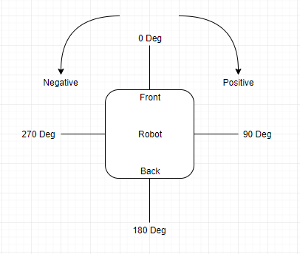

*Figure 1*. Heading convention indication.

8.6 TEST RESULTS

|  |  |  |  |  |
| --- | --- | --- | --- | --- |
| **Algorithm** | **Rising Edge (RE) Average Absolute Error (deg)** | **Spread of RE Error (deg)** | **Falling Edge (FE) Average Absolute Error (deg)** | **Spread of FE Error (deg)** |
| Group 43 | 7.4 | 8 | 9.8 | 8 |
| Group 45 | 2.0 | 4 | 2.8 | 8 |
| Group 50 | 10.8 | 6 | 6.2 | 16 |

*Table 1*. Average absolute error and spread of error of different ultrasonic localization algorithms in degrees.

**Formula:**

Average Absolute Error:

[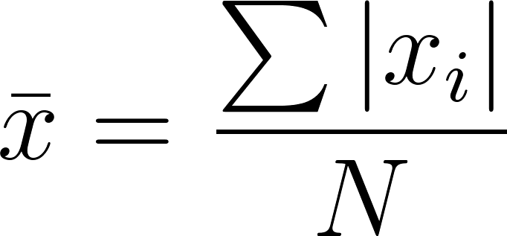](https://www.codecogs.com/eqnedit.php?latex=%5Cbar%7Bx%7D%20%3D%20%5Cdfrac%7B%5Csum%20%7Cx_%7Bi%7D%7C%7D%7BN%7D%250)

Spread:

[](https://www.codecogs.com/eqnedit.php?latex=s%20%3D%20Max%5C%20-%5C%20Min%250)

8.7 CONCLUSION

Ultrasonic localization with all three algorithms have some degree of error present. Group 45’s algorithm has the least average absolute error and the least spread. This implies both accuracy and precision.

8.8 ACTIONS

Implement final ultrasonic localization based on Group 45’s ultrasonic localization algorithm.

8.9 DISTRIBUTION

Software Leader; Software engineer; Project Manager; Documentation Manager.

8.10 APPENDIX

[Full Data](https://docs.google.com/spreadsheets/d/1a2xKk3jh6l3ai_6jcTCAki9RPq7TnnHHuo4sBEiD9g4/edit?usp=sharing)

# 9 NAVIGATION TEST

**Date:** 2019/03/12

**Tester:** Raymond Yang

**Duration:** 90 min

**Author:** Raymond Yang

**Hardware Version:** 2.0

**Software Version:** N/A

9.1 TEST PURPOSE

The purpose of this test is to determine which navigation algorithm is most accurate given the same set of track and wheel radius.

9.2 TEST OBJECTIVES

Gather data on the accuracy of the three different types of navigation algorithms, specifically the Euclidean error (ϵ), its mean and standard deviation.

9.3 TEST SETUP

The test uses the hardware design version 2.0. The robot should be placed at the origin, facing front, which is 0 degrees in our convention (refer to section 8.5 figure 1 for convention). The algorithms used are Group 43’s, Group 45’s, and Group 50’s codes from Lab 3. The robot will travel sets of different points.

9.3.1 PATH

Path = {(0,6), (3,3), (6,6), (6,3), (3,0)}.

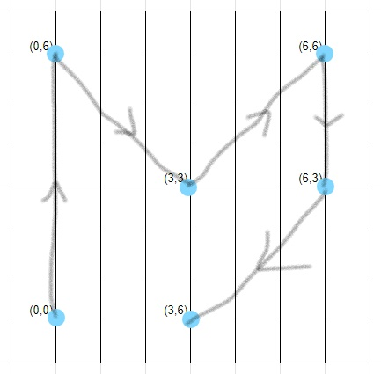

*Figure 1*. Path.

9.4 TEST PROCEDURE

1. Place robot on bottom-left origin, facing north.
2. Execute program.
3. Wait until robot finishes.
4. Measure error and record data.
5. Repeat all paths for all algorithms.

9.5 EXPECTED RESULTS

The robot should navigate to the spot with an Euclidean error as small as possible. This indicates accuracy. The standard deviation should also be as small as possible. This indicates precision.

9.6 TEST RESULTS

|  |  |  |
| --- | --- | --- |
| **Algorithm** | **Mean Euclidean Error (cm)** | **Standard Deviation (cm)** |
| **Group 43** | 7.62 | 0.89 |
| **Group 45** | 8.93 | 1.27 |
| **Group 50** | 12.36 | 1.10 |

*Table 1.* Mean and standard deviation of euclidean error of different navigation algorithms.

**Formula:**

[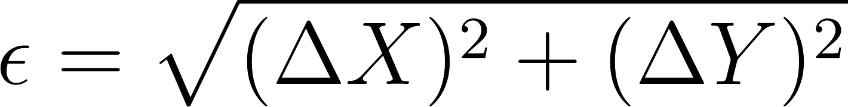](https://www.codecogs.com/eqnedit.php?latex=%5Cepsilon%20%3D%20%5Csqrt%7B(%5CDelta%20X)%5E2%20%2B%20(%5CDelta%20Y)%5E2%7D%250)

9.7 CONCLUSION

Group 43 and group 45’s algorithms had better performance than group 50’s algorithm, in terms of the euclidean error. Group 43’s algorithm had less standard deviation. Thus, Group 43’s algorithm has more stable performance. Yet, there is still significant error present, which is problematic and fatal when robot is travelling large distances.

9.8 ACTIONS

Develop a mechanism to correct error, such as correcting the heading with double light sensors.

9.9 DISTRIBUTION

Hardware Leader; Hardware Engineer; Software Leader; Software Engineer; Project Manager; Documentation Manager.

9.10 APPENDIX

[Full Data](https://docs.google.com/spreadsheets/d/1UHyz6OwemH8rOhWI97q31ZJ89zmfUGmQZtnFPDogPJE/edit?usp=sharing)

# 10 DOUBLE LIGHT LOCALIZATION TEST

**Date:** 2019/03/14

**Tester:** Raymond Yang

**Duration:** 30 min

**Author:** Raymond Yang

**Hardware Version:** 2.1

**Software Version:** 2.0

10.1 TEST PURPOSE

The purpose of the test is to test the functionality of the newly implemented double light sensor localization. The test also tests the localization accuracy, as well as identify any constraints or problems the double light localization might have.

10.2 TEST OBJECTIVES

Gather data from successive trials of the performance of the robot and measure the distance deviated from (0,0) and the heading deviated from 0 degrees. For the distance, measure the deviation in X and Y, then compute the euclidean distance error (ϵ). The mean and standard deviation of the errors will also be computed.

10.3 TEST SETUP

Set up the machine as follows. Hardware design version 2.1 and software design version 1.0 are used

10.3.1 PLACEMENT

Place the robot facing approximately 0 degrees, inside the tile at the corner of the demo board. The heading of the robot only has to be approximately 0 degrees. An error up to 10 degrees is allowed. The robot should be placed in the center of the tile. Again, the placement does not have to be exact, as long as the robot’s two light sensors does not cross the vertical grid line parallel to the robot, when the robot travels.

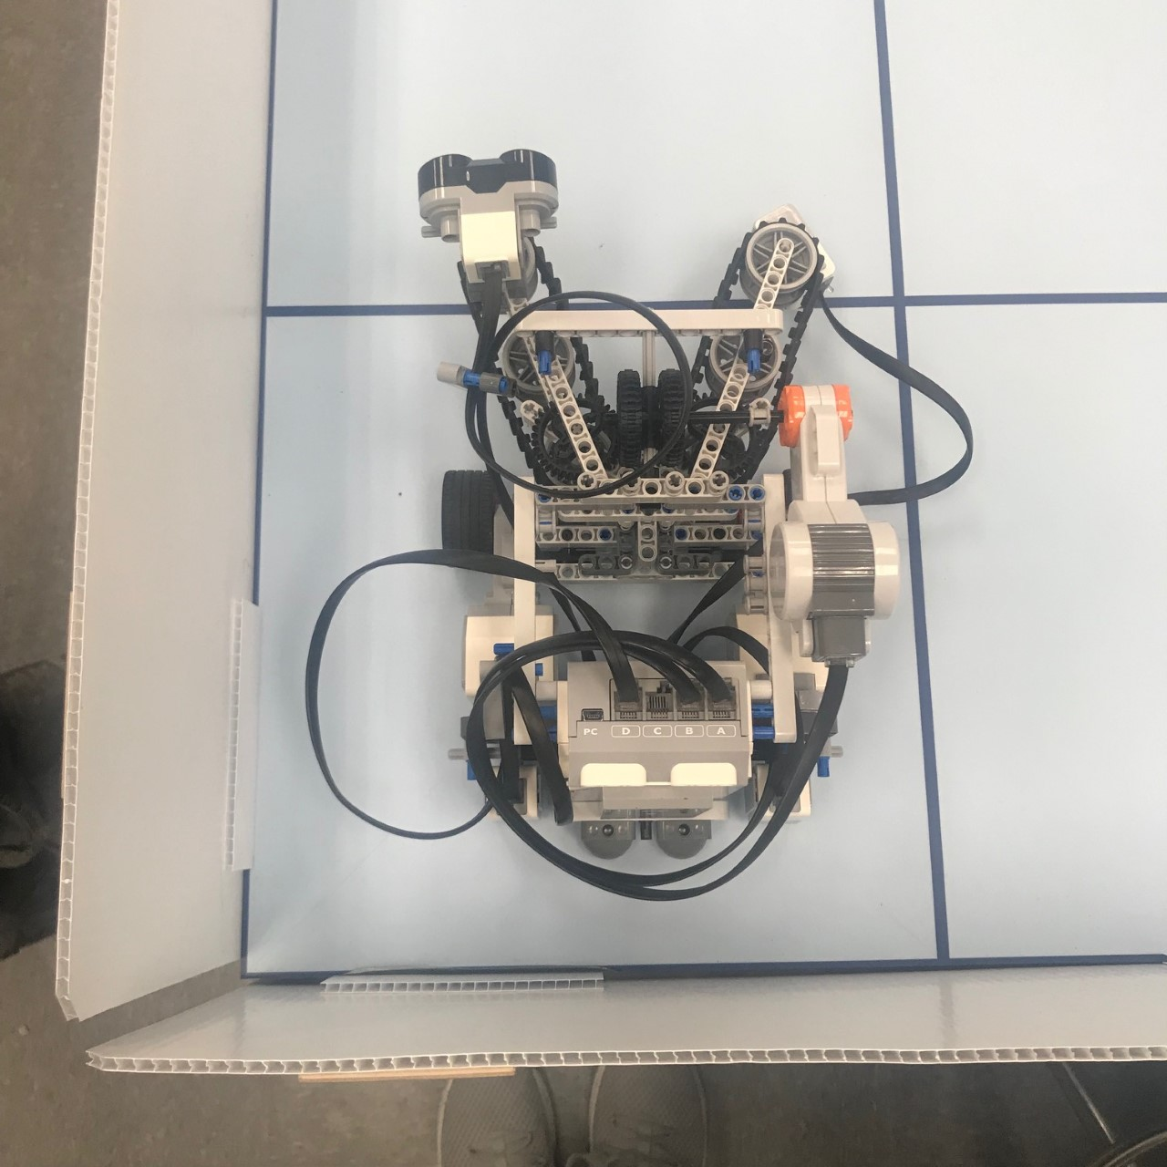

*Figure 1*. Robot placement. The hardware in the figure is a newer design version, but the placement is the same.

10.3.2 SOFTWARE

Using [DoubleLightLocalization.java](https://gist.github.com/d219ee9d3fc1616be1bc84e718ca5188.git) class, the robot is able to perform the localizing routine provided that the ultrasonic localization has already brings the robot to a heading close to 0 degree (that is, heading toward the positive Y axis, or north). The line detection in this algorithm uses a fixed value as the threshold, and was not integrated with the line detection filter yet.

10.3.3 MACHINE PARAMETERS

* TRACK: 15.4
* WHEEL_RAD: 2.15
* SENSOR_TOWHEEL: 12.6

10.4 TEST PROCEDURE

1. Locate the robot in an arbitrary square on the table with a heading of relatively 0 degree (an error upto 10 degrees is permitted).
2. After the machine finishes compiling the code, choose either falling edge or rising edge, based on initial robot orientation, to activate the localizing routine.
3. Repeat localization for 10 times.

10.5 EXPECTED RESULTS

The robot should autonomously locate itself at the upper right corner of that block (the hypothesized (0,0) point), aligning with the Y axis, facing the +Y-axis direction. Specifically, the robot should travel forward and adjust its heading at the horizontal grid line, then it should back up a little, turn right 90 degrees to face the upper right grid intersection, and move towards the intersection. After both light sensors cross the vertical grid line and corrects the heading, the robot should back up a bit, turn counterclockwise 45 degrees, and move to the origin. Lastly, the robot should turn another 45 degrees counterclockwise to finish localization. The error should not be larger than 3 cm (euclidean distance) and 5 degrees.

10.6 TEST RESULTS

|  |  |  |
| --- | --- | --- |
| **DLL Test** | **Euclidean Error (cm)** | **Heading Error (deg)** |
| **Mean** | 1.43 | -0.4 |
| **Standard Deviation** | 0.16 | 0.516 |

*Table 1*. Summarized results from double light localization test.

10.7 CONCLUSION

As shown in table 1, the light localization on its own is quite reliable. The mean euclidean distance is quite small and within 2 cm. The robot finishes at the upper-left of the target destination. The standard deviation of the euclidean distance also has a small magnitude, signifying the stability of this localization method. The final heading error is within 0.5 degrees in terms of magnitude. The robot finishes facing a little to the left. The standard deviation is also within reasonable magnitude. The double light sensor localization is reliable.

10.8 ACTIONS

Implement double localization method in the localization algorithm.

10.9 DISTRIBUTION

Hardware Leader; Hardware Engineer; Software Leader; Software Engineer; Project Manager; Documentation Manager.

10.10 APPENDIX

[Full Data](https://docs.google.com/spreadsheets/d/1jYGMVF5lvvPuJ8ticz7xhJfHFg8yWY1VVeKILcgk6mk/edit?usp=sharing)

[DoubleLightLocalization.java](https://gist.github.com/d219ee9d3fc1616be1bc84e718ca5188.git)

# 11 FULL LOCALIZATION TEST

**Date:** 2019/03/19

**Tester:** Raymond Yang

**Duration:** 45 min

**Author:** Raymond Yang

**Hardware Version:** 2.1

**Software Version:** 2.0

11.1 TEST PURPOSE

The purpose is to check whether robot can perform full localization, consisting of ultrasonic localization first, then double light localization. This test is also an integration test of the two localizations. Furthermore, this test also checks whether entire localization routine can be completed under the 30 second time limit.

11.2 TEST OBJECTIVES

Gather data from successive trials of the final heading and position of the robot after it has finished localization. Specifically, measure the deviation in X and Y. Compute the Euclidean distance error (ϵ). Measure the heading error. Record the time taken for each localization trial.

11.3 TEST SETUP

Set up the machine as follows.

11.3.1 PLACEMENT

Place the robot on the 45 degrees diagonal line from the bottom left corner to the upper-right corner of the tile. The orientation of the robot can be any direction.

11.3.2 SOFTWARE

The algorithm for the ultrasonic localization used is the USLocalizer.java and the algorithm used for the double light localization is the DoubleLightLocalization.java. Specific Java code can be found under section 11.10.

11.3.3 ULTRASONIC LOCALIZATION

There are two types of ultrasonic localization available once the code compiles on the machine. Rising edge localization should be used when robot faces at the wall. Falling edge localization should be used when robot faces away from the wall. Ideally, there should be 5 trials with rising edge localization and 5 trials with falling edge localization.

11.3.4 MACHINE PARAMETERS

* TRACK: 15.4
* WHEEL_RAD: 2.15
* SENSOR_TOWHEEL: 12.6

11.4 TEST PROCEDURE

1. Place robot in accordance to the placement requirements in the section above.
2. Select either rising edge or falling edge based on robot orientation.
3. Start timer.
4. Wait for localization to complete.
5. Stop timer.
6. Take measurements of X, Y, heading, and time taken.
7. Repeat for 10 trials.

11.5 EXPECTED RESULTS

The robot should perform ultrasonic localization first, turning to roughly 0 degrees. Then robot should perform light localization routine. After localization completes, the robot should have a mean euclidean distance error no greater than 2 cm, and a mean heading error no greater than 1 degrees in magnitude.

11.6 TEST RESULTS

|  |  |  |  |
| --- | --- | --- | --- |
| **Full Localization** | **Euclidean Error Distance (cm)** | **Heading Error (deg)** | **Time (sec)** |
| **Mean** | 1.29 | -0.2 | 28.26 |
| **Standard Deviation** | 0.166 | 0.422 | 1.341 |

*Table 1*. Mean and STDEV of ϵ, heading error, and time taken.

11.7 CONCLUSION

The integration of the ultrasonic localization and double light sensor localization is successful. The mean ϵ is around 1.29 cm with a very small standard deviation, as shown in table 1. On most occasions, there are no heading errors. The mean heading error is -0.2 degrees, also with a relatively small standard deviation. The time taken, on average, is 28.26 seconds, with a standard deviation of 1.341 seconds. Assuming the distribution is similar to a Gaussian distribution, there is around a 15.7% probability the time will exceed 30 seconds, using the 68-95-99 empirical rule. Thus, software improvements to enhance the performance of the localization is necessary.

11.8 ACTIONS

Improve the speed of the robot when performing ultrasonic and light localization. Turn minimum angle when performing ultrasonic localization. Integrate localization with rest of software.

11.9 DISTRIBUTION

Software Leader; Software Engineer; Documentation Manager; Project Manager.

11.10 APPENDIX

[Full Data](https://docs.google.com/spreadsheets/d/1AxS80Xi_NOOLd17rJvDiZWHUU63x2_5xQJ_TiRBl6CI/edit?usp=sharing)

[USLocalizer.java](https://gist.github.com/b785d3dbc79997118492f4c9661d4a46.git)

[DoubleLightLocalization.java](https://gist.github.com/d219ee9d3fc1616be1bc84e718ca5188.git)

# 12 DOUBLE LIGHT SENSOR CORRECTION

**Date:** 2019/03/17

**Tester:** Raymond Yang

**Duration:** 90 min

**Author:** Raymond Yang

**Hardware Version:** 2.1

**Software Version:** 2.0

12.1 TEST PURPOSE

The purpose of the test is to check whether the robot is able to perform odometry correction with the two light sensors. This test also determines how effective the correction is.

12.2 TEST OBJECTIVES

Gather data on robot performance without correction. Gather data from successive trials of the final heading and position of the robot after it has travelled a specific path. Data on error will also be gathered, such as the euclidean distance error (ϵ).

12.3 TEST SETUP

Set up the machine as follows. Three types of cases will be tested: going straight, turning right 90 degrees, and turning left degrees.

12.3.1 PLACEMENT

Place the robot on the origin (0,0), facing the +Y-axis direction. Upload the double light correction algorithm on to the machine.

12.3.2 SOFTWARE

Using .java class, the robot is able to perform the localizing routine provided that the ultrasonic localization has already brings the robot to a heading close to 0 degree (that is, heading toward the positive Y axis, or north). The line detection in this algorithm uses a fixed value as the threshold, and was not integrated with the line detection filter yet.

Path 1 uses a special class. Paths 2 - 5 only requires the modification of coordinate points in the corresponding section of the project.java class.

12.3.3 CORRECTION

There are two types of correction. One is the “half” correction, which only corrects the heading and **vertical** displacement, but does not correct the **horizontal** displacement (figure 1). The second type is the “full” correction. The robot corrects its heading, horizontal displacement, but also its vertical displacement. In other words, the full correction is equivalent to localization.

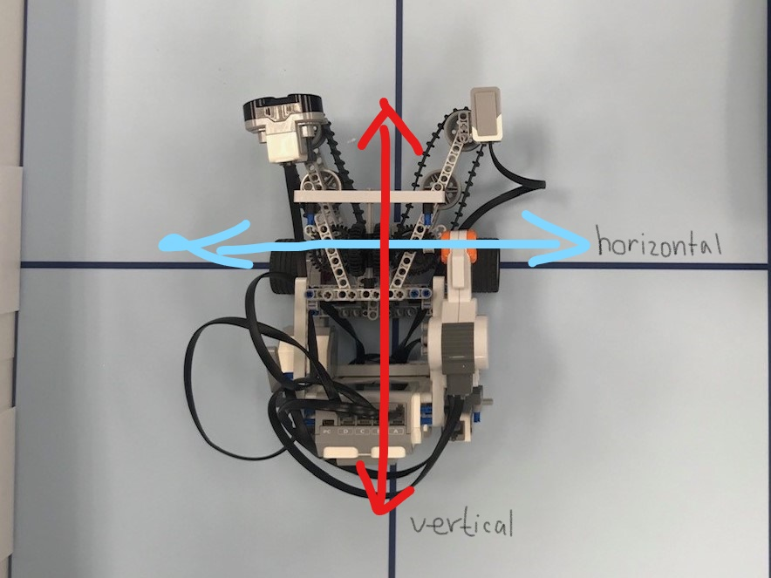

*Figure 1*. Display of horizontal and vertical directions.

12.3.4 MACHINE PARAMETERS

* TRACK:
* WHEEL_RAD:
* SENSOR_TOWHEEL:

12.3.5 PATH

1. Without correction, travel straight until one of the sensor crosses the grid lines parallel to the robot’s direction
2. With half correction, travel 13 tiles forward (maximum distance travelling along grid lines).
3. With half correction, travel two tiles, turn left 90 degrees, and travel another two tiles.
4. With half correction, travel two tiles, turn right 90 degrees, and travel another two tiles.
5. With half correction, travel the largest lap around the demo board, in a clockwise fashion.

|  |  |
| --- | --- |
|  |  |
|
|
|
|
|
| *Figure 1*. Path 5. | *Figure 2*. Path 2. |

|  |  |
| --- | --- |
|  |  |
| *Figure 3*. Path 3. | *Figure 4*. Path 4. |

12.4 TEST PROCEDURE

1. Locate the robot on the origin with a heading of 0 degree (as accurate as possible).
2. Execute program and wait for robot to reach destination.
3. Record final position and heading.
4. Repeat for all paths, each 5 times.

12.5 EXPECTED RESULTS

Without correction, robot should have an increasing euclidean error, and deviate more from its expected path. With correction, the robot should be able to keep a straight heading, and have a small euclidean error (less than 2 cm). With correction, the robot should have a very small heading error (less than 5 deg in magnitude). The robot corrects along its path, so the error should be contained within some limit. In addition, upon arriving at the final destination, the robot performs another localization to correct its error.

12.6 TEST RESULTS

|  |  |  |  |
| --- | --- | --- | --- |
| **Path** | **Min Tiles** | **Max Tiles** | **Mean Tiles** |
| 1 | 5 | 9 | 6.6 |

*Table 1*. Min, max, and mean tiles travelled, following path 1, without correction.

|  |  |  |  |  |
| --- | --- | --- | --- | --- |
| **Paths** | **Completed** | **Statistic** | **Euclidean Distance Error (cm)** | **Heading Error (deg)** |
| 2 | Yes | Mean | 1.240 | -0.6 |
| STDEV | 0.115 | 0.894 |
| 3 | Yes | Mean | 0.620 | -1.0 |
| STDEV | 0.131 | 0.707 |
| 4 | Yes | Mean | 0.700 | -1.2 |
| STDEV | 0.055 | 0.447 |
| 5 | Yes | Mean | 0.513 | -1.7 |
| STDEV | 0.142 | 0.577 |

*Table 2*. Mean and standard deviation for Euclidean distance error and heading error.

Observations:

1. For path 5, there were two trials out of five where the robot failed to complete. The reason was that as the robot travelled along the longer edge (13 tiles), the robot deviated too much horizontally, causing one of its light sensors to cross the vertical line the robot is travelling along. Without only half correction, the robot does not correct horizontally.

12.7 CONCLUSION

The robot can travel around 6.6 tiles without correction before there is too much deviation, where correction cannot be performed. From table 1, the minimum number of tiles was 5 tiles before failure. Thus, it is recommended that the robot performs a full correction at least once every 5 tiles travelled. With correction, the robot is able to travel any arbitrary path. If the light sensors are placed further apart, the heading can be corrected more with more precision.

12.8 ACTIONS

Set frequency for full localization. Robot should perform full localization at least once every 5 tiles travelled.

12.9 DISTRIBUTION

Hardware Leader; Hardware Engineer; Software Leader; Software Engineer; Project Manager; Documentation Manager.

12.10 APPENDIX

[Full Data](https://docs.google.com/spreadsheets/d/1-AyayRLVbTMldfKvFk7isZ82M8zG1KjE6DStB9JYWoU/edit?usp=sharing)

[Test Code for Path 1](https://gist.github.com/96dd662047ac0e1775aa05cfbacf84a8.git)

# 13 TUNNEL TRANSIT TEST

**Date:** 2019/03/17

**Tester:** Raymond Yang

**Duration:** 30 min

**Author:** Raymond Yang

**Hardware Version:** 2.1

**Software Version:** 2.0

13.1 TEST PURPOSE

The purpose of the test is to check whether robot can successfully navigate through the tunnel. Specifically, robot should be able to go through tunnel without making contact with the tunnel itself.

13.2 TEST OBJECTIVES

Gather data on whether robot is able to enter tunnel, navigate through tunnel, exit tunnel. Gather data on the tunnel itself as well.

13.3 TEST SETUP

Set up robot as follows.

13.3.1 PLACEMENT

Place robot on the bottom left grid point of the tile before the tunnel, facing 0 degrees, which is the +Y-axis.

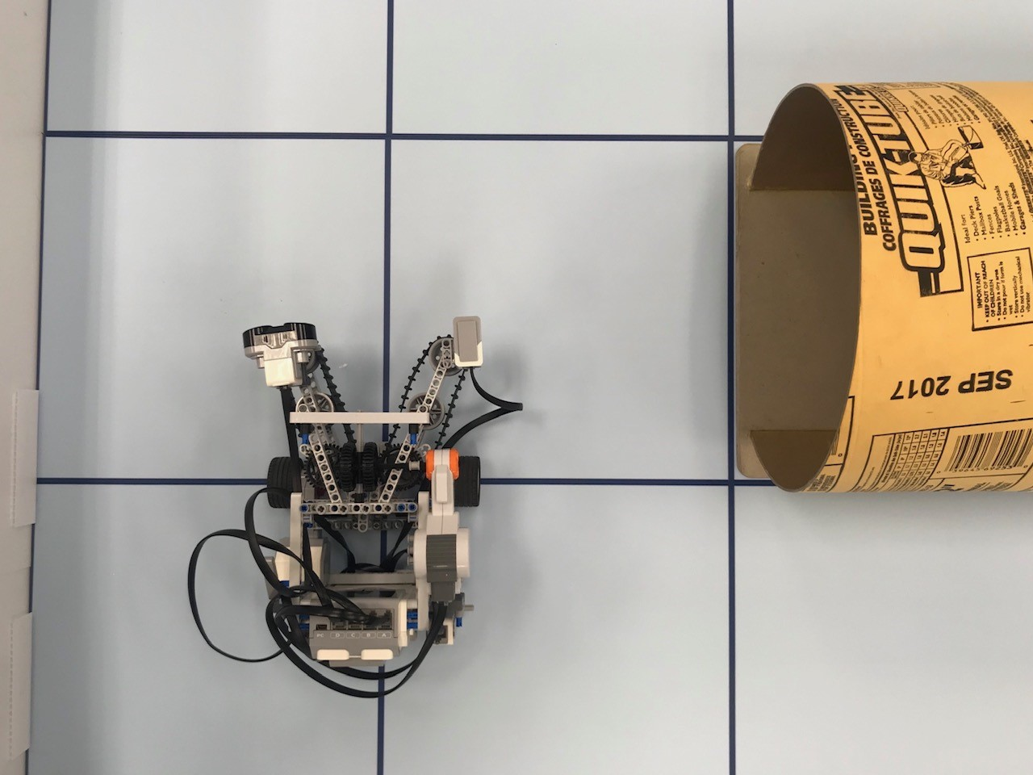

*Figure 1*. Test site setup.

13.3.2 SOFTWARE

Load software with following parameters:

* TRACK: 15.4
* WHEEL_RAD: 2.15
* SENSOR_TOWHEEL: 12.6

Test Logic:

1. Perform light localization on spot.
2. Navigate to center point of tile.
3. Turn to face tunnel.
4. Enter and travel through tunnel.
5. Stop when exited tunnel.

13.3.3 TUNNEL SPECS

* Height (H) = 24.0 cm
* Diameter (D) = 30.0 cm
* Base Width (BW) = 21.2 cm
* Length (L) = 2 tiles = 60.96 cm

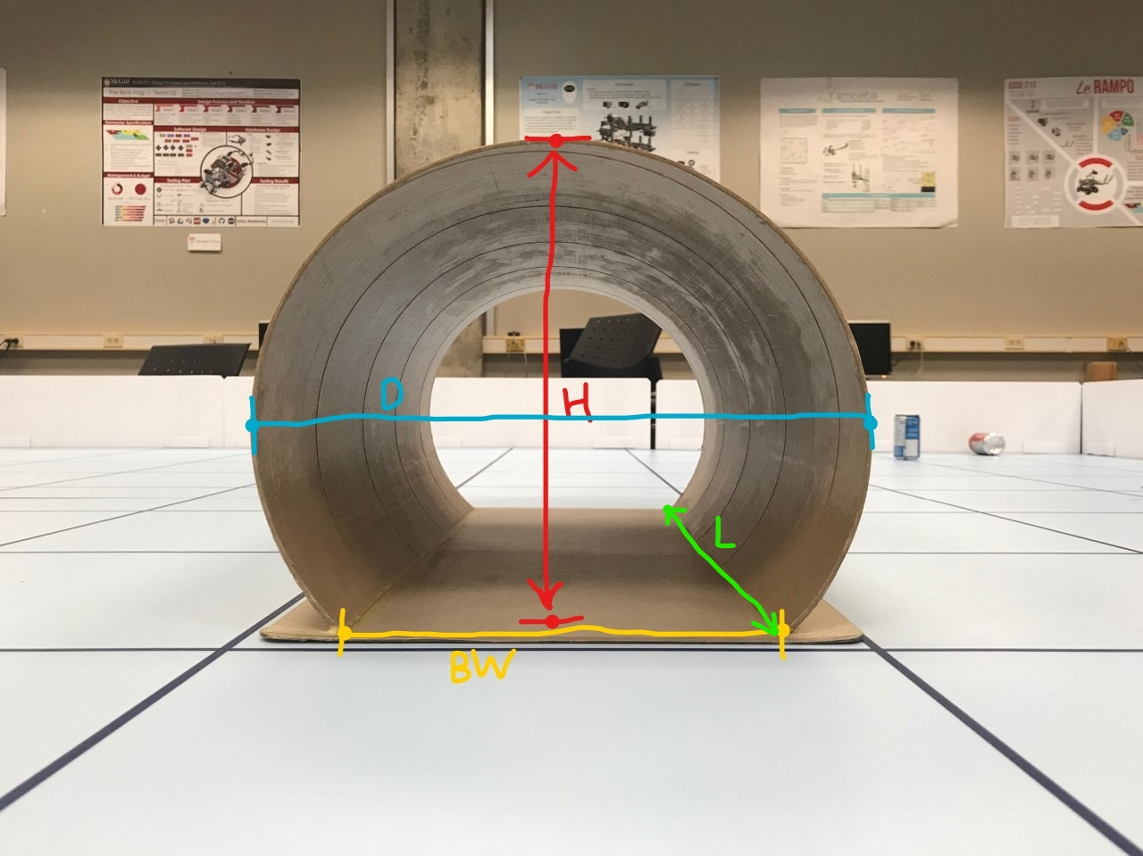

*Figure 2*. Tunnel specs.

13.4 TEST PROCEDURE

1. Place robot as described above.
2. Execute program and wait for robot to pass tunnel
3. Record robot behaviours.
4. Repeat test 10 times.

13.5 EXPECTED RESULTS

Robot should pass tunnel with ease, since it starts from a point very close to the tunnel. The only deviation is the step where the robot travels to the center of the tile and orients itself towards the tunnel. This should not introduce significant deviation. The uneven flooring due to the tunnel should not affect the robot significant enough for it to collide with the tunnel. In terms of the size of our robot, the robot is quite large compared to the diameter of the tunnel. Parts of robot might touch the tunnel at some point.

13.6 TEST RESULTS

|  |  |  |  |
| --- | --- | --- | --- |
| **Tunnel Nav Test** | **Enter Tunnel** | **Exit Tunnel** | **No Collision** |
| **Success Rate** | 100 % | 100 % | 80% |

*Table 1*. Success rates for tunnel navigation.

Observation:

1. In 2 out of 10 trials, collision took place. In both cases, the wire of the robot touched the side of the tunnel. The robot was still successful in navigating through the tunnel. The robot’s motion was not affected.

13.7 CONCLUSION

The robot is able to successfully navigate through the tunnel, provided that it is able to arrive at the starting point before the tunnel (figure 1). Although the wire sometimes touch the tunnel, it does not affect the robot’s path. The size of the robot is acceptable.

13.8 ACTIONS

Proceed with current hardware design.

13.9 DISTRIBUTION

Hardware Leader; Hardware Engineer; Software Leader; Software Engineer; Project Manager; Documentation Manager.

13.10 APPENDIX

[Full Data](https://docs.google.com/spreadsheets/d/1AAMqpf294mf5T1FnRxaP4pDca227B4NAe__o3gYhq1U/edit?usp=sharing)

# 14 SENSOR MECHANISM TEST

**Date:** 2019/03/21

**Tester:** Raymond Yang

**Duration:** 30 min

**Author:** Raymond Yang

**Hardware Version:** 2.1

**Software Version:** 2.0

14.1 TEST PURPOSE

This test is a proof-of-concept test, targeting to check our design of mounting both the ultrasonic and light sensors on the claw mechanism, and turning the sensors in sync with the belt of the claw mechanism is a valid and practical design.

14.2 TEST OBJECTIVES

Gather data on the maximum angle the sensors can turn with the belt without a can in the claw. Gather data on the heading of the sensors after it has swept for a number of times left and right to measure the deviation of the heading of the sensors over time. The mean and standard deviation of the heading errors will be computed.

14.3 TEST SETUP

The test only requires the claw mechanism and the sensors mounted on the claw. The test uses the hardware design version 2.1. The test does not need to be performed on the demo board. To measure the heading angle deviation, a protractor is used. A can is needed for this test. For the test software, there is a piece of code written and attached in the appendix section (14.10). For heading conventions, refer to section 8.5 figure 1.

14.3.1 SOFTWARE PARAMETERS

* Sensor motor speed: 250
* Sensor motor acceleration: 6000

14.4 TEST PROCEDURE

There are 2 parts in this test.

14.4.1 WITHOUT CAN

1. Before uploading the code to the robot, correct both the ultrasonic sensor and light sensor to face 0 degrees (front).
2. Upload code and record the maximum angle the sensor can turn clockwise and counterclockwise, without affecting other components on the robot.
3. At the maximum counterclockwise angle, place a can in the expected position of the claw, and record whether then light sensor is able to read the can’s color during its rotation.

14.4.2 ACCURACY TEST

1. Before uploading the code to the robot, correct both the ultrasonic sensor and light sensor to face 0 degrees (front).
2. Sweep the sensors for 50 repetitions (1 repetition is defined as from -45 degrees to 45 degrees then back to -45 degrees) with no can in the claw.
3. Record the deviation in heading, from 0 degrees, of both sensors.
4. Repeat for 10 trials

14.5 EXPECTED RESULTS

For the angle, the sensors should be able to turn 120 degrees in the negative and positive direction from 0 degrees. When the can is placed in the claw, the light sensor is expected to be able to read the can. For the accuracy, after the sensor has swept 50 repetitions, it should have a heading deviation of less than 5 degrees.

14.6 TEST RESULTS

|  |  |  |
| --- | --- | --- |
| **Sensor** | **Negative Max Angle (deg)** | **Positive Max Angle (deg)** |
| **Ultrasonic (left)** | 85 | 65 |
| **Light (right)** | 100 | 25 |

*Table 1*. Maximum turning angles, both in the positive direction and negative direction.

|  |  |  |
| --- | --- | --- |
| **Sensor** | **Heading Error (deg)** | **STDEV of Error (deg)** |
| **Ultrasonic (left)** | 1.0 | 1.674 |
| **Light (right)** | -0.4 | 2.011 |

*Table 2*. Heading error of both sensor after sweeping 50 repetitions.

14.7 CONCLUSION

The light sensor has a maximum sweeping angle of 125 degrees, and is able to turn 100 degrees counterclockwise, which allows it to read cans in front of the robot’s claw. The ultrasonic sensor has a maximum sweeping angle of 150 degrees, which is more than enough for the search. There is very small error after 50 repetitions of sweeping motion. The ultrasonic sensor, mounted on the left, points more and more to the right after 50 repetitions; the light sensor, mounted on the right, points more and more to the left after 50 repetitions. It is very likely that the errors are due to the way cables are connected. The stress in the bending of the cables might be the source of this error. Furthermore, the belt mechanism has plenty of friction when it turns. This may cause the sensors to rotate less than expected. No conclusion could be made at this moment on whether the error would affect the entire operation.

14.8 ACTIONS

For the time being, continue to use this sensor mechanism. The current mechanism is connected to a series of mechanisms, and is difficult to modify.

14.9 DISTRIBUTION

Hardware Leader; Hardware Engineer; Project Manager; Documentation Manager.

14.10 APPENDIX

[Full Data](https://docs.google.com/spreadsheets/d/1Bz26cerCcPj9nJFgrI-jKXO7LNBpNETR9FXRwECxx2A/edit?usp=sharing)

[Test Code](https://gist.github.com/a2a768e3353127d8171146df6861067a.git)

# 15 ULTRASONIC SENSOR SCAN TEST

**Date:** 2019/03/21

**Tester:** Raymond Yang

**Duration:** 90 min

**Author:** Raymond Yang

**Hardware Version:** 2.1

**Software Version:** 2.0

15.1 TEST PURPOSE

The purpose of this test is to determine whether the robot can detect the can using its ultrasonic sensor, which is mounted on the “claw” that acquires cans. The test also aims to determine the detection area of the ultrasonic sensor. We also want to know how fast the robot should turn to be able to find the closest can. The results of this test will influence the design of the search mechanism and algorithm.

15.2 TEST OBJECTIVES

In this test, we will gather data on whether the robot detected the can and the success rate of the detection mechanism. We will gather specific readings from the ultrasonic sensor as the robot turns a full 360 degrees to determine the detection width of the ultrasonic sensor. We will also gather specific sensor readings when the robot turns at different speeds. A line graph of the points will be produced for analysis.

15.3 TEST SETUP

The robot will be placed on the demo board with the ultrasonic sensor turned on. The robot can rotate either counterclockwise or clockwise. Cans will be placed around the robot, within two tile length (60.96 cm) of the robot. See appendix (15.10) for testing code. Ultrasonic sensor sampling period is set to 30 ms.

15.3.1 CAN PLACEMENT

* Test 1: Only one can will be used. It will be placed at the following locations: three quarters of a tile (0.75), one tile (1.00), one and a quarter tile (1.25), one and a half tile (1.50), one and three quarters of a tile (1.75), and two tiles (2.00) away from the robot. The robot will not be placed near the wall for test 1.
* Test 2: The robot will be placed at the grid point closest to the corner, with one can placed at one tile length (the same length as the shortest distance from the robot to the wall) from the robot, farthest from the corner. See figures below for a visual illustration.
* Test 3: 4 cans placed at different distances from the robot, all within 2 tile lengths.
* Test 4: 1 can placed at 1 tile away from the robot. The robot will scan while turning at different speeds. The setup is similar to test 1.

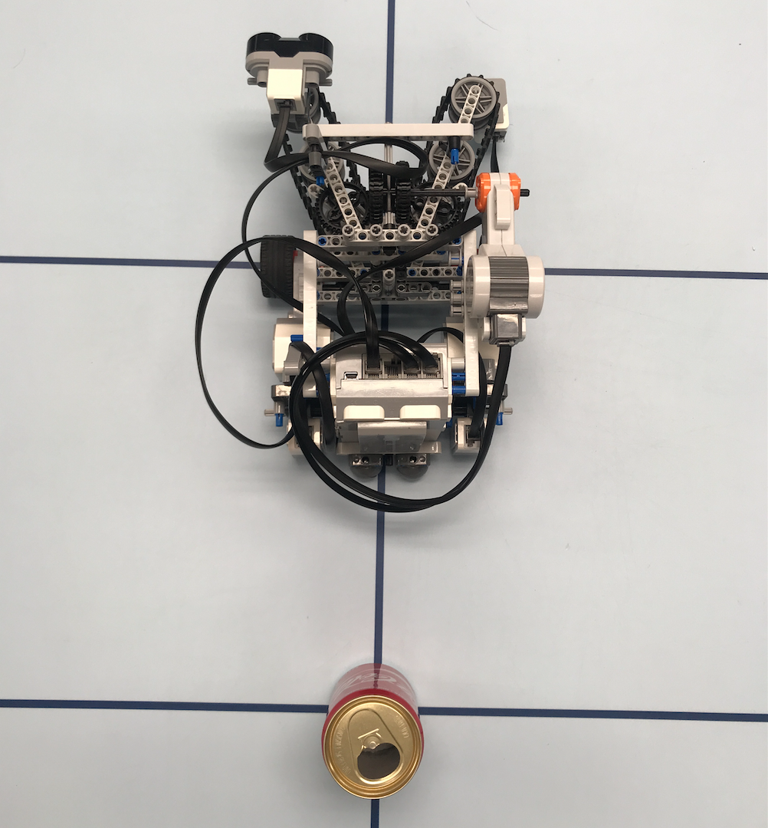 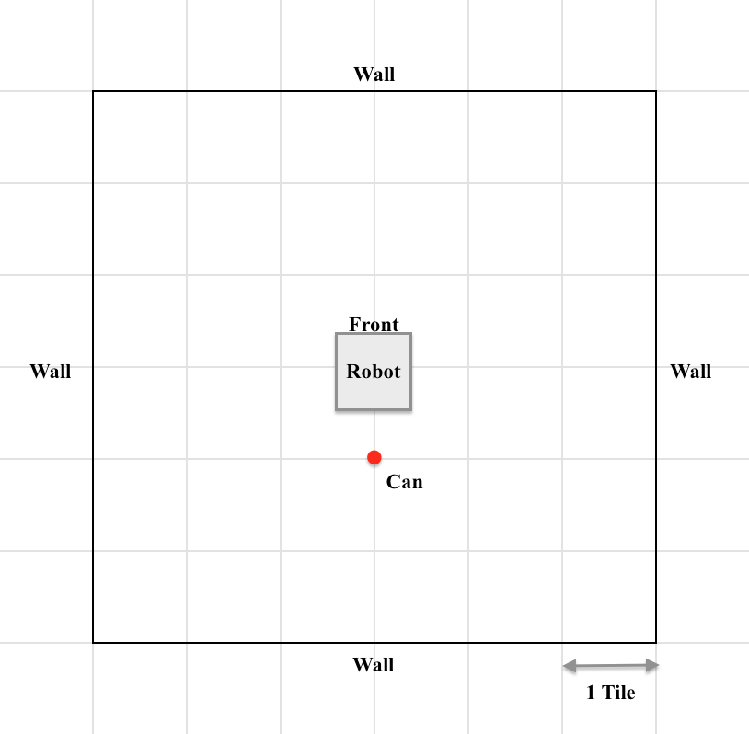

*Figure 1*. Sample placement for test 1 where can is placed at 1 tile away. Robot turns a full circle counterclockwise, and the ultrasonic sensor scans the can during the process.

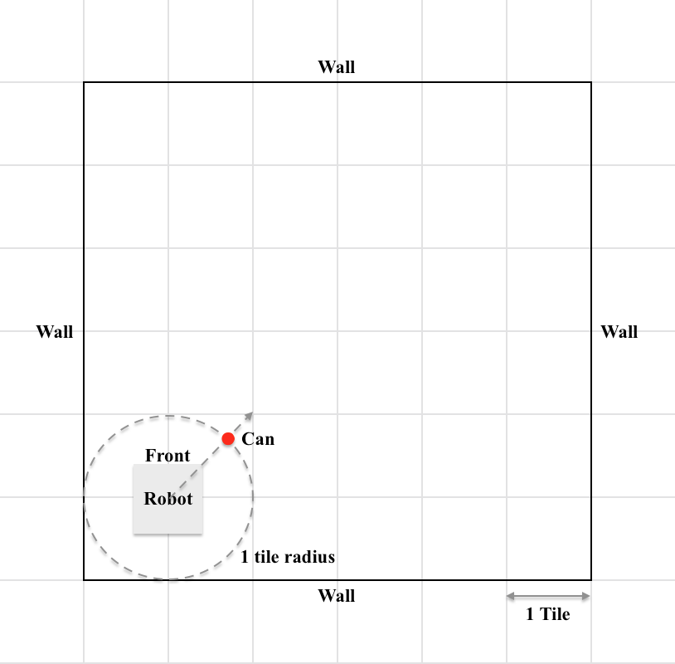

*Figure 2*. Placement for test 2. Can is placed 1 tile away from robot and equi-distance from both walls of the corner.

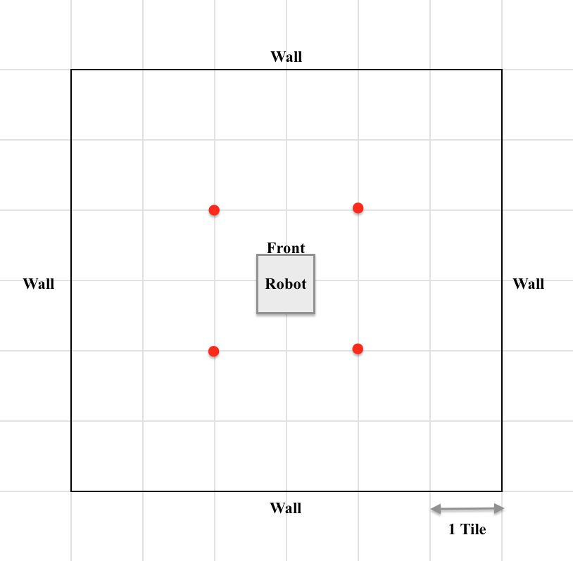 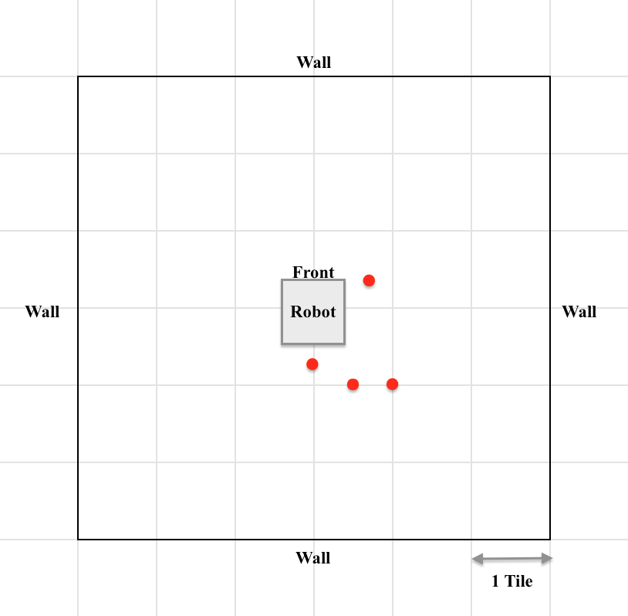

*Figure 3*. Test 3 placement 1.

*Figure 4*. Test 3 placement 2.

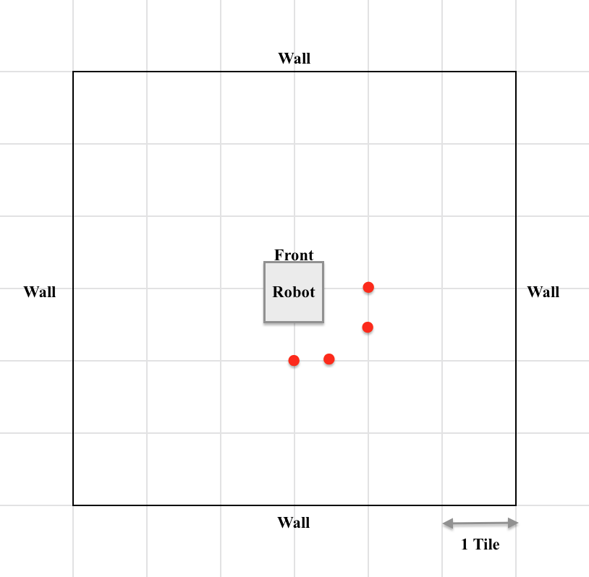

*Figure 5*. Test 3 placement 3.

15.4 TEST PROCEDURE

15.4.1 TEST 1

1. Place robot on grid point, place a can at one of the six positions at the back of the robot (so the graph of readings can be “continuous”).
2. Run program.
3. Repeat for all six distances.

15.4.2 TEST 2

1. Place robot on grid point that is closest to the corner.
2. Place can as shown in figure 2 above.
3. Run program.

15.4.3 TEST 3

1. Place 4 cans within 2 tiles randomly. Cans should not entirely overlap each other.
2. Run program.
3. Repeat for 3 different random placements.

15.4.4 TEST 4

1. Place 1 can at 1 tile distance away.
2. Run program at different rotation speeds: 100, 150, 200, 250, 300, 350.

15.5 EXPECTED RESULTS

The graphs generated from the readings are expected to show troughs for where the cans are present. It is expected that the range (in degrees) of the ultrasonic scanning range be obtained from the graph. We also expect to find a clear indication of the presence cans in the line graph. The cans that are closer are expected to produce a deeper trough and cans that are farther are expected to produce a shallower trough.

15.6 TEST RESULTS

15.6.1 TEST 1 RESULTS

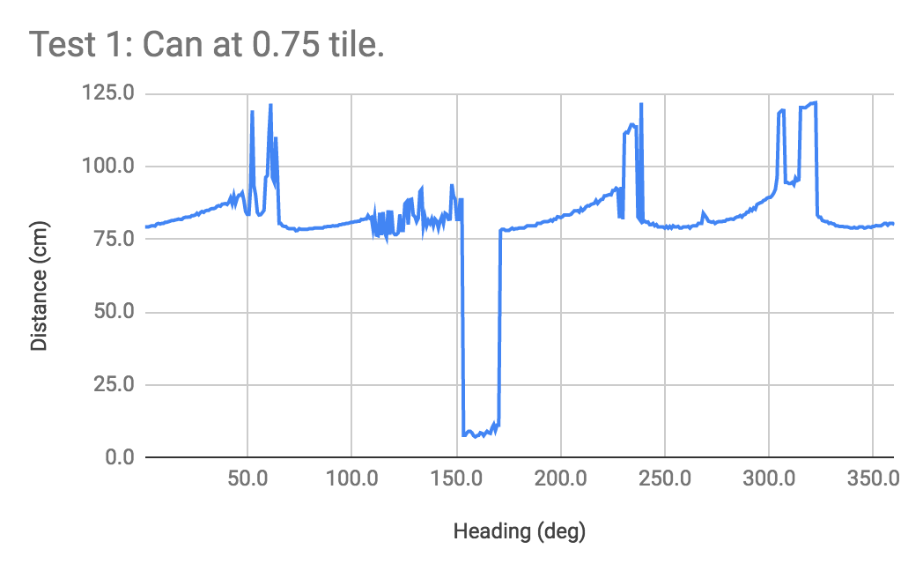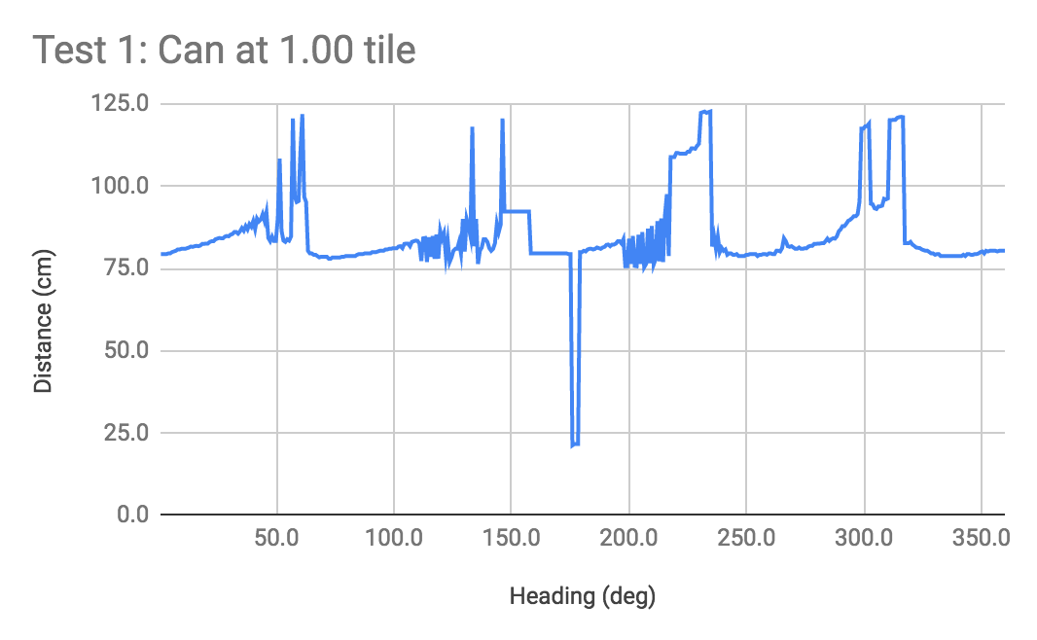

*Figure 6*. Test 1 with can at 0.75 tile away.

*Figure 7*. Test 1 with can at 1.00 tile away.

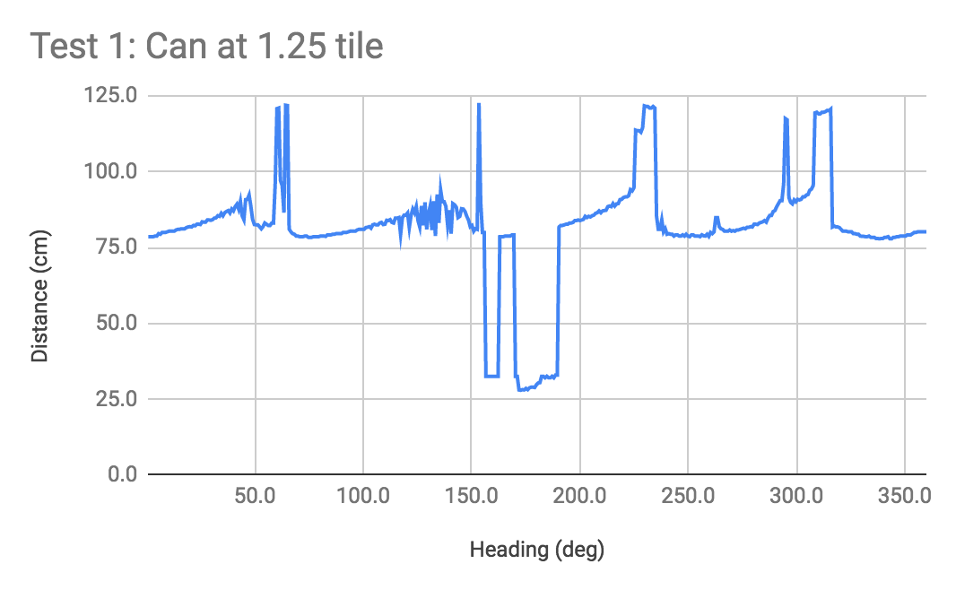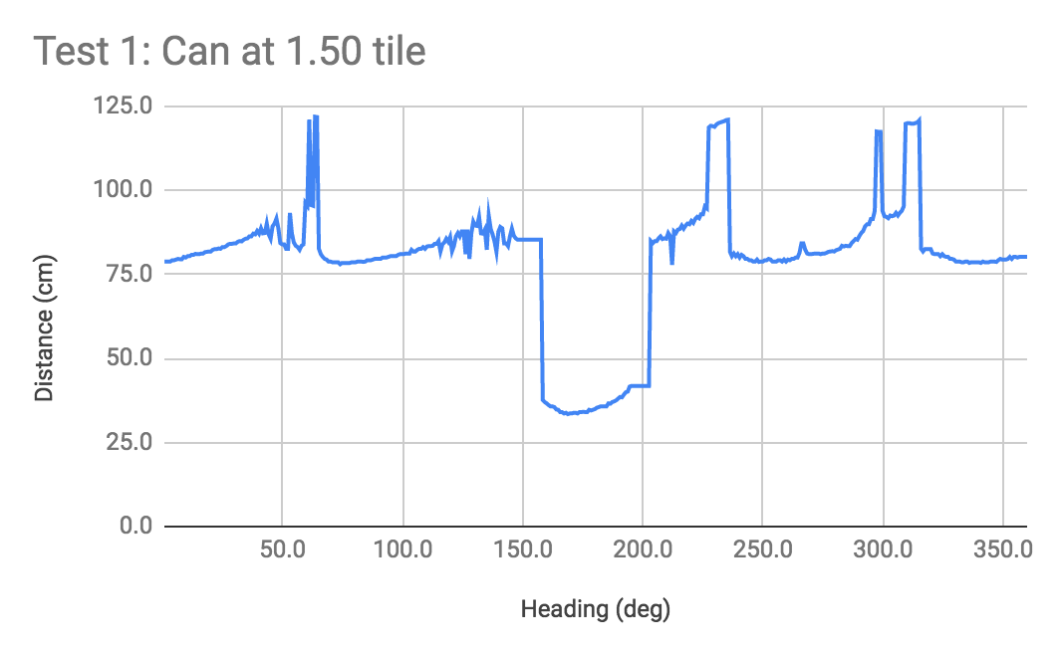

*Figure 8*. Test 1 with can at 1.25 tile away.

*Figure 9*. Test 1 with can at 1.50 tile away.

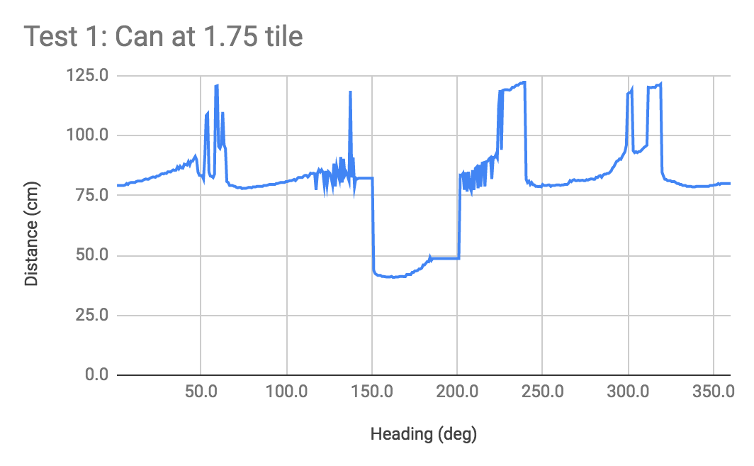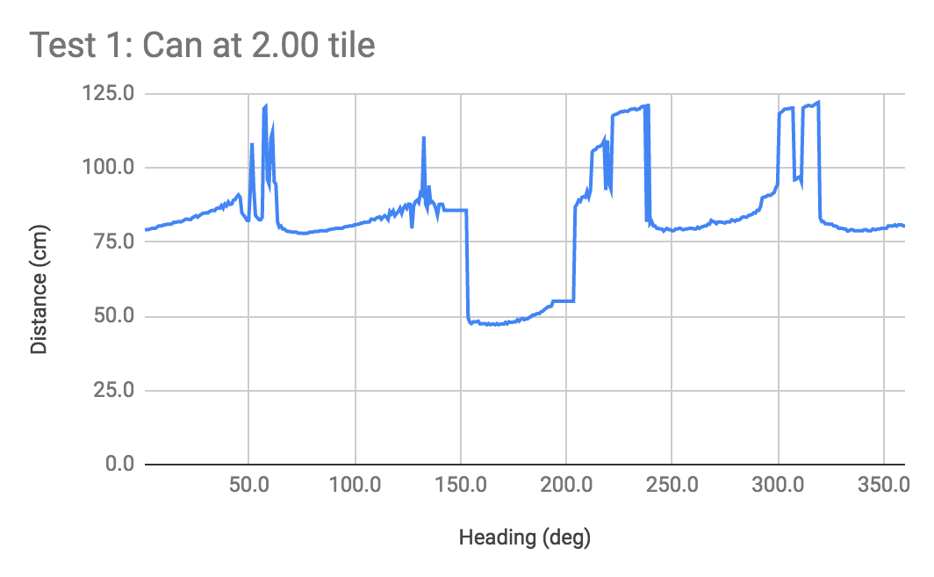

*Figure 10*. Test 1 with can at 1.75 tile away.

*Figure 11*. Test 1 with can at 2.00 tile away.

15.6.2 TEST 2 RESULTS

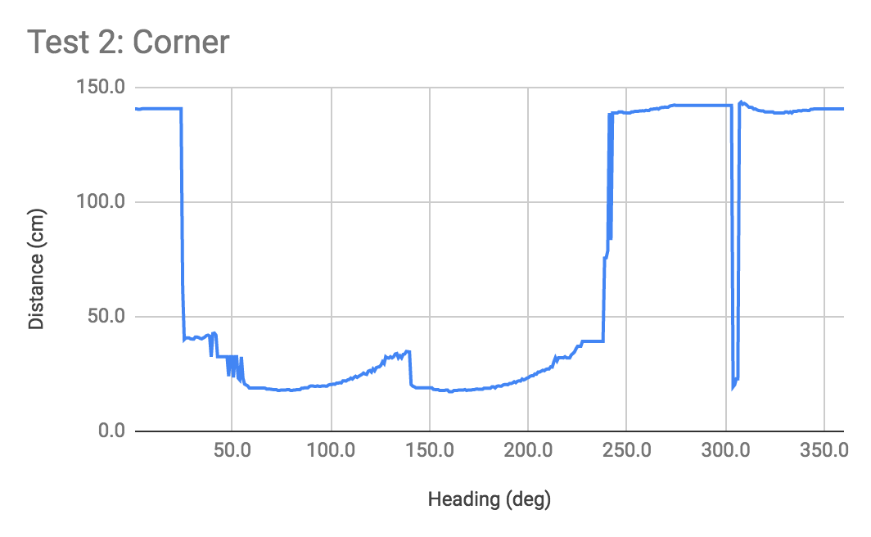

*Figure 12*. Plotted readings for test 2.

15.6.3 TEST 3 RESULTS

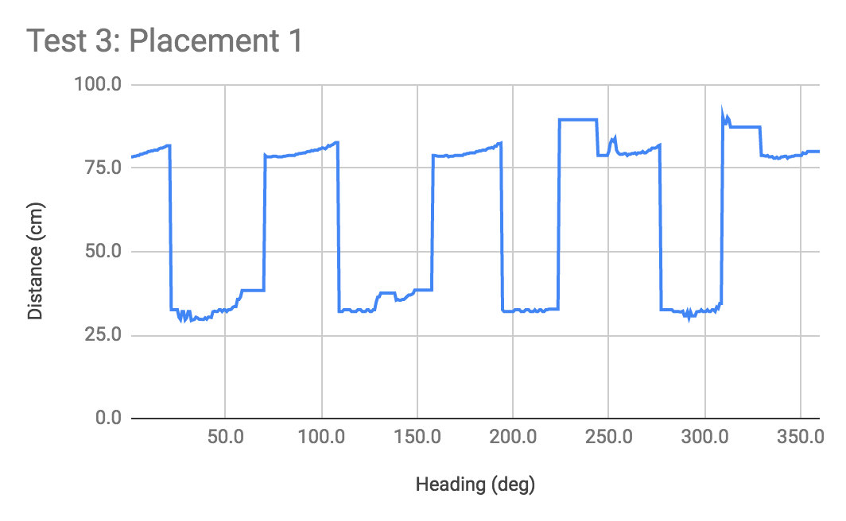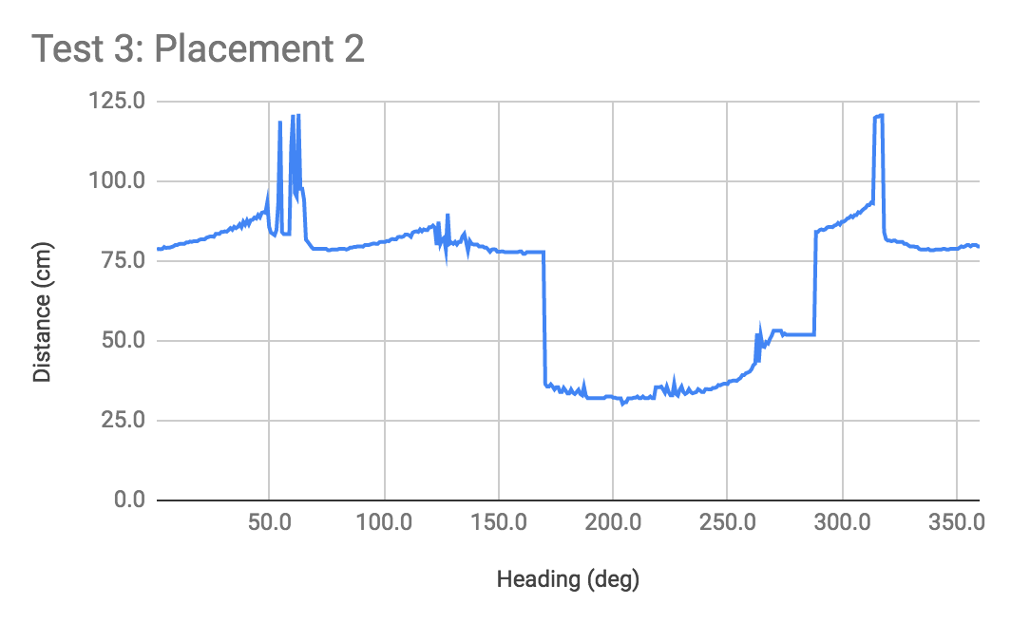

*Figure 13*. Test 3 placement 1 readings.

*Figure 14*. Test 3 placement 2 readings.

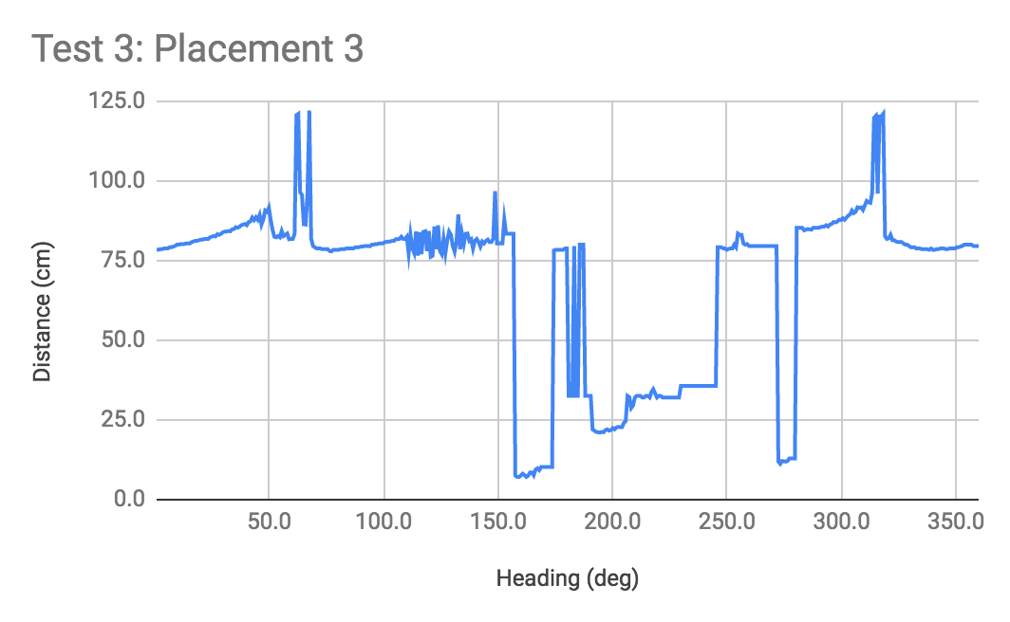

*Figure 15*. Test 3 placement 3 readings.

15.6.4 TEST 4 RESULTS

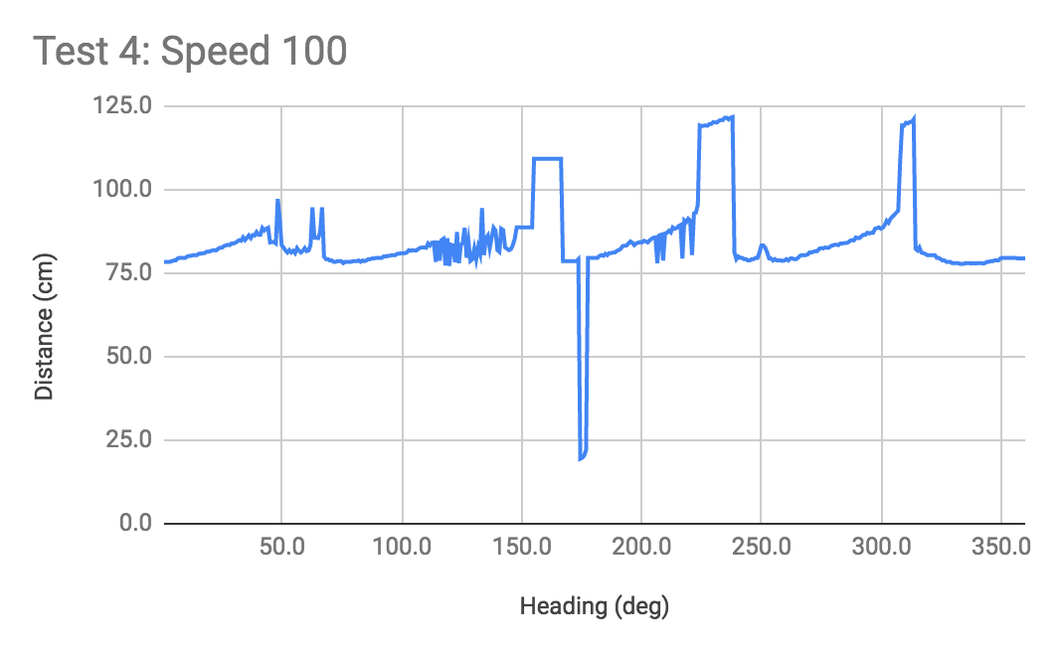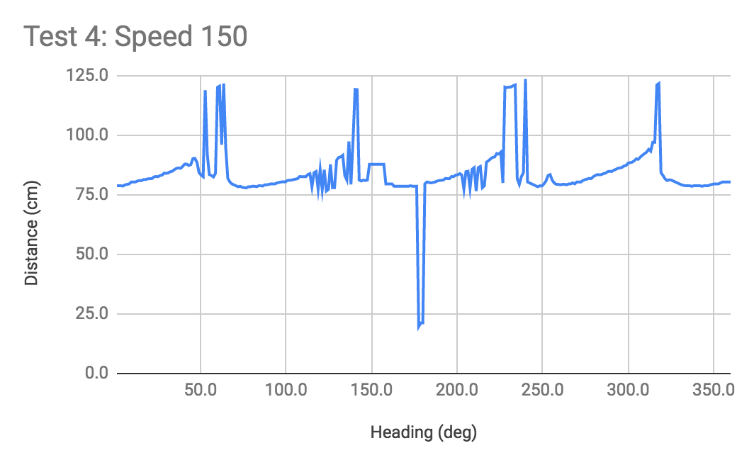

*Figure 16*. Test 4 speed 100 readings.

*Figure 17*. Test 4 speed 150 readings.

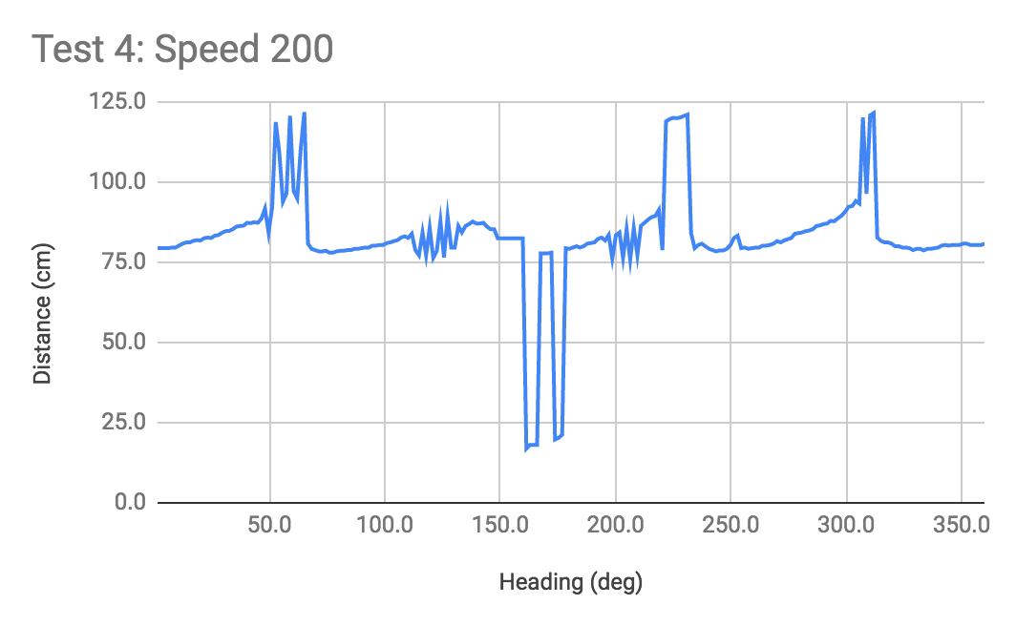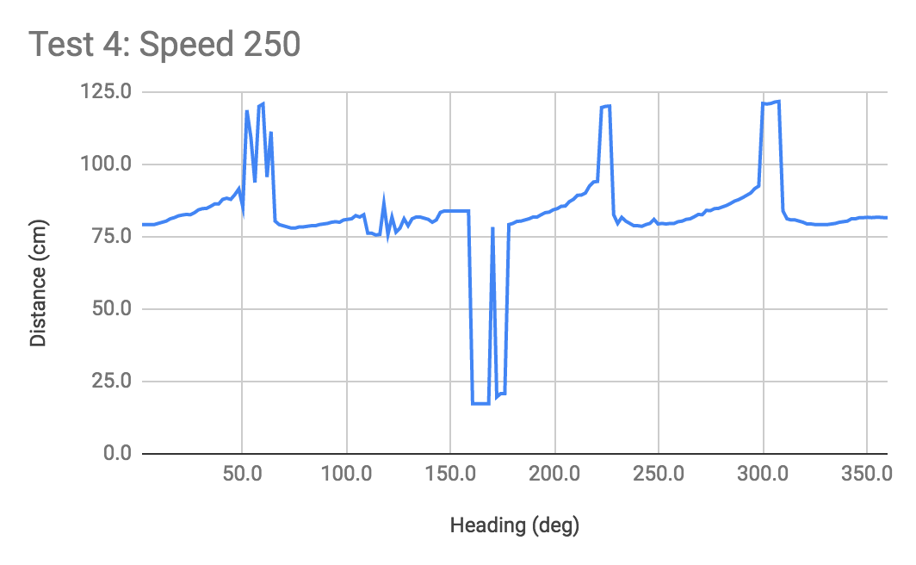

*Figure 18*. Test 4 speed 200 readings.

*Figure 19*. Test 4 speed 250 readings.

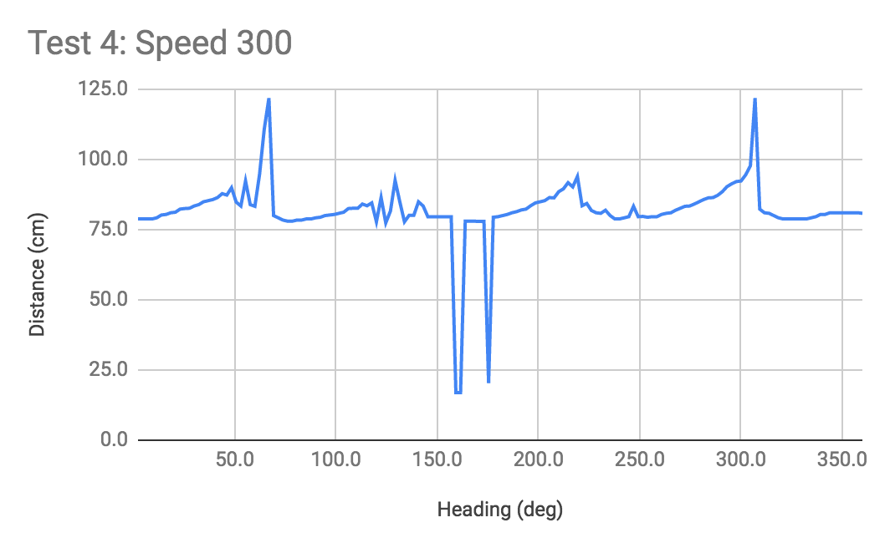

*Figure 20*. Test 4 speed 300 readings.

15.6.5 DATA ANALYSIS

For each test and subtest, the readings are plotted and graphs are obtained:

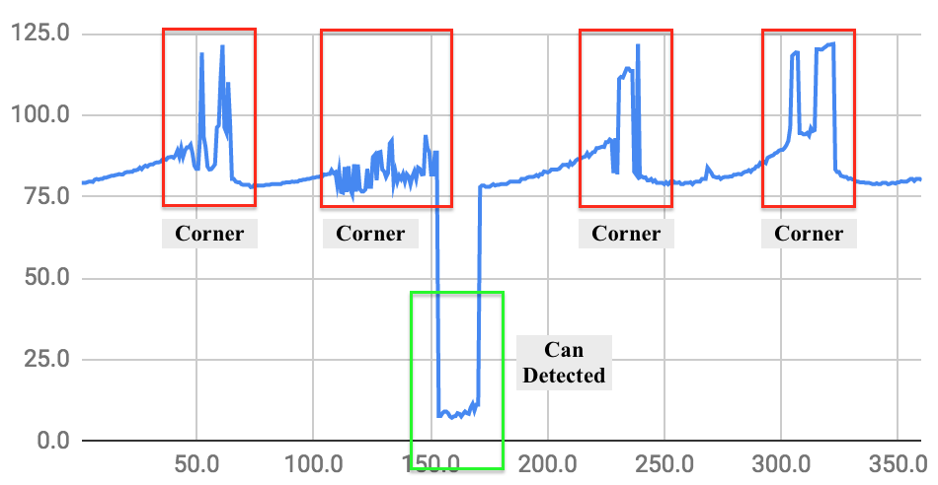

*Figure 21*. Guidelines on interpreting the plot.

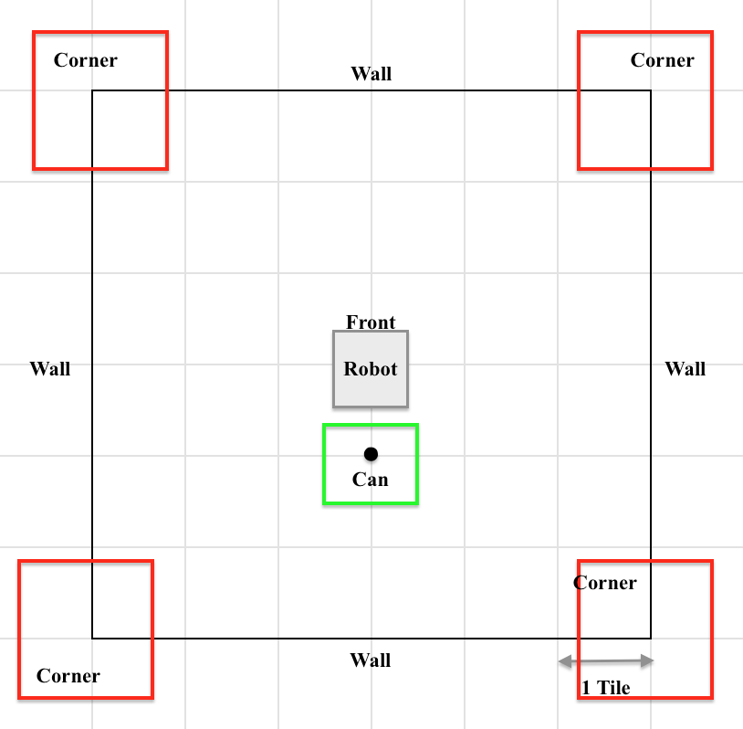

*Figure 22*. Corresponding red and green boxes on the setup diagram.

As shown in figure 21 and 22, the four peaks (as shown in red boxes) represent the four corners of the setup, and the trough (as shown in green box) represents the can.

15.7 CONCLUSION

15.7.1 REGARDING TEST 1

In figures 6 - 11, the graphs show clear troughs, indicating detection of the can. As the can is placed farther and farther away from the sensor, the trough is shallower and shallower. One should also note the width of the trough changes as the cans are placed farther; however, there is no relationship to be found between the distance of cans and the width of the trough. Thus, it is possible to use distinguish the distance of cans based on the sensor reading.

15.7.2 REGARDING TEST 2

As shown in figure 12, when the can is placed at the same distance as the wall, from the robot, the width of the trough shows the wall and the can. The wall has a much wider trough while the can has a much smaller and sharper trough. If the can was placed on the same side as the wall, it could be distinguished by finding the lowest point of the trough. However, if the nearest can is farther away from the robot than the wall is, then there needs to be some algorithm that determines whether the object is a wall or a can.

15.7.3 REGARDING TEST 3

As shown in figures 13 - 15, when 4 cans are placed around the robot, the robot is able to find the closest can by finding the deepest trough. However, in figure 14, when the cans are placed closely together at about the same distance from the robot, the pattern produced from the readings is very similar to the one produced when a wall is present. Again, the robot would have to distinguish between a wall and several closely placed cans.

15.7.4 REGARDING TEST 4

With the same sampling period, there are less data points if the speed of rotation is increased. The can is still detectable when the speed is 300. However, the single trough split into two narrow and deep troughs as the speed increases, as shown in figures 16 - 20. The effect is unknown; however, the robot could travel to the average heading (of the two headings corresponding to the two troughs), and the robot is likely going to find the can.

15.8 ACTIONS

Discuss more with software team and project manager about the use of the scanning method of the ultrasonic sensor.

15.9 DISTRIBUTION

Software Leader; Software Engineer; Project Manager; Documentation Manager.

15.10 APPENDIX

[Full Data](https://docs.google.com/spreadsheets/d/1H_42m0tg24KJ3MCLmY9kfS190zgXDq-0SA2VQMwMh5A/edit?usp=sharing)

[Test Code](https://gist.github.com/e231ee1f726793cc6dd0180727bfc9f0.git)

# 16 CAN IDENTIFICATION TEST

**Date:** 2019/03/21

**Tester:** Raymond Yang

**Duration:** 90 min

**Author:** Raymond Yang

**Hardware Version:** 2.1

**Software Version:** 2.0

16.1 TEST PURPOSE

The purpose of this test is to determine whether the light sensor is able to accurately identify the cans’ colors. This test is different from previous light sensor tests in the way that it targets can identification. Being able to identify the cans allow us to pick up the right can.

16.2 TEST OBJECTIVES

Gather data on the color the robot reads and whether it is accurate, given the computed thresholds.

16.3 TEST SETUP

This test takes place after the robot finds a can and approaches the can. Red, green, blue, and yellow cans are used. The test is to be performed on different locations of the demo board, to simulate random locations. For the software, it is modified based on software version 2.0, and can be found in the appendix section (16.10).

16.3.1 COLOR THRESHOLDS

|  |  |  |  |
| --- | --- | --- | --- |
| **Color** | **R** | **G** | **B** |
| Red | 0.98 | 0.24 | 0.07 |
| Green | 0.35 | 0.85 | 0.39 |
| Blue | 0.19 | 0.60 | 0.65 |
| Yellow | 0.85 | 0.52 | 0.09 |

*Table 1*. Thresholds for RGB values of red, green, blue, and yellow colors.

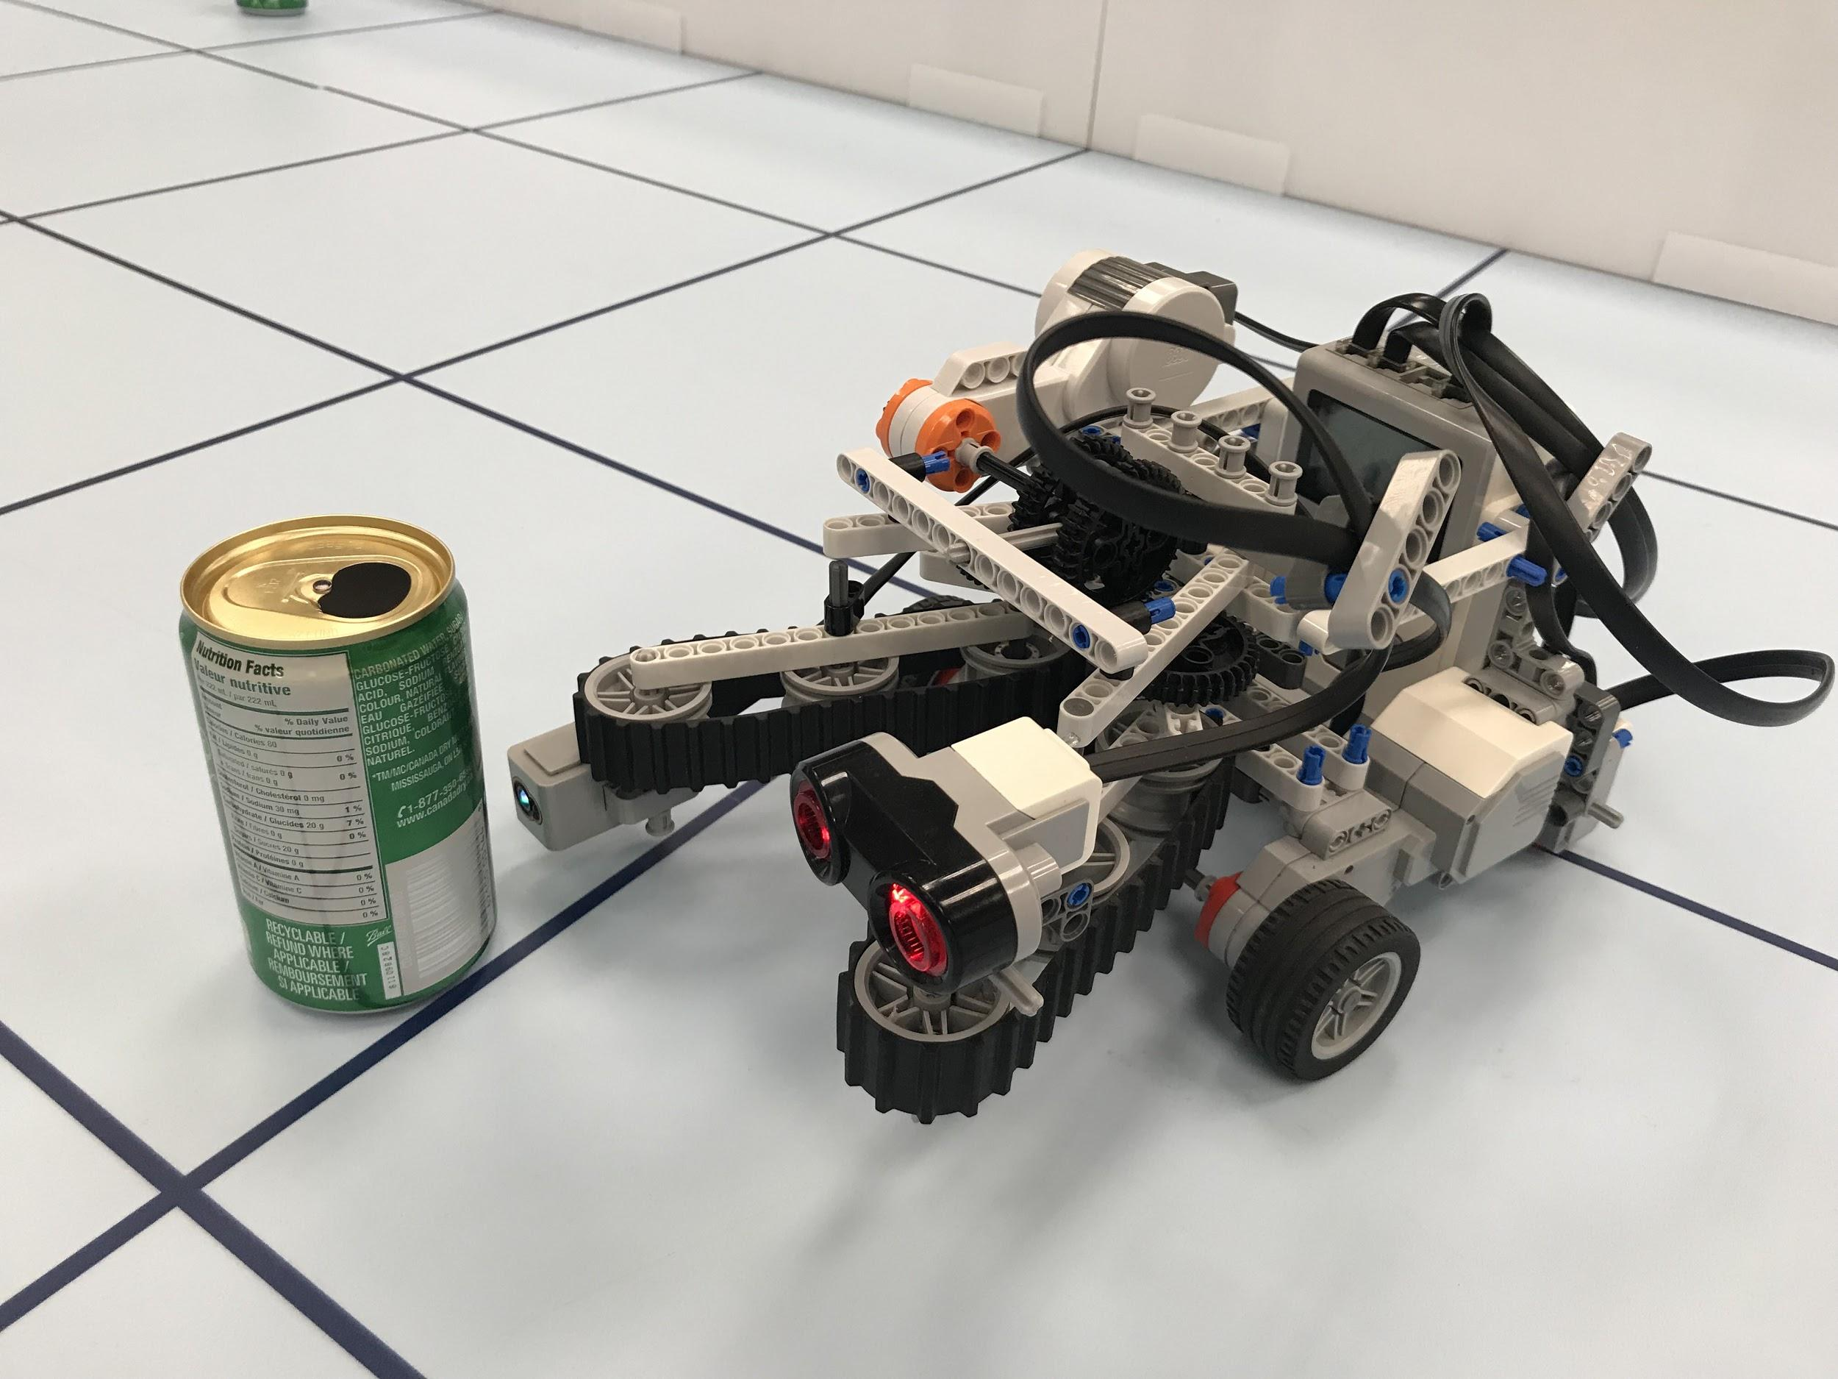

*Figure 1*. Test setup.

16.4 TEST PROCEDURE

1. Upload code and execute.
2. Place a can within the range of the light sensor for detection.
3. Record detection result and RGB values.
4. Repeat 10 trials for cans of each color, change testing location on demo board randomly during the trials.

16.5 EXPECTED RESULTS

The robot is able correctly identify the can’s color. If a color other than the four colors are read (the label), the robot should use the belt mechanism to rotate the can and read from another angle, until the color can be determined.

16.6 TEST RESULTS

|  |  |
| --- | --- |
| **Color** | **Identified Correctly?** |
| **Red** | Yes |
| **Green** | Yes |
| **Blue** | Yes |
| **Yellow** | Yes |
| **Other** | Yes |

*Table 2*. Results of color identification tests.

When sweeping the sensors, they had trouble pointing accurately at the can for measurement. Thus, the sweeping and re-read mechanisms were disabled, or else the test could not be done.

16.7 CONCLUSION

The current thresholds and algorithm are accurate in color identification. If the color is something other than the four designated colors, the robot signals “other”. However, the current measurement mechanism was not able to perform the task. The sensor was not able to point in the correct direction (at the can) after it has identified the can. Furthermore, the sensor was also off when re-measuring.

16.8 ACTIONS

Improve software for adjusting the sensor so that after the robot finds a can, it adjusts accurately to point the light sensor at the can.

16.9 DISTRIBUTION

Software Leader; Software Engineer; Project Manager; Documentation Manager.

16.10 APPENDIX

[Full Data](https://docs.google.com/spreadsheets/d/1RzzrIlrfh8YkoodxKD0a7-VPw1pIqeH9g9SCtNeumSM/edit?usp=sharing)

[Test Code](https://gist.github.com/f1a91bac4966ead48805276eddb28f80.git)

# 17 SEARCH TEST

**Date:** 2019/03/21

**Tester:** Antoine Wang, Raymond Yang

**Duration:** 90 min

**Author:** Raymond Yang

**Hardware Version:** 2.4

**Software Version:** 2.1

17.1 TEST PURPOSE

The purpose of the test is to determine whether the search is functional; without acquisition of the cans, only search and identification of the color. This test is also considered an integration testing. Components such as the scanning of the cans with the ultrasonic sensor, color identification using the light sensor, and search area traversal method are integrated and tested as a whole.

17.2 TEST OBJECTIVES

Gather data on:

1. The color and weight of the can robot approached.
2. The color and weight of the can robot identified, through different length and times of beeping.
3. Whether the color and weight are identified correctly.

17.3 TEST SETUP

17.3.1 PLACEMENT

Place the robot at the search zone starting coordinate. Place cans randomly in terms of location and density within the search area. Do not place cans on the starting grid point or the ending grid point.

17.3.2 INDICATIONS

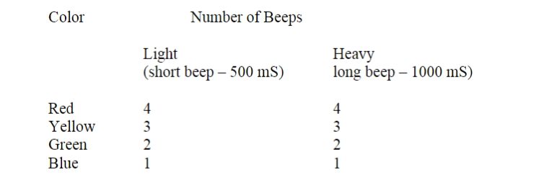

*Figure 1*. Beeping sequence to indicate detection.

17.3.3 SEARCH ZONE

The search zone should contain all the cans. The robot will pick up the nearest can. Thus, the end point of the search zone is not as relevant.

17.4 TEST PROCEDURE

1. Place robot on starting coordinate grid point of search zone.
2. Execute program.
3. Record beeps of different types and note behaviour.
4. Change can placements and repeat for 20 trials.

17.5 EXPECTED RESULTS

The robot is expected to scan, using the ultrasonic sensor, for the nearest can. The robot will approach the can and detect for its color and weight. The robot will beep according to the indication pattern shown in section 17.3.2.

17.6 TEST RESULTS

|  |  |  |
| --- | --- | --- |
| **Item** | **Color Identification** | **Weight Identification** |
| **Success Rate** | 70.0% | 60.0% |

*Table 1*. Success rates for color and weight identification.

17.7 CONCLUSION

The robot is able to scan and find the cans successfully. However, the color identification and weight identification are not functioning well. However, from the previous color identification test, where the can is placed right in front of the sensor, it is able to identify colors correctly every time. Thus, the error is most likely due to the robot’s movements.

17.8 ACTIONS

Experiment placing the light sensor at a different height and check if color identification improves. Experiment with a different weight identification method.

17.9 DISTRIBUTION

Software Leader; Software Engineer; Project Manager; Documentation Manager.

17.10 APPENDIX

[Full Data](https://docs.google.com/spreadsheets/d/10GtZHIb3jwq3fCzlnvgXqd9BjytPYoD90lsjPzrwJog/edit?usp=sharing)

[Test Code](https://gist.github.com/cd317ece0f28d6d22acbf50054e0458c.git)

# 18 PRE-TUNNEL TRAVERSAL TEST 1

**Date:** 2019/03/22

**Tester:** Raymond Yang

**Duration:** 90 min

**Author:** Raymond Yang

**Hardware Version:** 2.1

**Software Version:** 2.1

18.1 TEST PURPOSE

This test is dedicated to the analysis of Beta demo. In Beta demo, the robot failed during traversal to the tunnel, because the light sensor on the left crossed the vertical grid line the robot is travelling along. This test will check whether robot is able to travel to the tunnel.

18.2 TEST OBJECTIVES

Gather data on whether robot is able to localize, travel to tunnel, and adjust its position and heading, so that it faces the tunnel, staying at half a tile length away from the tunnel. Gather data on whether robot is able to successfully pass tunnel to verify that robot is correctly set up when pre-tunnel traversal finishes.

18.3 TEST SETUP

18.3.1 ROBOT PLACEMENT

Place the robot on the 45 degrees diagonal line from the bottom left corner to the upper-right corner of the tile. The orientation of the robot can be any direction. Modify the software such that it stops when it reaches the tunnel, then proceeds to transit the tunnel after any button on the brick is pressed.

18.3.2 TUNNEL PLACEMENT

As specified in the design project requirements, the search zone can range from 2x2 to 9x9, considering limits on search zone areas and tunnel lengths. Thus, the tunnel can be placed in any fashion as long as the entrance touches the edge of the search zone, and the exit touches the search zone. The tunnel is allowed to overlap the home zone by one tile. The tunnel can be placed either in a vertical fashion or a horizontal fashion. The length of the tunnel can either have a length of 1 or length of 2.

There are six different tunnel placements:

|  |  |  |  |
| --- | --- | --- | --- |
| **Placements** | **Starting Corner** | **TN_UR (x,y)** | **TN_LL (x,y)** |
| 1 | 0 | (7,2) | (8,4) |
| 2 | 0 | (3,5) | (5,6) |
| 3 | 3 | (3,3) | (4,5) |
| 4 | 3 | (0,3) | (1,5) |
| 5 | 1 | (11,3) | (13,4) |
| 6 | 2 | (14,4) | (15,6) |

*Table 1*. Six different tunnel placements used in testing.

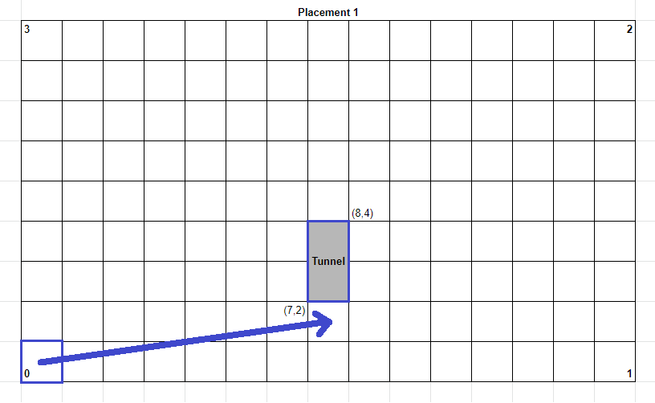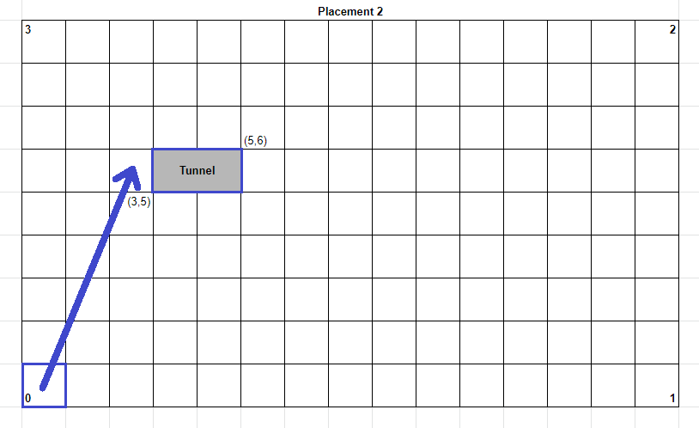

*Figure 1*. Placement 1 with starting corner, tunnel, and robot’s position shown.

*Figure 2*. Placement 2 with starting corner, tunnel, and robot’s position shown.

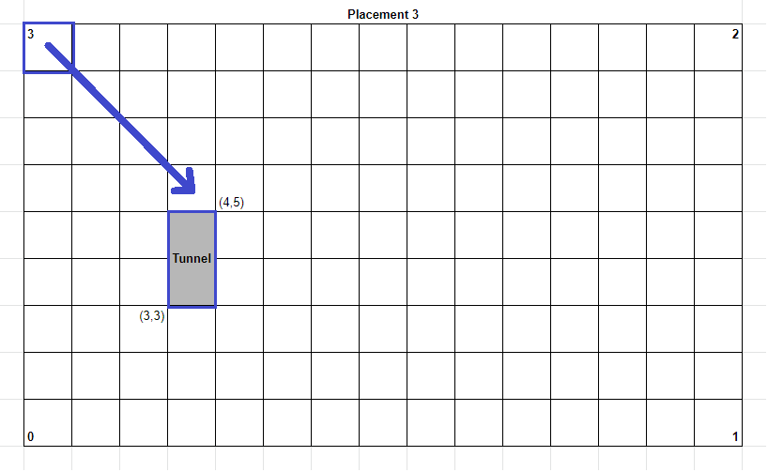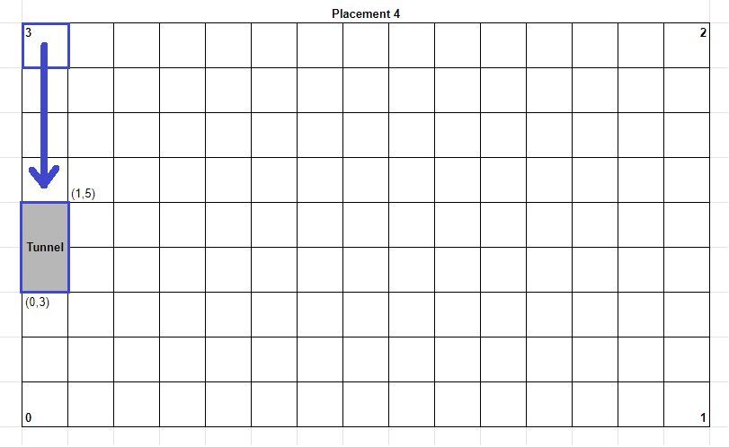

*Figure 3*. Placement 3 with starting corner, tunnel, and robot’s position shown.

*Figure 4*. Placement 4 with starting corner, tunnel, and robot’s position shown.

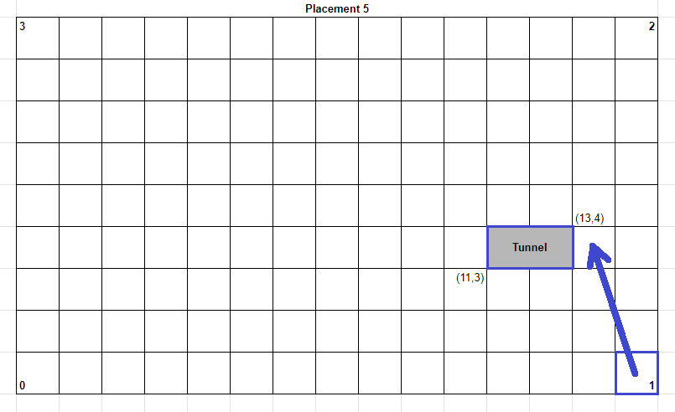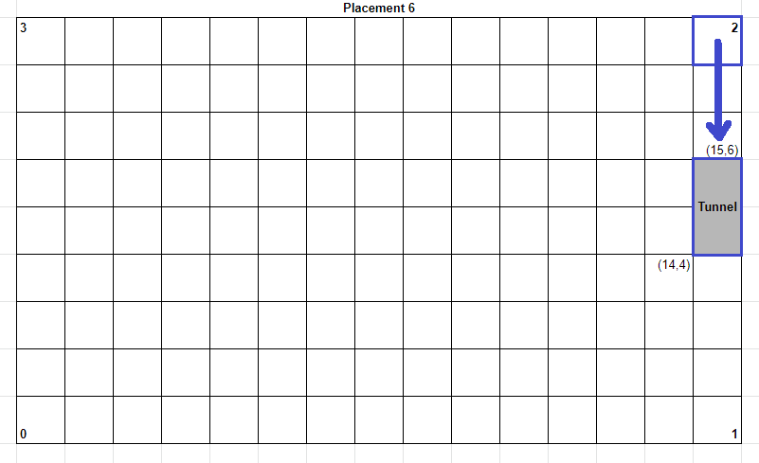

*Figure 5*. Placement 5 with starting corner, tunnel, and robot’s position shown.

*Figure 6*. Placement 6 with starting corner, tunnel, and robot’s position shown.

18.3.3 COORDINATE SYSTEM

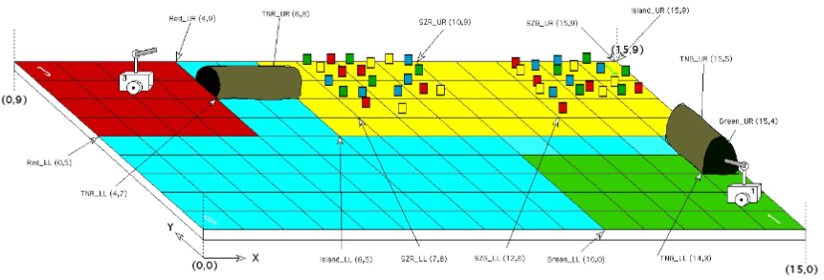

*Figure 7*. Coordinate system.

18.4 TEST PROCEDURE

1. Place robot near the corner as specified above.
2. Enter placement information into code
3. Execute program.
4. Wait until robot travels to the entrance of the tunnel.
5. Record time if robot successfully reaches tunnel.
6. Record results and repeat 6 times each for all six different tunnel placements.

18.5 EXPECTED RESULTS

The robot should be able to reach the entrance of the tunnel at least 90% of the time successfully. The robot should be pointing straight at the tunnel such that, if it were programmed to move straight forward, it would pass the tunnel successfully. The pre-navigation should take 90 seconds at most. It is optimal if the entire process takes less than 60 seconds. The localization should take at most 30 seconds.

18.6 TEST RESULTS

|  |  |  |
| --- | --- | --- |
| **Placement** | **Time (s)** | **Success Rate** |
| **1** | N/A | 0.0% |
| **2** | 34.7 | 50.0% |
| **3** | 35.0 | 66.7% |
| **4** | N/A | 0.0% |
| **5** | 33.0 | 33.3% |
| **6** | N/A | 0.0% |

*Table 2*. Success rates for all six placements. Each placement is tested six trials.

|  |  |
| --- | --- |
| **Target Success Rate** | 90.0% |
| **Actual Success Rate** | 25.0% |

*Table 3*. Target and total actual rate for all 36 trials.

Note: As long as robot enters tunnel, the test is deemed successful, even if robot fails to exit tunnel.

Observations:

1. There is no ultrasonic localization present to correct heading at start
2. For placement 1, the y parameter is off by +1. The tunnel is placed at (7,2), but robot travels towards (7,3).
3. For placement 2, robot enters tunnel successfully half of the time, but rides on the left tunnel wall on the inside; for the other half of the time, robot crashes into the left tunnel wall at the entrance.
4. For placement 3, robot successfully enters tunnel 66.7% of the time, but fails to exit the tunnel. For the rest of the time, robot crashes into the left side of the tunnel wall at the entrance and fails to enter tunnel.
5. For placement 4, robot crashes into left wall of tunnel before entering tunnel.
6. For placement 5, robot successfully enters tunnel 33.3% of the time, but fails to exit tunnel and stops 1.5 tiles away from the destination. Robot scrapes along the inside of the tunnel as it transits the tunnel. For the times where the robot fails to enter tunnel, it crashes into the left wall at the entrance.
7. For placement 6, robot fails all trials, crashing into the right wall at the entrance.

18.7 CONCLUSION

There is no ultrasonic localization present. Robot had to be placed facing roughly 0 degrees for all trials of the test. As a result, the average time taken is from light localization to entrance of tunnel. There is no correction present after initial localization. From light localization to entering the tunnel, it takes around 35 seconds for different placements. If ultrasonic localization is included, the entire pre-tunnel traversal will likely take less than 1 minute. The success rate for all 6 placements (36 trials in total) is 25.0%. For 77.8% percent of the failures, robot crashes the edge of the tunnel wall, as shown in figure 8a) below; for 22.2% of the failures, robot crashes the larger side of the tunnel wall, as shown in figure 8b) below. The pre-tunnel traversal fails the test with a 25.0% success rate.

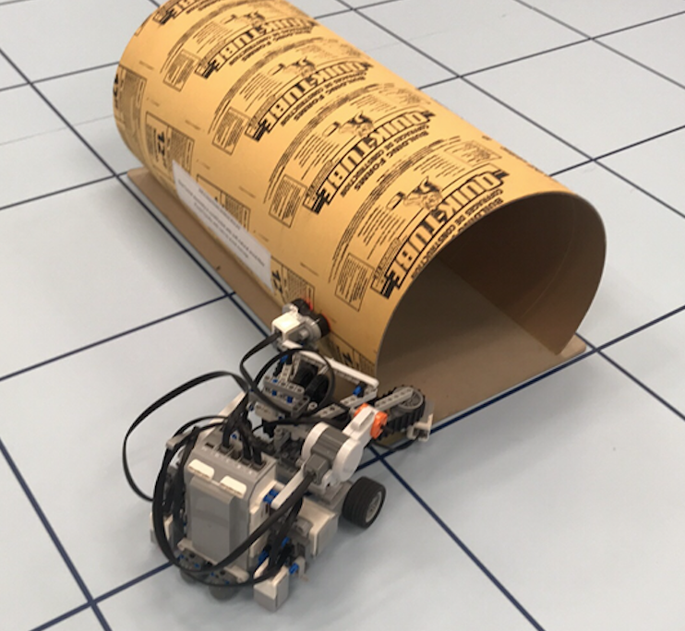 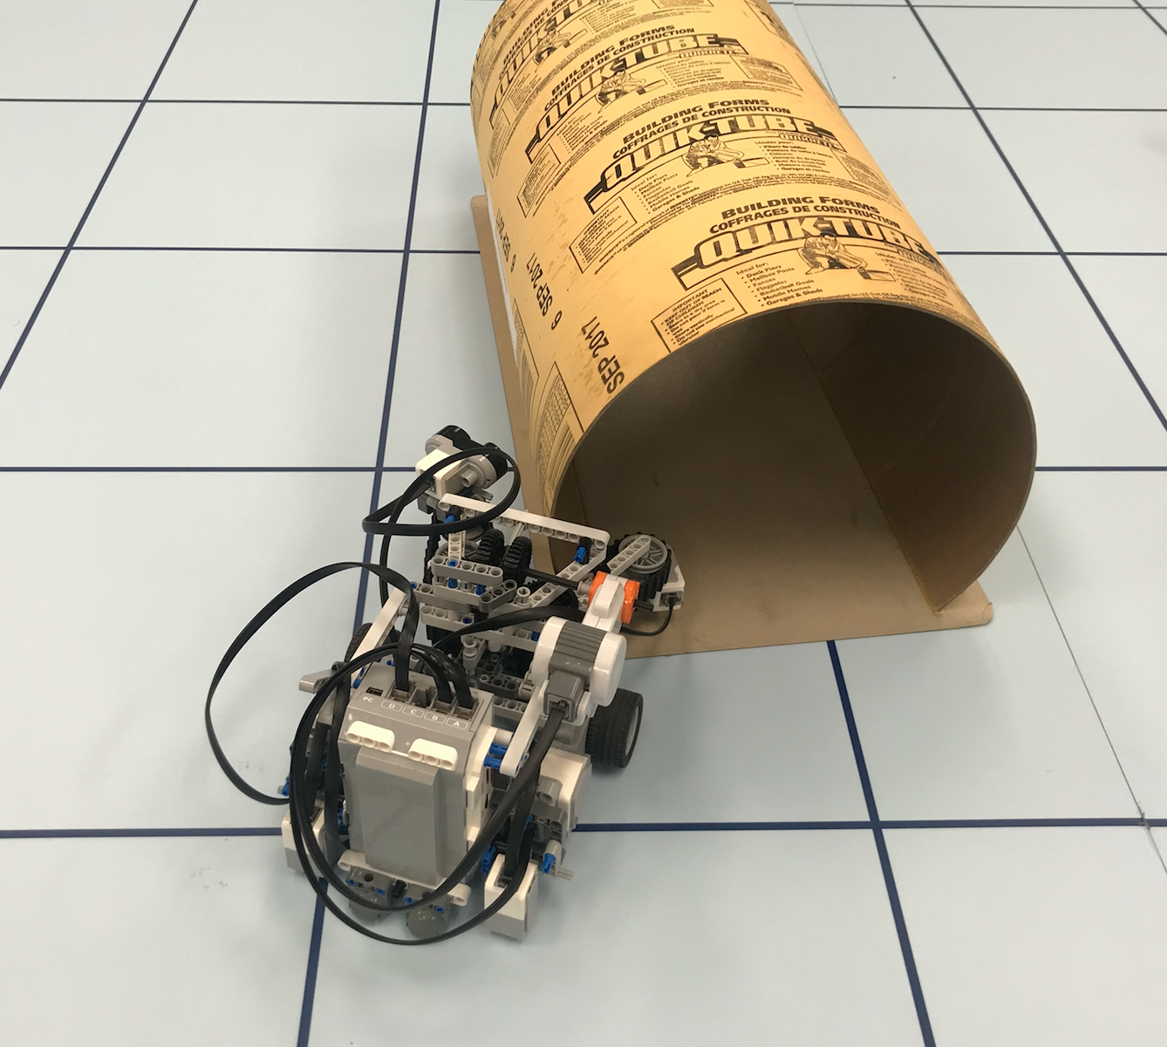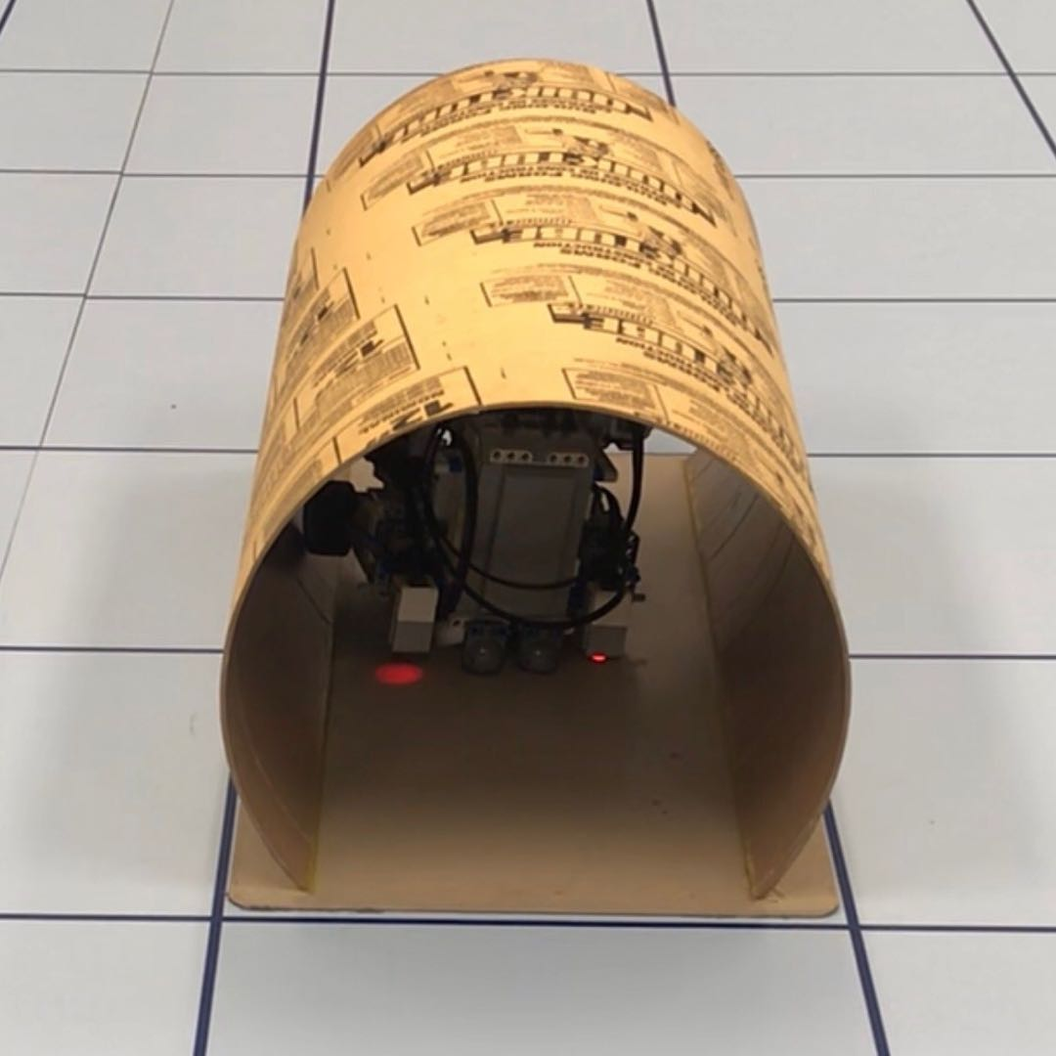

*Figure 8*. a) Crashing into the side of the tunnel; b) Crashing into the edge of tunnel; c) Riding up the side wall of tunnel.

18.8 ACTIONS

Reconsider implementation of pre-tunnel traversal.

18.9 DISTRIBUTION

Software Leader; Software Engineer; Project Manager; Documentation Manager.

18.10 APPENDIX

[Full Data](https://docs.google.com/spreadsheets/d/1-7uVqLwFXwa91mOqg2lRyBcYeUe7amGa1wViawoJMdI/edit?usp=sharing)

[Test Code](https://gist.github.com/7f7bd70f8398d978772ea928a759f45b.git)

# 19 WEIGHT IDENTIFICATION TEST 1

**Date:** 2019/03/23

**Tester:** Antoine Wang, Raymond Yang

**Duration:** 45 min

**Author:** Raymond Yang

**Hardware Version:** 2.4

**Software Version:** 2.2

19.1 TEST PURPOSE

The purpose of this test is to determine whether the robot can identify lighter and heavier cans through measuring the time taken after travelling a fixed distance with a known expected time, while holding the can. This test allows the team to evaluate this type of weight detection method, which does not require special hardware or software, and does not require a high precision.

19.2 TEST OBJECTIVES

In this test, we aim to gather data on the effectiveness of the weight identification mechanism. Specifically, we want to obtain the number of times the weight identification was performed, the number of times it was successful, and the success rate. The time taken (in seconds) to perform the identification is also recorded.

19.3 TEST SETUP

The robot should be placed at a grid point, with a can placed in the claw mechanism. The cans used can be categorized into 2 types: heavy cans and light cans. Only the weight identification portion of the software will be executed for the purpose of this test. Have 3 light cans and 3 heavy cans ready for testing.

19.3.1 LOCATION

The test will be performed at 3 types of locations on the demo board:

1. Corner.
2. Beside a wall.
3. In the middle with no obstacle on all sides.

19.4 TEST PROCEDURE

1. Place robot in correct location.
2. Place can inside the claw of the robot.
3. Execute program.
4. Record behaviour and switch the can.
5. Repeat 10 trials. Re-setup the test scene for each trial.
6. Change location type every 10 trials, so a total of 30 trials is to be performed for this test.

19.5 EXPECTED RESULTS

The robot is expected to identify light and heavy cans through the weight identification mechanism. The success rate is expected to reach 90%. The time take for determination of weight is expected to take less than 15 seconds.

19.6 TEST RESULTS

|  |  |  |
| --- | --- | --- |
| **Location** | **Success Rate** | **Time (s)** |
| **Corner** | 40.0% | 14.45 |
| **Wall** | 50.0% | 14.44 |
| **Center** | 40.0% | 14.50 |

*Table 1*. Success rate and time taken for weight identification

19.7 CONCLUSION

The test fails to identify the weight of the cans. The test can be performed at all three locations, taking around 14.50 seconds. However, a 40.0% to 50.0% success rate likely indicates that the results are random.

19.8 ACTIONS

Investigate and experiment with other weight identification methods.

19.9 DISTRIBUTION

Software Leader; Software Engineer; Project Manager; Documentation Manager.

19.10 APPENDIX

[Test Code](https://gist.github.com/3bbda2c7203b49df56c0d8acfb0317ee.git)

[Full Data](https://docs.google.com/spreadsheets/d/1VUZ6VA31d7BVRH33LR34p6uoehmpFpjg28658Aj75uc/edit?usp=sharing)

# 20 OBJECT ACQUISITION TEST

**Date:** 2019/03/23

**Tester:** Raymond Yang

**Duration:** 30 min

**Author:** Raymond Yang

**Hardware Version:** 2.4

**Software Version:** 2.2

20.1 TEST PURPOSE

The purpose of the test is to determine whether robot can pick up the can, hold the can, and travel with the can while holding on to it. This test aims to verify the design of the claw mechanism.

20.2 TEST OBJECTIVES

In this test, data on whether can is acquired, robot passed through tunnel with can still in the claw, and whether can is upright when released.

20.3 TEST SETUP

The robot will be placed at the lower left corner of the search zone. Only one can of any color is placed in the search zone, within the tiles around the robot. A tunnel will be prepared and kept on the side. After robot finishes acquiring the can and localizing with the can, the tunnel should be placed directly in front of the robot for it to pass through.

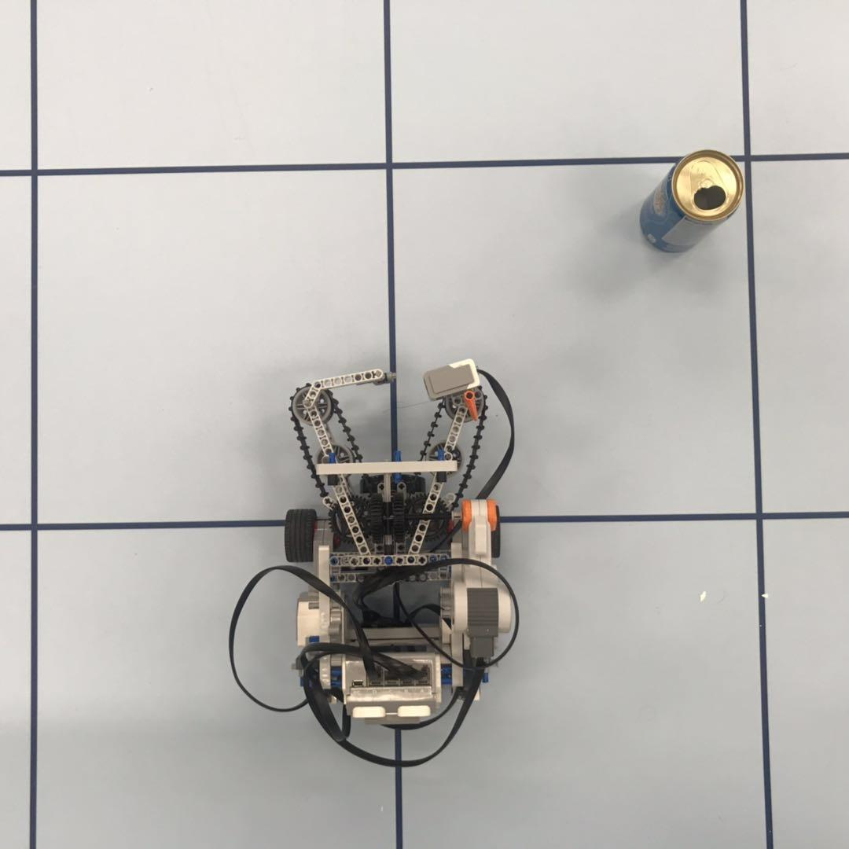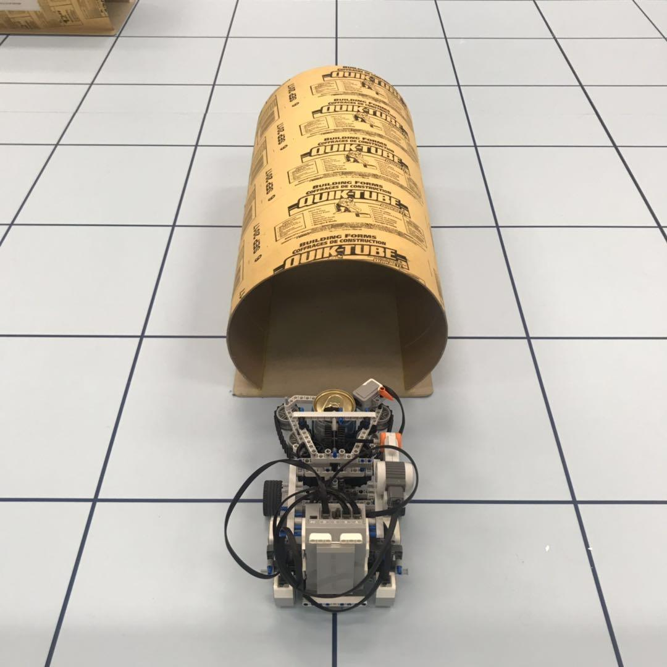

*Figure 1*. Setup of robot and can.

*Figure 2*. Setup of tunnel after robot grabs can and returns to grid point.

20.4 TEST PROCEDURE

1. Place robot and can on demo board as described above.
2. Have tunnel ready.
3. Execute program.
4. After robot finishes localization, place tunnel as described above.
5. Wait until robot stops and record results.

20.5 EXPECTED RESULTS

The robot is expected to acquire the can, localize with the can locked in its claws, and pass through the tunnel without losing or dropping the can.

20.6 TEST RESULTS

|  |  |  |  |
| --- | --- | --- | --- |
| **Acquired Can** | **Passed Tunnel** | **Can Upright** | **Success Rate** |
| Yes | Yes | Yes | 80.0% |

*Table 1*. Recorded results for test of 10 trials.

20.7 CONCLUSION

The test is successful. The robot is able to acquire the can and able to bring the can across the tunnel in all trials of this test. The success rate for object acquisition is 80.0%. The claw mechanism for can acquisition is a successful design. Further improvements in the algorithm aiming to solve the can placement issue will be added to counter the specific failure of the test.

20.8 ACTIONS

Proceed with current hardware mechanism for can acquisition.

20.9 DISTRIBUTION

Hardware Leader; Hardware Engineer; Project Manager; Documentation Manager.

20.10 APPENDIX

[Test Code](https://gist.github.com/2c44bfdeb123e1db5a4223415b6eb35d.git)

[Full Data](https://docs.google.com/spreadsheets/d/1Mo_3D3kBlWMj4HFZ6z_c-0GackskgXydrQk2s1N7oUQ/edit?usp=sharing)

# 21 PRE-TUNNEL TRAVERSAL TEST 2

**Date:** 2019/03/30

**Tester:** Raymond Yang

**Duration:** 180 min

**Author:** Raymond Yang

**Hardware Version:** 2.4

**Software Version:** 2.3

21.1 TEST PURPOSE

This is the second iteration of the pre-tunnel traversal test, with the updated traversal software design. The purpose is to test all actions before traversing the tunnel.

21.2 TEST OBJECTIVES

Refer to section 18.2.

21.3 TEST SETUP

There are 16 test cases: 4 test cases for each of the four corners. At each corner, there will be 2 cases where tunnel is horizontal, and 2 cases where tunnel is vertical. For each of the 2 cases, one is general and one is extreme. Each of the 16 cases is tested 3 trials.

Important: the figure coloring is different from the requirements document. In the figures below: the star is the robot’s starting location; the red region is the home zone; the grey region is the tunnel; the yellow region is the island; the blue region is the search region; and the white region is the “river” or “water”.

21.3.1 ROBOT PLACEMENT

Robot is placed at the tile in the corresponding corner of each case. Robot is placed to face 0 degrees relative to each corner. This is to prepare for light localization. The robot should be placed far enough from the wall so that it does not collide into the wall during light localization.

21.3.2 TUNNEL PLACEMENTS: GENERAL CASES

Skip to Procedure.

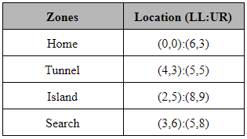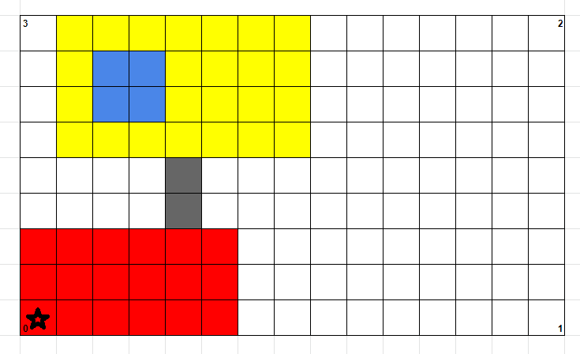

Table 1 & Figure 1. Corner 0; vertical tunnel; general case.

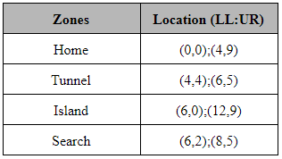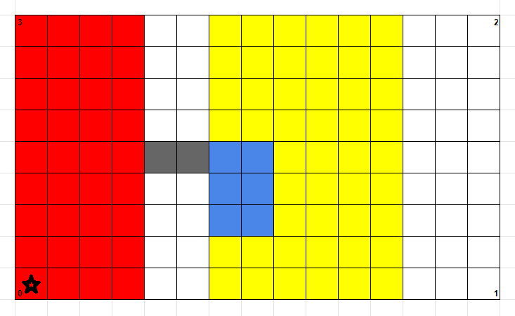

Table 2 & Figure 2. Corner 0; horizontal tunnel; general case.

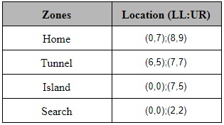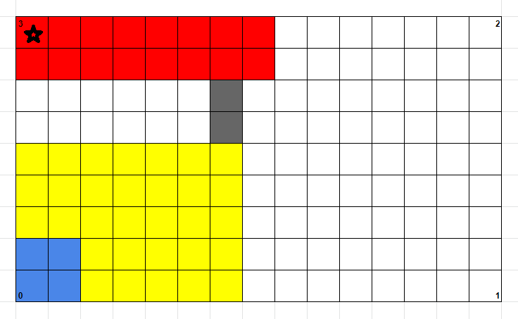

Table 3 & Figure 3. Corner 3; vertical tunnel; general case.

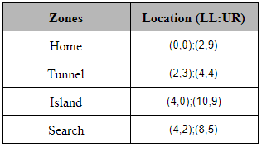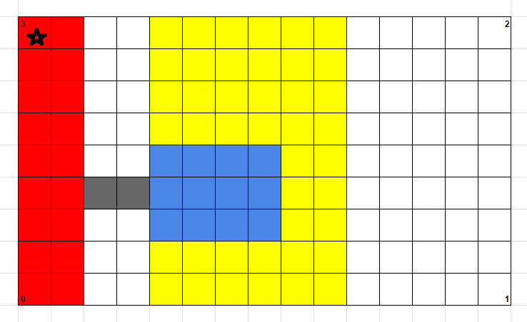

Table 4 & Figure 4. Corner 3; horizontal tunnel; general case.

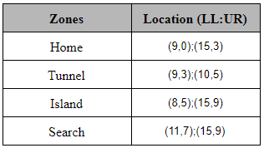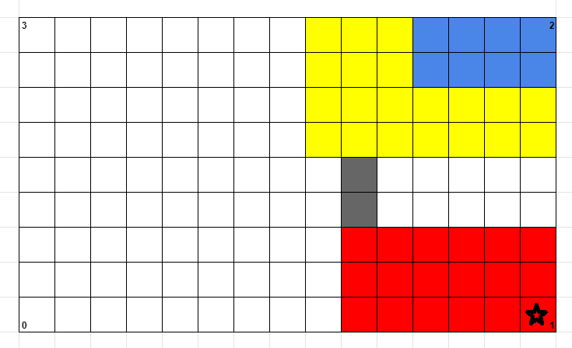

Table 5 & Figure 5. Corner 1; vertical tunnel; general case.

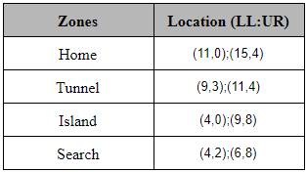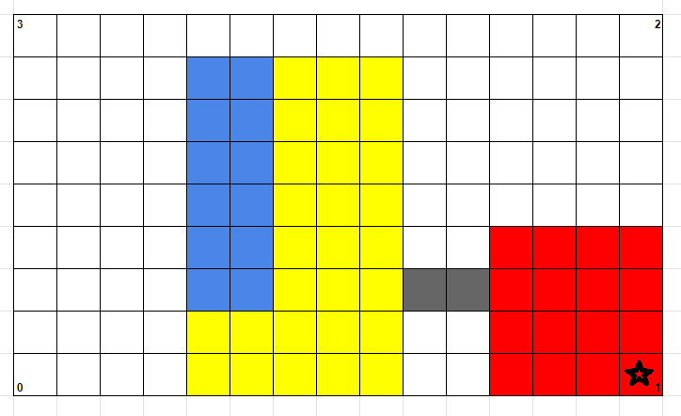

Table 6 & Figure 6. Corner 1; horizontal tunnel; general case.

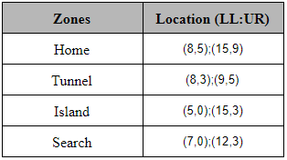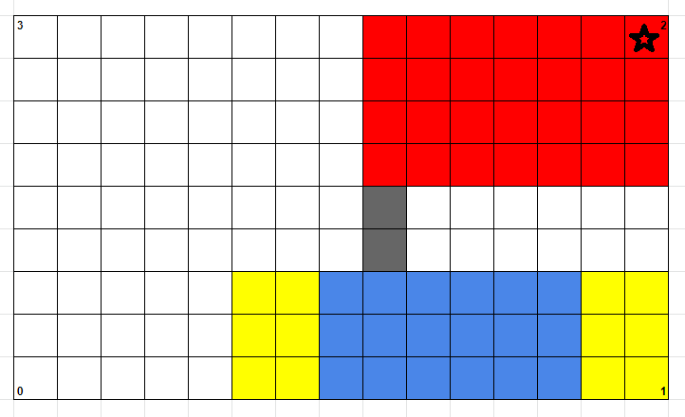

Table 7 & Figure 7. Corner 2; vertical tunnel; general case.

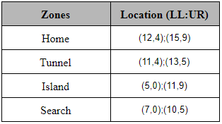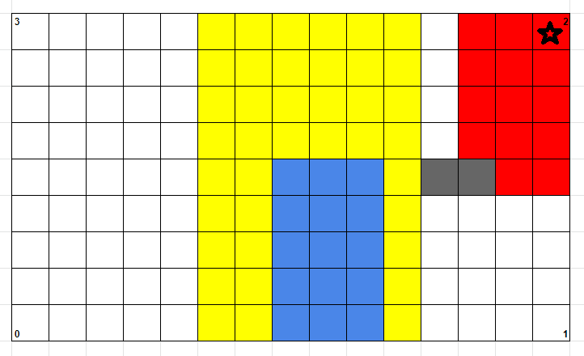

Table 8 & Figure 8. Corner 2; horizontal tunnel; general case.

21.3.3 TUNNEL PLACEMENTS: EXTREME CASES

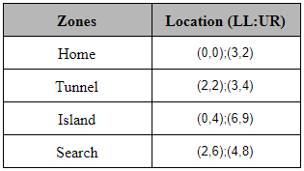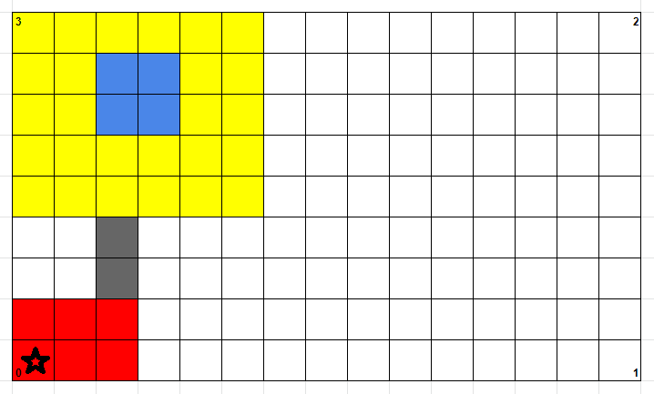

Table 9 & Figure 9. Corner 0; vertical tunnel; extreme case.

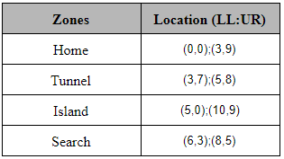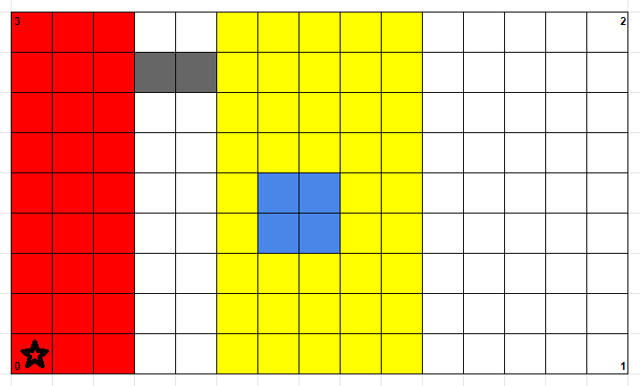

Table 10 & Figure 10. Corner 0; horizontal tunnel; extreme case.

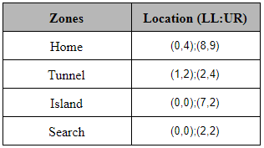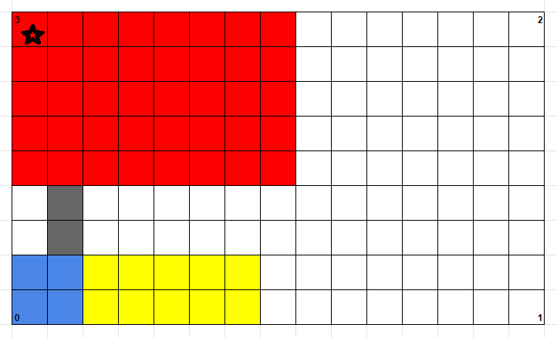

Table 11 & Figure 11. Corner 3; vertical tunnel; extreme case.

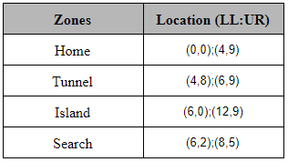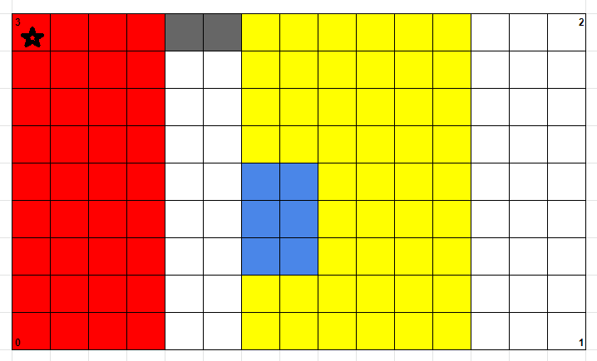

Table 12 & Figure 12. Corner 3; horizontal tunnel; extreme case.

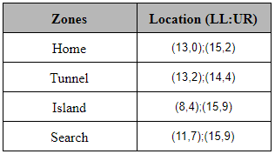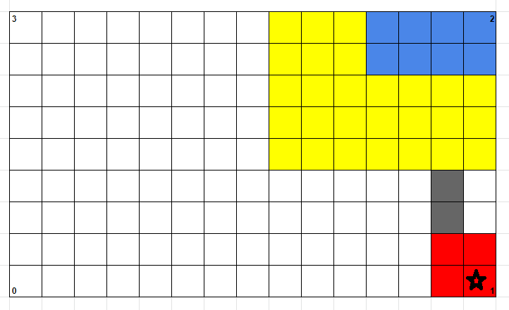

Table 13 & Figure 13. Corner 1; vertical tunnel; extreme case.

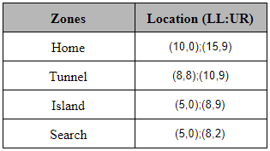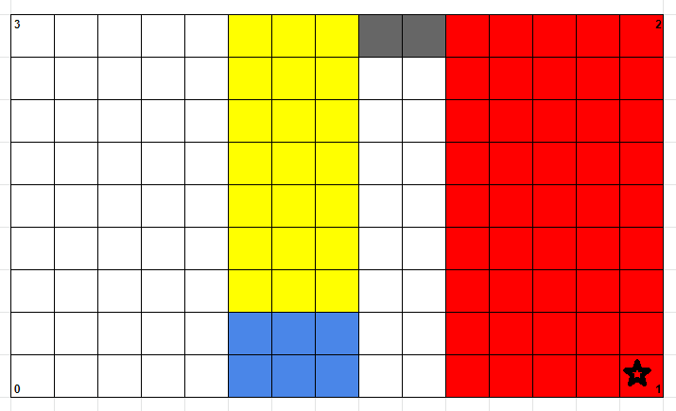

Table 14 & Figure 14. Corner 1; horizontal tunnel; extreme case.

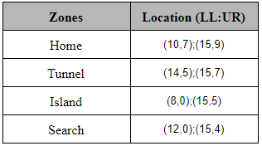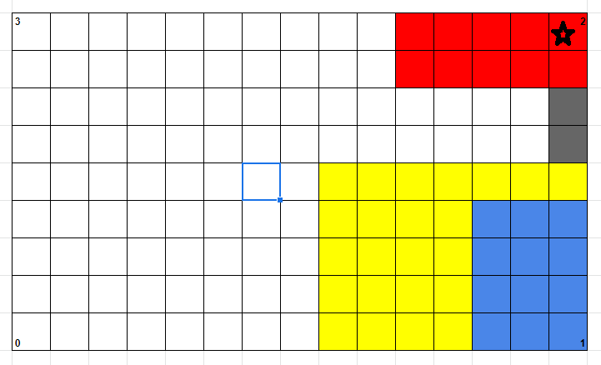

Table 15 & Figure 15. Corner 2; vertical tunnel; extreme case.

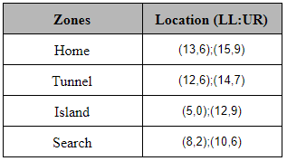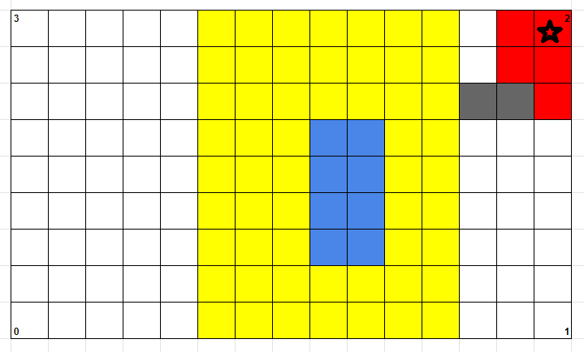

Table 16 & Figure 16. Corner 2; horizontal tunnel; extreme case.

21.4 TEST PROCEDURE

Refer to section 18.4.

21.5 EXPECTED RESULTS

For each case, the robot should be able to localize, travel to the tunnel, localize before entering the tunnel, and successfully pass through the tunnel. On the second localization, the robot should localize on a grid point that is not on the edge. Otherwise, part of the robot will be in the “river” area.

21.6 TEST RESULTS

|  |  |  |  |
| --- | --- | --- | --- |
| **Corner** | **Tunnel Orientation** | **Case Type** | **Success Rate** |
| 0 | Vertical | General | 0.0% |
| 0 | Vertical | Extreme | 0.0% |
| 0 | Horizontal | General | 0.0% |
| 0 | Horizontal | Extreme | 66.7% |
| 3 | Vertical | General | 0.0% |
| 3 | Vertical | Extreme | 0.0% |
| 3 | Horizontal | General | 0.0% |
| 3 | Horizontal | Extreme | 100.0% |
| 1 | Vertical | General | 0.0% |
| 1 | Vertical | Extreme | 0.0% |
| 1 | Horizontal | General | 0.0% |
| 1 | Horizontal | Extreme | 0.0% |
| 2 | Vertical | General | 0.0% |
| 2 | Vertical | Extreme | 0.0% |
| 2 | Horizontal | General | 100.0% |
| 2 | Horizontal | Extreme | 0.0% |

Table 17. Success rates for the 16 cases, 48 trials.

|  |  |
| --- | --- |
| **Target Success Rate** | 90.0% |
| **Actual Success Rate** | 16.7% |

Table 18. Target and actual success rate for the 16 cases, 48 trials.

Observations:

Most of the failures were due to this problem: robot travels a shorter distance than expected, so it localized at the incorrect grid line. In other cases, the robot localized on the wrong side of the tunnel, with half of the robot in the “river”. On rare occasions, the right wheel spun rapidly for a short period of time, which is suspected to be caused by threading issues. There were also cases, such as the extreme case at corner 3 with vertical tunnel placement, where the robot localized successfully but did not turn in the right direction (the direction the tunnel entrance is in). Errors were present with the ultrasonic localization as the ultrasonic sensor was placed in a different location on the robot. Thus, ultrasonic localization was bypassed in this test.

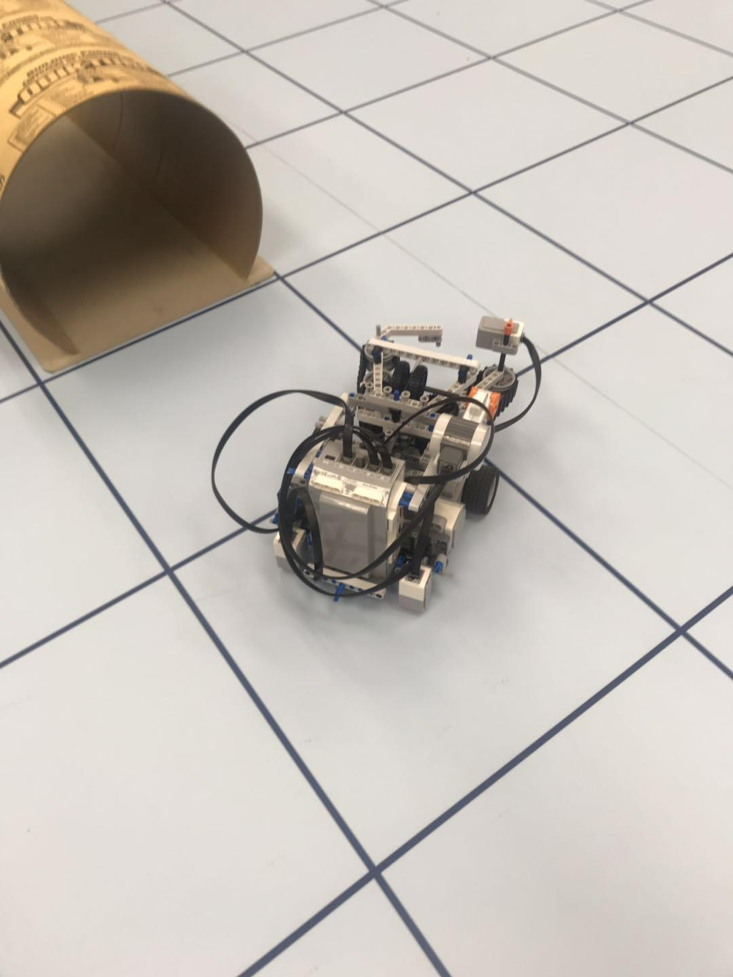

*Figure 17*. Robot travelling a distance less than expected and not reaching the grid point. Light sensor scans wrong grid line during localization before entering tunnel.

21.7 CONCLUSION

The updated algorithm for pre-tunnel traversal attempts to account for more cases. However, the performance is unacceptable for most cases. For only 3 out of the 16 test cases, the robot is able to enter the tunnel and pass through the tunnel. The overall success rate of 16.7% is lower than the first pre-tunnel traversal’s success rate of 25.0%. They both do not satisfy the target success rate of 90.0%. This robot fails the pre-tunnel traversal test.

21.8 ACTIONS

Set up test for another version of pre-tunnel traversal.

21.9 DISTRIBUTION

Software Leader; Software Engineer; Project Manager; Documentation Manager.

21.10 APPENDIX

[Full Data](https://docs.google.com/spreadsheets/d/1YCkk9AQUmAys91qbkWEkE4F38tdHbP0ffVmOJtw5wW8/edit?usp=sharing)

[Test Code](https://gist.github.com/3554a21b9fbb533fc430ae4691bae5aa.git)

# 22 WIFI CLASS TEST

**Date:** 2019/03/30

**Tester:** Raymond Yang

**Duration:** 20 min

**Author:** Raymond Yang

**Hardware Version:** 2.4

**Software Version:** 2.3

22.1 TEST PURPOSE

The purpose of this test is to verify whether the Wifi class is able to receive data and initialize the correct variables in our code. This would help alleviate the sources of error before integration testing.

22.2 TEST OBJECTIVES

The objective of this test is to gather the data passed into the robot using the Wifi class. The data of the placements and zones will be gathered and compared with the data entered on the computer.

22.3 TEST SETUP

The computer needs to be connected to the DPM wifi. The IP address of the computer needs to be entered in the Wifi class. The robot and the computer should be connected to the same access point (DPM).

22.4 TEST PROCEDURE

1. Run “DPM Server Winter 2019.jar”. Fill in designed number. Note that for generality team number 23 can be both red or green (meaning both data sets needed to be received correctly).
2. Run only the wifi.java class. Wait until the compilation and the transmission of .jar file finishes.
3. When the testline “team 23 connected appears”, hit “start” to transmit the data (details please see figure 1 below)

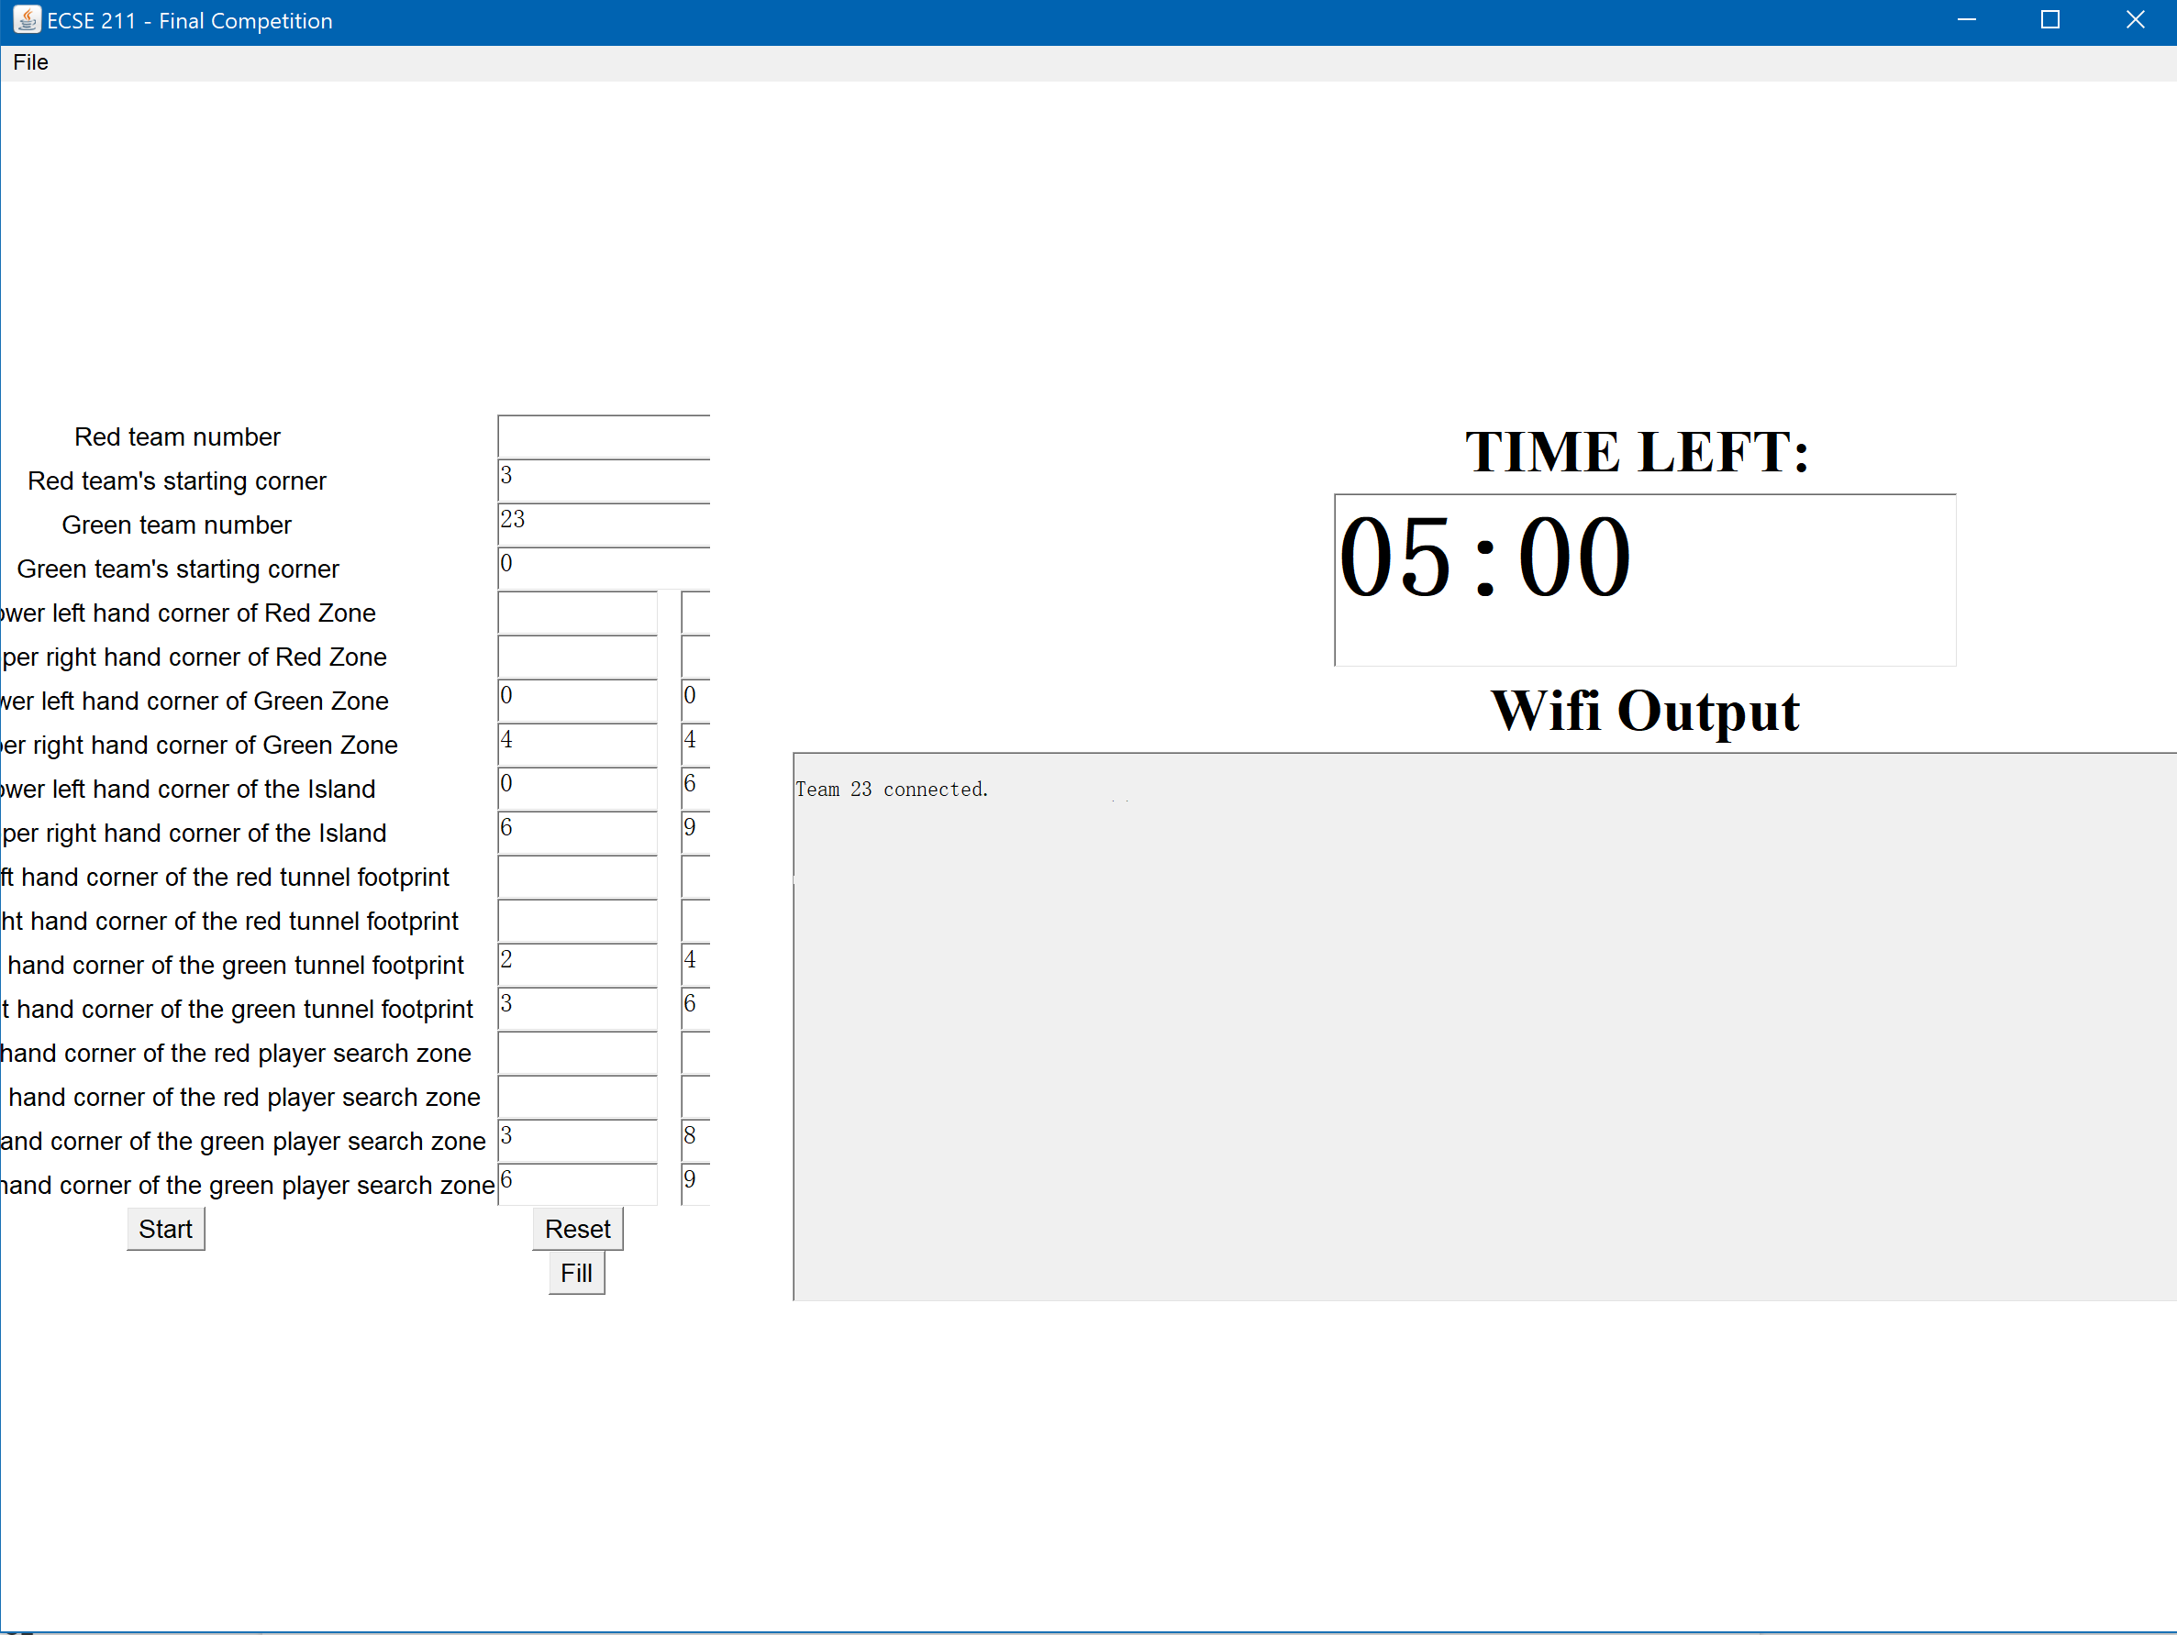

*Figure 1*. An example indicating the server is ready to pass the data. Note the text line in the console.

1. Parameters which are initialized should be printed onto the screen right now. Note that the parameters are not required to be legitimate since this test only aims to test whether the Wifi class is functioning. Those values can also be accessed through EV3 console using applet “EV3 Control Center”.

22.5 EXPECTED RESULTS

There should not be interruptions during the transmission. The data should be passed successfully and correctly, meaning the value of parameters printed onto the robot screen should be same as input value filled in the server.jar applet.

22.6 TEST RESULTS

|  |  |  |  |
| --- | --- | --- | --- |
| **Total Trials** | **Number of Parameters** | **Correct Parameters** | **Success Rate** |
| 5 | 65 | 65 | 100% |

*Table 1*. Tests result and success rate of the Wifi class.

22.7 CONCLUSION

The Wifi class has no problems and passes data correctly from computer to robot.

22.8 ACTIONS

None.

22.9 DISTRIBUTION

Software Leader; Software Engineer; Project Manager; Documentation Manager.

22.10 APPENDIX

[Full Data](https://docs.google.com/spreadsheets/d/11zMkVC-dlxd5K_01T4Rgv3CS1DPeF085Vq1TkSQrfI8/edit?usp=sharing)

# 23 PRE-TUNNEL TRAVERSAL TEST 3

**Date:** 2019/03/31

**Tester:** Raymond Yang

**Duration:** 180 min

**Author:** Raymond Yang

**Hardware Version:** 2.4

**Software Version:** 2.3

23.1 TEST PURPOSE

This test aims to re-test pre-tunnel traversal with another algorithm, which was developed in parallel. Refer to section 21.1.

23.2 TEST OBJECTIVES

Refer to section 21.2.

23.3 TEST SETUP

Refer to section 21.3.

23.4 TEST PROCEDURE

Refer to section 21.4.

23.5 EXPECTED RESULTS

Refer to section 21.5.

23.6 TEST RESULTS

|  |  |  |  |
| --- | --- | --- | --- |
| **Corner** | **Tunnel Orientation** | **Case Type** | **Success Rate** |
| 0 | Vertical | General | 100.0% |
| 0 | Vertical | Extreme | 100.0% |
| 0 | Horizontal | General | 100.0% |
| 0 | Horizontal | Extreme | 66.7% |
| 3 | Vertical | General | 100.0% |
| 3 | Vertical | Extreme | 100.0% |
| 3 | Horizontal | General | 100.0% |
| 3 | Horizontal | Extreme | 100.0% |
| 1 | Vertical | General | 100.0% |
| 1 | Vertical | Extreme | 33.3% |
| 1 | Horizontal | General | 100.0% |
| 1 | Horizontal | Extreme | 100.0% |
| 2 | Vertical | General | 100.0% |
| 2 | Vertical | Extreme | 100.0% |
| 2 | Horizontal | General | 100.0% |
| 2 | Horizontal | Extreme | 0.0% |

*Table 1.* Success rates for the 16 cases, 48 trials.

|  |  |
| --- | --- |
| **Target Success Rate** | 90.0% |
| **Actual Success Rate** | 87.5% |

*Table 2*. Target and actual success rate for the 16 cases, 48 trials.

Observation:

Most of the time, as robot passes through tunnel, it is a bit shifted to the right, and the right wheel rides on the right tunnel wall. For the last map, where there is only 1 tile free between the wall and the tunnel entrance, the robot crashes into the wall to localize.

23.7 CONCLUSION

Overall, the robot performs well. It has a stable performance for most of the test cases. For the three extreme test cases 4, 10, and 16, the robot is unable to perform the traversal with a 100.0% success rate. In the end, the actual success rate of 87.5% is very close to 90.0%, and is acceptable, needing only minor optimization.

Comparing the two versions of the pre-tunnel traversal algorithms, this one (second one) is the superior one in terms of performance and stability.

23.8 ACTIONS

Re-test cases 4, 10, 16, and make improvements to pre-tunnel traversal algorithm. It is suggested that the robot uses double light sensor correction just before it enters the tunnel.

23.9 DISTRIBUTION

Software Leader; Software Engineer; Project Manager; Documentation Manager

23.10 APPENDIX

[Test Code](https://gist.github.com/6cbc79ebaa626ee76c4c2bfa4c81689e.git)

[Full Data](https://docs.google.com/spreadsheets/d/1XVNT4sBI7L-hA0H_1Ly4dX-fuEq2nynJ_orEuDmU5c4/edit?usp=sharing)

# 24 ROTATION TEST

**Date:** 2019/04/03

**Tester:** Raymond Yang

**Duration:** 30 min

**Author:** Raymond Yang

**Hardware Version:** 2.4

**Software Version:** 2.3

24.1 TEST PURPOSE

This test aims to test whether the robot is able to rotate the degrees as expected, with the current track and wheel radius parameters. Since this hardware version would most likely be the final design, it is best to check that the track and wheel radius parameters are accurate.

24.2 TEST OBJECTIVES

In this test, we aim to gather data on how much error there is, after the robot turns a full circle. Specifically, the robot will use the “turnTo” method to turn a full circle in the clockwise direction and the counterclockwise direction; and the robot will use the “rotate” method to do the same.

24.3 TEST SETUP

Place the robot on any grid point, the robot’s heading should point roughly at either the horizontal or vertical line.

24.4 TEST PROCEDURE

1. Place robot in correct location.
2. Execute program.
3. Record data.
4. Repeat for all trials.

24.5 EXPECTED RESULTS

The current track and wheel radius parameters are adjusted and tuned through numerous experiments; they are expected to be accurate. Thus, the robot is expected to have less than 5 degrees of error in any trial, for both turning methods.

24.6 TEST RESULTS

|  |  |  |
| --- | --- | --- |
|  | **turnTo Method** | |
| **Item** | **Error with Clockwise Turning (deg)** | **Error with Counterclockwise Turning (deg)** |
| **Mean** | 0.2 | 0.1 |
| **STDEV** | 0.422 | 0.316 |

*Table 1*. Mean and standard deviation of error of turning full circle clockwise and counterclockwise with the turnTo method.

|  |  |  |
| --- | --- | --- |
|  | **rotation Method** | |
| **Item** | **Error with Clockwise Turning (deg)** | **Error with Counterclockwise Turning (deg)** |
| **Mean** | 0.3 | 0.3 |
| **STDEV** | 0.675 | 0.483 |

*Table 2*. Mean and standard deviation of error of turning full circle clockwise and counterclockwise with the rotate method.

|  |  |
| --- | --- |
| **Track (cm)** | **Wheel Radius (cm)** |
| 15.95 | 2.15 |

*Table 3*. Track and wheel radius tested.

24.7 CONCLUSION

As seen in tables 1 and 2, the mean error is less than 0.5 degrees and the standard deviation is also around 0.5 degrees. The mean error is well below 5 degrees. The robot is expected to turn accurately in future testing. The current track and wheel radius parameters are tuned well.

24.8 ACTIONS

None. Keep the current track and wheel radius parameter values.

24.9 DISTRIBUTION

Software Leader; Software Engineer; Hardware Leader; Hardware Engineer; Project Manager; Documentation Manager.

24.10 APPENDIX

[Test Code](https://gist.github.com/b482c716e50d47785ff9727ec112fc8a.git)

[Full Data](https://docs.google.com/spreadsheets/d/12zUwohGqoDl6FBHJQpnUeu9Z61RPIuiwud0XVcYWoK4/edit?usp=sharing)

# 25 WEIGHT IDENTIFICATION TEST 2

**Date:** 2019/04/03

**Tester:** Raymond Yang

**Duration:** 30 min

**Author:** Raymond Yang

**Hardware Version:** 2.4

**Software Version:** 2.3

25.1 TEST PURPOSE

The purpose of this test is to determine whether the improved weight identification algorithm is able to detect weight accurately. Refer to section 19.1.

25.2 TEST OBJECTIVES

Refer to 19.2.

25.3 TEST SETUP

Refer to 19.3.

25.4 TEST PROCEDURE

Refer to 19.4.

25.5 EXPECTED RESULTS

Refer to 19.5.

25.6 TEST RESULTS

|  |  |  |  |
| --- | --- | --- | --- |
| **Location** | **Corner** | **Wall** | **Center** |
| **Success Rate** | 100.0% | 80.0% | 100.0% |
| **Overall Success Rate** | 93.33% | | |

*Table 1*. Success rates of updated weight identification at different locations.

Observations:

1. The average time taken to measure the weight of cans is 25 seconds.
2. The two failure cases were not reproducible. The cause is suspected to be the claw not gripping the can tight enough.

25.7 CONCLUSION

This weight identification performs with a much higher success rate than the previous version. The time taken is 25 seconds in average to perform a weight identification. The overall success rate of 93.33% is very promising. However, the can must be gripped tight and cannot wobble in order to achieve a successful weight identification.

25.8 ACTIONS

Implement and integrate this weight identification method in the final software.

25.9 DISTRIBUTION

Software Leader; Software Engineer; Hardware Leader; Hardware Engineer; Project Manager; Documentation Manager.

25.10 APPENDIX

[Test Code](https://gist.github.com/797ac81d24db567ef90e237ab5d3d627.git)

[Full Data](https://docs.google.com/spreadsheets/d/1UAvGpHlFiFrU00s5F_p6ht34-DD_-dfw4nEV_gcbcLk/edit?usp=sharing)

# 26 INTEGRATION TEST 1

**Date:** 2019/04/03

**Tester:** Raymond Yang

**Duration:** 180 min

**Author:** Raymond Yang

**Hardware Version:** 2.4

**Software Version:** 2.3; 2.3-A

26.1 TEST PURPOSE

The purpose of this test is to test the performance of the robot when all the individual components (localization, navigation to tunnel, tunnel transit, navigation to search zone, search, object acquisition, and can retrieval) are integrated. There might be compatibility issues present when codes are merged, and this test aims to identify these issues.

There are two softwares developed in parallel. Each one is tested with the same test cases and maps. The success rate and performance will be compared to select a superior one.

26.2 TEST OBJECTIVES

The object of this test is to gather data on the behaviour and end result of the robot as it tries to complete the assigned task. Specifically, data on the stages the robot completed successfully, should be gathered. The stages are the components described in section 26.1. The general objective is to observe the overall behavior of the robot and to detect potential logic errors, not the detailed performance like time or accuracy.

26.3 TEST SETUP

In total 4 trials will be conducted starting from 4 corners respectively. Robot are placed inside the starting block with the diagonal line crossing the center of the vehicle at any orientation. The robot should be placed far enough from the wall so that it does not collide into the wall during light localization.

26.3.1 MAP ARRANGEMENT

Since the test mainly focuses on the qualitative behavior of the robot and the integrated algorithm, regular maps will be used to the test the generality of the algorithm and the overall performance. For cases starting from corner 1 and 3, same arrangement from the requirement is chosen as the diagram below illustrated.

Refer to section 18.3.3 for arrangement of the map starting from corner 1 and 3.

For cases for corner 2 and 4, the maps are demonstrated below. The program will be initiated both from red and green zone. After traversing the tunnel, marked by the grey blocks below, the vehicle should be arriving at the search zone, specified by pink and light green colored zones.

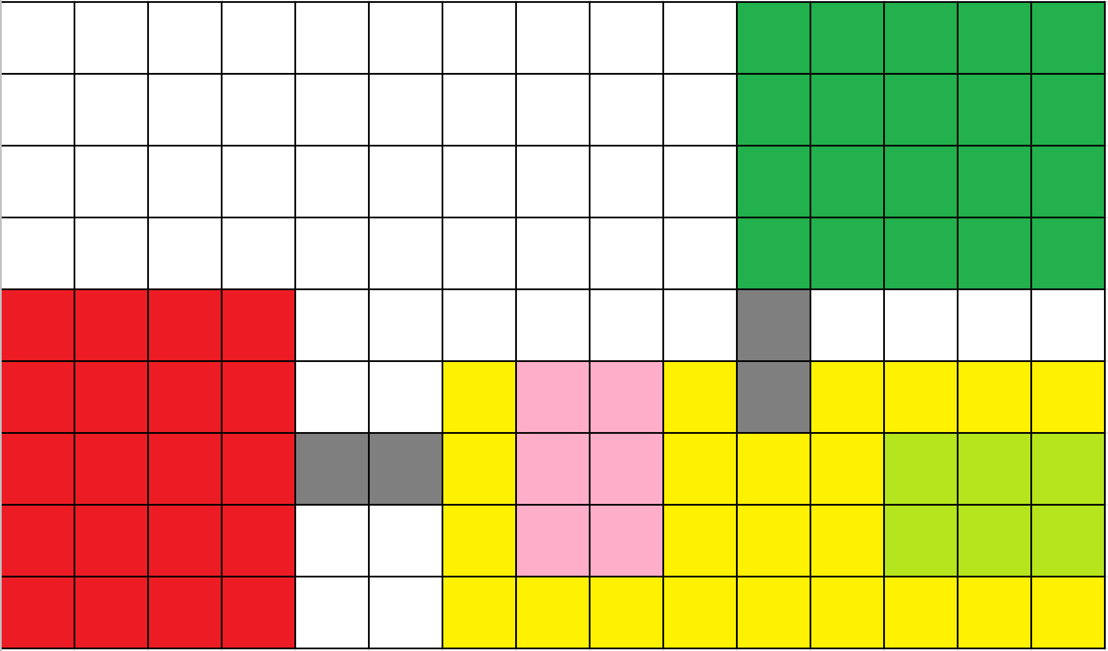

*Figure 2*. Arrangement of the map starting from corner 0 and 2.

26.4 TEST PROCEDURE

1. Place the robot with the center of rotation locating at the interior of starting blocks. The orientations of the robot are random, meaning that testers can put the robot towards the wall.
2. Load the parameters into the robot. For detailed set-up instruction of wifi class please refer to section 22.4 and 22.5.
3. After the parameters are loaded the robot should be running autonomously.

26.5 EXPECTED RESULTS

The robot is expected to localize, travel through the tunnel, reach the search zone, find a can and attempt to identify its weight and color. The robot is not expected to have correctly identify the color and weight in all cases, because there is still known problems with the color identification and weight detection systems. The robot is expected to bring the can back through the tunnel and reach the starting corner. The can is expected to be placed upright in the starting corner.

26.6 TEST RESULTS

**Software Version 2.3-A**

|  |  |
| --- | --- |
| **Map Configuration** | **Completion Rate** |
| Map 2 Corner 0 | 93.8% |
| Map 2 Corner 2 | 62.8% |
| Map 1 Corner 1 | 87.9% |
| Map 1 Corner 3 | 73.4% |

*Table 1*. Completion rates for 4 different map configurations for version 2.3-A.

**Software Version 2.3**

|  |  |
| --- | --- |
| **Map Configuration** | **Completion Rate** |
| Map 2 Corner 0 | 37.5% |
| Map 2 Corner 2 | 37.5% |
| Map 1 Corner 1 | 33.3% |
| Map 1 Corner 3 | 37.5% |

*Table 2*. Completion rates for 4 different map configurations for version 2.3.

**Observations for software version 2.3-A:**

1. Problems appeared in ultrasonic sensor localization. This part of localization was skipped to make the most of of this test. By having the robot roughly at 0 degrees, light localization is able to localize and continue the program.
2. Incorrect can color and weight readings. In particular, light sometimes read as heavy. Red read as yellow and yellow read as red.
3. Sometimes the can would get hit out of the starting tile after the robot returns and places in the starting corner.
4. On rare occasions, the heavy can would get stuck on the edge of the tunnel when robot is entering tunnel with can.
5. On rare occasions, the robot’s arm would knock the can down during search, trying to acquire the can.

**Observations for software version 2.3:**

1. Problems appeared in ultrasonic sensor localization. This part of localization was skipped to make the most of of this test. By having the robot roughly at 0 degrees, light localization is able to localize and continue the program.
2. In all cases, robot passed search zone but did not stop.

26.7 CONCLUSION

Software version 1 has a higher success rate for each map configuration than software version 2. There are numerous minor problems in version 1, this may not be the case in version 2. However, the robot was unable to stop at the search zone. Thus the search, can acquisition, and returning to starting corner functionalities were not tested. Software version 1 is superior.

26.8 ACTIONS

Due to time constraints, the team will be moving forward with software version 2.3-A rather than software version 2. Software version 2.3-A will be used in integration test 2.

26.9 DISTRIBUTION

Software Leader; Software Engineer; Hardware Leader; Hardware Engineer; Project Manager; Documentation Manager.

26.10 APPENDIX

Test Code: Refer to Software Document software version 2.3 and 2.3-A.

[Full Data](https://docs.google.com/spreadsheets/d/1GNXsXa0p7EuQOoLFYsKCcXmL0AawtcIUqjvyKnF2wgw/edit?usp=sharing)

# 27 INTEGRATION TEST 2

**Date:** 2019/04/03

**Tester:** Raymond Yang

**Duration:** 180 min

**Author:** Raymond Yang

**Hardware Version:** 2.4

**Software Version:** 2.3-A

27.1 TEST PURPOSE

This is the second integration test. The superior software from test 26 integration test 1 was selected and moved on for further testing. Refer to section 26.1.

27.2 TEST OBJECTIVES

Refer to section 26.2.

27.3 TEST SETUP

Refer to section 26.3.

27.3.1 MAP ARRANGEMENT

For cases starting from corner 0 and 1, the maps are demonstrated below.

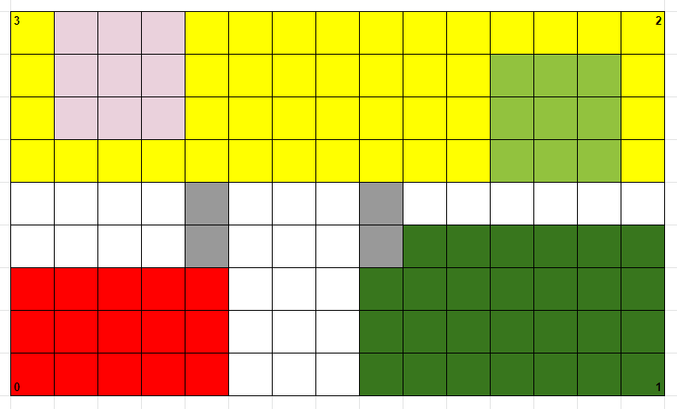

*Figure 1*. Arrangement of the map starting from corner 0 and 1. Although the island length is greater than the maximum length required (10), the robot can still be tested.

For cases for corner 2 and 4, the maps are demonstrated below.

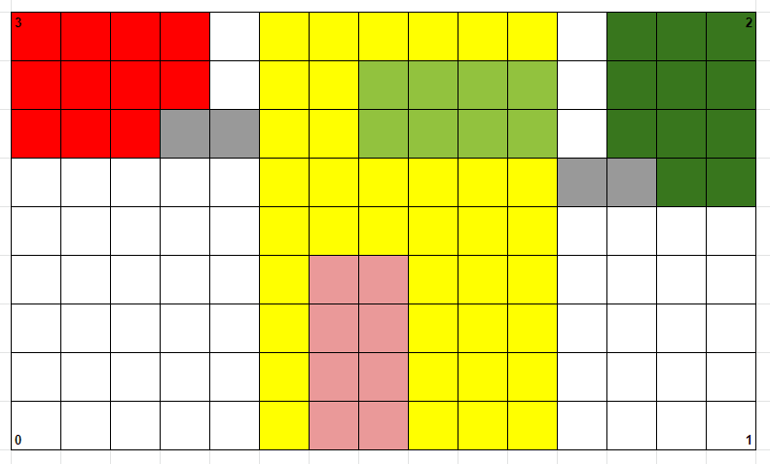

*Figure 2*. Arrangement of the map starting from corner 2 and 3.

27.4 TEST PROCEDURE

Refer to section 26.4.

27.5 EXPECTED RESULTS

Refer to section 26.5. The expected results are very similar to that of test 26. However, since this is integration test 2, the robot is expected to perform through all actions and succeed at least once for every corner.

27.6 TEST RESULTS

|  |  |
| --- | --- |
| **Map Configuration** | **Completion Rate** |
| Map 1 Corner 0 | 52.1% |
| Map 1 Corner 1 | 75.0% |
| Map 2 Corner 2 | 83.4% |
| Map 2 Corner 3 | 95.8% |

*Table 1*. Completion rates for 4 different map configurations.

**Observations:**

1. Robot often reads light cans as heavy cans.
2. Robot often mixes red and yellow cans in color identification.
3. On rare occasions, heavy cans get stuck on the edge of the tunnel when entering tunnel.
4. On rare occasions, the dent between demo boards throw the robot off its path.

27.7 CONCLUSION

There are several problems still persistent. Problems mainly appear in light and weight identifications, especially when the robot does not travel perfectly towards the can or grasp the can tightly. The completion rate of the task is over 50.0% for all maps and very high for some particular maps. Most of the time, even if identification is not accurate, the robot is still able to bring the can back to the starting corner.

27.8 ACTIONS

At this time, because the demo day is close, no changes are made to the hardware or software.

27.9 DISTRIBUTION

Software Leader; Software Engineer; Hardware Leader; Hardware Engineer; Project Manager; Documentation Manager.

27.10 APPENDIX

Test Code: Refer to Software Document software version 2.3-A.

[Full Data](https://docs.google.com/spreadsheets/d/12aypaD05KSDOWmkTVdbtTlSu2_-jDAY2P6dQ6Ywmr04/edit?usp=sharing)

1. 30.48 cm and 60.96 cm corresponds to 1 and 2 tile lengths, on the demo floor.